

**Quarterly Economic Update**

**Second Quarter 2017**

**Your Name**

**“”’’**

While political stories dominated the headlines, investors enjoyed another positive quarter. The second quarter extended the upward movement of U.S. equity markets from the first quarter, allowing equity investors to enjoy reasonable returns for the first half of 2017.

The second quarter of 2017 also marked the seventh straight quarter that the DJIA and S&P 500 have risen.

(***Bigcharts.com 7/13/17)***

***(***[***www.blogs.wsj.com***](http://www.blogs.wsj.com) ***7/5/17)***

The S&P 500 produced a total return of over 2.5% and closed the quarter at 2,423.41. This is up from the previous quarter’s close of 2,362.72. While the second quarter was strong, its overall gain was lower than quarter one.

The Dow Jones Industrial Average (DJIA) increased in the second quarter, but it experienced slower gains than those of the first quarter. The DJIA closed the second quarter at 21,349.63, up from its 20,663 quarter one close.

(***Bigcharts.com 7/13/17)***

In June, the Federal Reserve approved the expected second federal funds rate increase of 2017. Back in March, the Federal Reserve raised the rate to between 0.75% and 1%. Currently, as of June’s increase, the new range is 1% to 1.25%. During the June Federal Reserve’s Committee meeting, it was announced that they will begin the process of reducing their $4.5 trillion balance sheet sometime in 2017, however their timeline was unspecified. The post-meeting statement noted, "The committee currently expects to 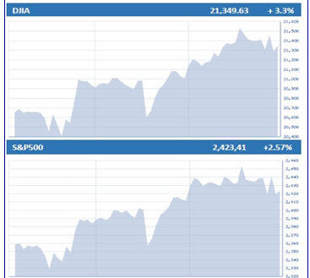begin implementing a balance sheet normalization process this year, provided the economy evolves broadly as anticipated.” ***(***[***www.cnbc.com***](http://www.cnbc.com) ***6/14/17)***

Some experts believe that both the rate increase and the Fed’s upcoming efforts to reduce their balance sheet will produce a more stringent monetary policy during a time when inflation is lower than expected. ***(***[***www.cnbc.com***](http://www.cnbc.com) ***6/14/17)***

The U.S. economy is continuing to look strong with positive unemployment and housing market data. Unemployment statistics are seeing lower percentages than they typically see 96% of the time since 1970.

***(***[***www.am.jpmorgan.com***](http://www.am.jpmorgan.com) ***6/17/17)***

Due to housing demand, the U.S. housing market continues to have a healthy outlook despite high price gains. “Household formation growth over the past year had a notable uptick this quarter over last, playing a big factor in driving up demand for housing and maintaining a strong market,” said David Berson, Nationwide Senior Vice President and Chief Economist. “We are, however, keeping a close eye on affordability and especially house price appreciation as it is well above the long-term average.”   
***(***[***www.nationwide.com***](http://www.nationwide.com) ***6/20/17)***

**Market Records Continue**

The day before the Fed meeting, the market experienced a “Fed drift,” the tendency of the markets to rise a few days before their meetings. On June 13, the DJIA rose about 90 points, hitting intraday and closing records, closing at 21,328.47. The S&P also had a record close that day, gaining 10.96 points (0.45%) to close at 2,440.35.

***(***[***www.cbnc.com***](http://www.cbnc.om) ***6/13/17)***

While the markets continue to impress us with records and milestones, it is still prudent for investors to remain vigilant. It is easy to get lost in the headlines that the media presents, however, our job requires us

|  |
| --- |
| **Key Points** |
| **1** Quarter 2 continued strong adding to a   healthy first half of 2017. |
| **2** The Federal Reserve raised the federal funds rate by 25 basis points to 1.0% - 1.25% in June. |
| **3** Equity markets continue to break   records. |
| **4** Concerns continue over how global   issues will affect markets. |
| **5** Oil prices remain low. |
| **6 Investors need to be cautious and**  **watchful.** |
| **7 Focus on your personal goals and call us with any concerns.** |

to remind you that it is best to stay focused on the progress of your own personal goals and plans. While year-to-date, the equity markets have been marching steadily higher and bond rates have drifted lower with limited, if any, volatility, experts are predicting more turbulence for the second half of the year.

***(Barron’s 6/12/2017)***

**Global Watch and Concerns**

Brexit is again at the forefront of potential global financial woes. According to Deloitte, “The rate of chief financial officers who expect some negative, long-term effects from a so-called Brexit climbed to 72% in the second quarter of 2017, from 60% in the first quarter.”

***(***[***www.marketwatch.com***](http://www.marketwatch.com) ***7/10/17)***

Following the United Kingdom’s (U.K.) general election in June, a slowing economy growth of 0.2% (down from 0.7%) in the fourth quarter of 2016, and Brexit negotiations underway in Brussels, many financial executives are increasingly showing lack of faith in the U.K.’s economic stability once it leaves the European Union. While the monetary policy of the U.K. remains in limbo, volatility will remain in the U.K. equity market.

***(***[***www.marketwatch.com***](http://www.marketwatch.com) ***7/10/17)***

Bonds are still considered expensive in all regions. According to Russell Investments 2017 Global Market Outlook, the U.S. has the closest fair value, while on the opposite end of the spectrum are Germany and the United Kingdom. Japan is still on task for their target of zero percent for the 10-year bond yield and the European Central Bank continues with negative rates and asset purchases until at least the end of this year, the report continues.

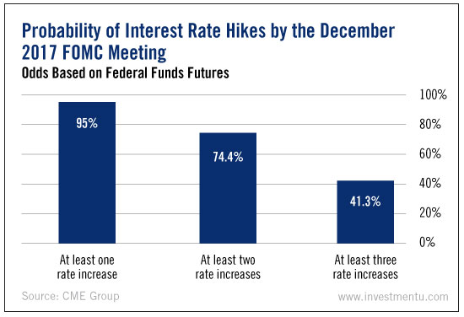

Additionally, the geopolitical pressures from North Korea and Syria remain potential global concerns that investors need to monitor. For now, global concerns have not affected the equity markets, but investors still need to be attentive to global issues.

**Oil Prices**

A significant increase of U.S oil production increased the global supply of oil in the first half of 2017. Oil prices continue to stay low, with the price of WTI finding itself steadying between the $44-45/bbl range. With these lower oil prices, U.S. production may begin to slow down. This, along with OPEC attempting to control production levels, may cause oils prices to rebound for the second half of 2017. ***(***[***www.forbes.com***](http://www.forbes.com) ***6/19/17)***

"It's going to be difficult to have a rally unless there's a disruption or some news from OPEC," said Olivier Jakob, Managing Director with PetroMatrix. Without any major global conflicts that restrict oil exportation or OPEC inundating the market with excess crude, oil prices should not expect to see major price fluctuations for the remainder of 2017.

***(***[***www.forbes.com***](http://www.forbes.com) ***6/19/17,*** [***www.cnbc.com***](http://www.cnbc.com) ***6/15/17)***

**Interest Rates**

For 2017, interest rates should remain high on an investor’s watch list. As mentioned, the Fed’s raised interest rates by 25 basis points to 1% - 1.25% at their June meeting. This marked the second of three rate hikes that the Federal Reserve suggested we could see this year. There is a third rate increase expected before the end of 2017. Interest rates need to be monitored and there is some speculation as to whether or not the Feds will actually decide to increase the rate any more this year.

The Feds announced in June that it will begin the daunting process of reducing its balance sheet that was expanded to help fight the housing crisis that began almost a decade ago. Interest rates are an area that we will continue to watch. Investors should continue to monitor how the bond and equity markets fare with the reduction of Federal Reserve stimulus money.

As short term interest rates rose, the 10-year Treasury yield fell. On June 15, the 10-year Treasury yield dropped six basis points to 2.15%, which was close to a seven-month low that eventually moved back up to close at 2.31% for the second quarter. ***(***[***www.seekingalpha.com***](http://www.seekingalpha.com) ***6/16/2017; ycharts.com)***

Interest rate concerns arose when Fed Chairwoman Janet Yellen announced that, “The recent lower reading on inflation has been driven significantly by what appears to be one-off reductions in certain categories of prices,” reflecting the Federal Open Market Committee’s reduction in their forecast for headline inflation down to 1.6% from the 2% target. Yellen herself is not concerned about the weakening inflation trend, stating that it reflects the, “progress the economy has made and is expected to make toward maximum employment and price stability assigned to us by law.”

***(***[***www.cnbc.com***](http://www.cnbc.com) ***6/14/17)***

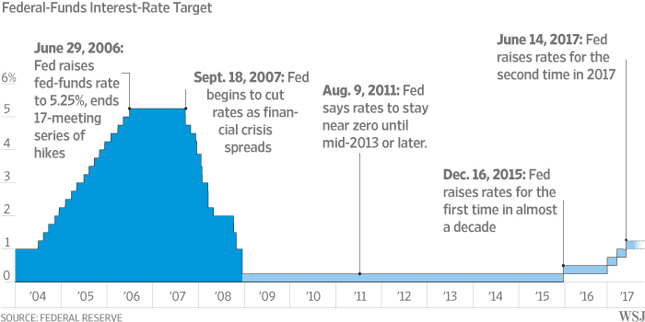Fidelity Investments feels that, “Markets are anticipating the Fed will hike rates only twice through December 2018, instead of the 4 times the Fed projects.” They also say that, “historically, the yield curve typically flattens as the Fed hikes rates and the business cycle matures, with inversions occurring prior to each of the last 7 recessions. Typically, U.S. equity markets have fared well in a rising interest rate environment, but investors still need to pay close attention to interest rate movements.   
***(www.fidelity.com)***

**Market Outlook**

The second quarter was a healthy one for investors. While the outlook for the remainder of the year still looks positive for equity investors, there are several factors to continue keeping a close eye on.

Geopolitical unrest remains, political gridlock in the U.S., oil prices and further interest rate movement can all be impactful on the U.S. and world investment markets. As always, if you are planning on making any investment changes, it is helpful to discuss these changes and your personal situation with us.

Many market analysts are skeptical of the second half of 2017. “It’s hard to imagine the second half being as good as the first,” says Bill Stone, Global Chief Investment Strategist at PNC Asset Management. Analysts are finding it difficult to believe that the sizeable gains seen in the first half of 2017 can continue. They also suspect that these gains may have taken away from potential gains that might have happened later in the year*.*

*(*[***www.usatoday.com***](http://www.usatoday.com) ***6/30/17)***

Skeptical sentiment is resonated with comments as Brian Nick’s, Chief Investment Strategist at TIAA Investments, saying, “The market has run as far as it is gonna’ run.”

***(***[***www.usatoday.com***](http://www.usatoday.com) ***6/30/17)***

However, some other Wall Street strategists remain optimistic, expecting the 2017 stock market to repeat its successful first half. Jonathan Golub of RBC Capital Markets, known for being Wall Street’s biggest bull, believes the market will increase 6-7% before the year end.

***(***[***www.usatoday.com***](http://www.usatoday.com) ***6/30/17)***

The fact is, U.S. equities are highly-priced, thus the sentiment that they are susceptible to a swing in the other direction. U.S. Treasuries remain expensive and there are many additional factors that can directly impact the U.S., including:

* Geopolitical and social unrest, such as Brexit and the future of the Eurozone;
* Continued terrorist attacks that create an uncertain and cautious perspective with investors;
* Policy gridlock and the potential roadblocks that President Trump’s administration will face when attempting to pass the stimulus plan.

The Fed’s upcoming balance sheet reduction efforts are worth watching as well, although, according to San Francisco Federal Reserve President John Williams, will be, “widely telegraphed, gradual, and – frankly – boring; and the more public understanding there is, the lesser the risk of market disruption and volatility."

***(***[***www.forbes.com***](http://www.forbes.com) ***5/29/17)***

Oppenheimer’s Chief Investment Officer reports that, “heading into the second half of 2017, we believe the elongated U.S. credit and business cycle – currently eight years old and counting – will continue through the end of the year. Yet for the first time in almost a decade, the risks to the global economy are centered in the U.S. and not in other major world economies.” They go on to also report that “growth in much of the rest of the world is stable or accelerating and “in our view, the biggest threat to the global economy is the prospect of the U.S. Federal Reserve (Fed) further tightening U.S. monetary policy.”

***(www.Oppenheimerfunds.com, Midyear 2017 Outlook)***

**Conclusion:   
What Should an Investor Do?**

For the first half of 2017, stocks have marched higher, bond yields have drifted lower and volatility has not been an issue. Investors have not experienced any dramatic up or down swings, however, that does not mean investors should become complacent.

Barron’s reports that, so what if stock markets are up nicely in India, Hong Kong and Korea, U.S. investors have had a lot to celebrate so far this year. Although the republican controlled Congress has not yet, as of this writing, delivered tax reform or the financial stimulus it promised, the S&P 500 has delivered 24 record highs. The main question on everyone’s mind is - will the fireworks continue in the second half of 2017?

***(***[***Barron’s***](http://www.cnbc.com) ***7/3/17)***

“The market is always vulnerable to a news event, an economic event or an earnings event,” says Robert Sluymer, managing director of technical strategy at FundStrat Global Advisors, a Wall Street research firm.

***(***[***www.usatoday.com***](http://www.usatoday.com) ***6/11/17)***

Guggenheim Global Chief Investment officer Scott Minerd wrote that “stock and bond markets have rarely been more expensive and stable, and that has me worried.” This is an ideal time for investors to be cautious and alert. Many experts feel that a diversified portfolio can help provide some shelter from possible storms. However, with interest rates low, trying to generate high returns while achieving diversification can be difficult.

***(Barron’s 6/12/17)***

**Volatility might return for**

**investors and therefore we   
need to proceed with caution.**



Today’s fixed rate returns will not help most investors reach their financial goals so they probably will need to include equities in portfolios. We are carefully monitoring equity markets and interest rates so we can communicate with clients. Market volatility is a part of investing and instead of being worried by volatility, try to be ready.

**Focus on your own**

**personal objectives.**

During times that call for caution, it is always wise to create realistic time horizons and return expectations for your own personal situation and to adjust your investments accordingly. We try to understand your personal commitments so we can categorize your investments into near-term, short-term and long-term.

Investors should always be prepared. While the market is currently strong, potential volatility should cause you to be concerned, but panic is not a plan. Market downturns do happen and so do recoveries. This is the ideal time to ensure that you fully understand your time horizons, goals and risk tolerances. Looking at your entire picture can be a helpful exercise in determining your strategy. We always welcome the opportunity to discuss any updates to your thoughts or situation.

**Discuss any concerns with us.**

Our advice is not one-size-fits-all. We will always consider your feelings about risk and the markets and review your unique financial situation when making recommendations.

**We pride ourselves in offering:**

* consistent and strong communication,
* a schedule of regular client meetings, and
* continuing education for every member of our team on the issues that affect our clients.

A good financial advisor can help make your journey easier. Our goal is to understand our clients’ needs and then try to create a plan to address those needs. We continually monitor your portfolio. While we cannot control financial markets or interest rates, we keep a watchful eye on them. No one can predict the future with complete accuracy, so we keep the lines of communication open with our clients. Our primary objective is to take the emotions out of investing for our clients. We can discuss your specific situation at your next review meeting or you can call to schedule an appointment. As always, we appreciate the opportunity to assist you in addressing your financial matters.

Insert Approved B/D/ Disclaimer Here

Note: The views stated in this letter are not necessarily the opinion of SagePoint Financial, Inc., and should not be construed, directly or indirectly, as an offer to buy or sell any securities mentioned herein. Investors should be aware that there are risks inherent in all investments, such as fluctuations in investment principal. With any investment vehicle, past performance is not a guarantee of future results. Material discussed herewith is meant for general illustration and/or informational purposes only, please note that individual situations can vary. Therefore, the information should be relied upon when coordinated with individual professional advice. This material contains forward looking statements and projections. There are no guarantees that these results will be achieved. All indices referenced are unmanaged and cannot be invested into directly. Unmanaged index returns do not reflect fees, expenses, or sales charges. Index performance is not indicative of the performance of any investment. The S&P 500 is an unmanaged index of 500 widely held stocks that is general considered representative of the U.S. Stock market. Dow Jones Industrial Average (DJIA), commonly known as “The Dow” is an index representing 30 stock of companies maintained and reviewed by the editors of the Wall Street Journal. Diversification does not ensure a profit or protect against a loss. Investing in oil involves special risks, including the potential adverse effects of state and federal regulation and may not be suitable for all investors. Due to volatility within the markets mentioned, opinions are subject to change without notice. Information is based on sources believed to be reliable; however, their accuracy or completeness cannot be guaranteed. U.S. Government Bonds are guaranteed by the U.S. government and, if held to maturity, offer a fixed rate of return and guaranteed principal value. Bloomberg Barclays Aggregate Bond ETF seeks to provide investment results that, before fees and expenses, correspond generally to the price and yield performance of the Bloomberg Barclays U.S. Aggregate Index. The Bloomberg Barclays U.S. Aggregate Index represents the securities of the US dollar denominated investment grade bond market. Sources: wsj.com, cnbc.com, Barron’s, nationwide.com, jpmorgan.com, marektwatch.com, usatoday.com, forbes.com; Contents Provided by The Academy of Preferred Financial Advisors, Inc 2017

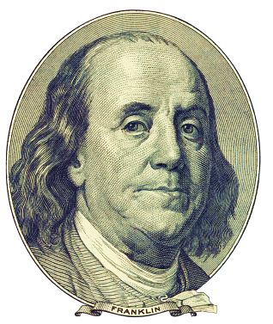

**Benjamin Franklin is one of the only non-Presidents to appear on a bill.**

**Today, the highest publicly circulating denomination of U.S. paper currency is the $100 bill. The $100 is one of the few circulating currencies that does not feature an American president on its face. Founding Father, Benjamin Franklin has the honor.**

***(Source: Business Insider)***



***Help us grow in 2017!***

**This year, one of our goals is to offer our services to several other people just like you!   
  
Many of our best relationships have come from introductions from our clients.   
Do you know someone who could benefit from our services?**

**We would be honored if you would:**

* **Add a name to our mailing list,**
* **Bring a guest to a workshop,**
* **Have someone come in for a complimentary financial checkup.**

**Please call Full Name and Approved Title at Business Name, (Phone)   
and we would be happy to assist you!**