Portfolio Rebalancing in Today’s Market:
Consider More Than a Formula!
Insert Logo/Masthead

Your Name

Rebalancing your portfolio can be a good way to help keep your investment strategy on track toward your goals. Doing this on a fairly consistent basis can help the soundness of your portfolio during times of market fluctuations, interest rates changes and life situation changes. With the new tax law changes and the most recent market volatility investors saw in the beginning of this year, now may be a great time to conduct a review of your portfolio to see if it needs any rebalancing.

What Is Rebalancing?
The term "rebalance" makes investing sound as simple as having your tires rotated or your car’s alignment checked. The basic concept behind this exercise is mostly straightforward.

According to Investopedia.com, rebalancing is defined as the process of buying and selling portions of your portfolio in order to set the weight of each asset class back to its original state. In addition, if an individual’s investment strategy or tolerance for risk has changed, he or she can use rebalancing to readjust the weightings of each security or asset class in the portfolio to fulfill a newly devised asset allocation.

Rebalancing your investment portfolio is a simple strategy and it makes sense to do this at regular intervals so your investments are closely aligned with your long-term financial plan. This generally means periodically reviewing your portfolio’s mix of investments. After a market rise, many investors lighten the upside (and downside) potential of equities with hopefully less volatile returns of fixed income when one or the other gets overinflated in your portfolio. While rebalancing does not assure superior performance, it helps keep portfolios updated on targeted asset allocations.

The First Two Steps
to Traditional Rebalancing

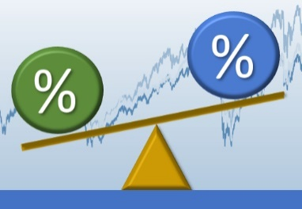
Traditional rebalancing usually has two simple steps. However, in today’s market there is a third step that can be very difficult.

Step One: When you design your investment plan, you decide your ideal mix of equity and income based on your personal situation, including your long-term goals and risk tolerance.

Step Two: As your investment portfolio’s value changes, you need to check it periodically to see how your personal mix of investments move with market changes. You should then consider adjusting your holdings to reflect your personal situation by reviewing your goals, age and risk appropriateness. For many investors, tax time is one of the more popular times to perform this checkup.

When you complete the rebalance, your hope is to sell what has increased and could potentially be high and buy what has not reached a greater value and is possibly low. Traditional rebalancing is supposed to give investors the discipline to attempt to do that.
In keeping a balanced portfolio, debt securities have nearly always provided a natural hedge: traditionally bonds have usually gained in value when stocks went down. Their yields have risen proportionately when stocks have gone up (mostly during an improving economy). Rebalancing can provide a continuous readjustment, and as a result, it can keep people from letting emotions rule investments. That rule still holds, even if the asset mix is changing.

The rule of thumb has traditionally been "100 minus your age." It tells you roughly how much equity you should have. Doing that math, at age 40, your equity should be 60 percent and the rest should be fixed income. At 60, those numbers are flipped, with 60 percent in fixed income and 40 percent in stocks. When you have a mix of stocks and bonds in your portfolio, when stocks generate a higher return, they will become a larger percentage of your holdings. Conversely, when bonds do better than stocks, your portfolio balance will shift toward bonds. The allocation you choose should depend on your individual risk tolerance and investment goals.

2017 brought consistent interest rate hikes. There have been Federal Fund rate increases already this year and more are scheduled for 2018. For those with fixed income vehicles, with rates rising and bond prices falling, rebalancing portfolios now is typically a healthy practice in potential risk management and loss prevention.

The Consequences of Imbalance
A popular belief among many investors is that if an investment has performed well over the last year, it should perform well over the next year. Unfortunately, past performance is not always an indication of future performance. This is a fact many investments disclose, but still many investors remain heavily invested in last year's "winning" portfolios and may drop their portfolio weighing in last year's "losing" portfolios. Remember, equities are more volatile than fixed-income securities, so the source of last year's large gains may translate into losses over the next year.

Normal rebalancing rules would suggest that with the large gain in stocks recently, investors should start lightening up on equities and switch to fixed income investments to restore that balance.

But, due to the rising rates, yields for short-term bonds have risen, triggering short-term bond prices to fall. On the other hand, intermediate and long-term bonds have experienced the opposite effect – rising prices and falling yields – as foreign investors turned to short-term U.S. Treasury notes instead. (Source: money.usnews.com 1/26/2018)

A number of investing allocation experts are currently leery of loading up on more fixed income, especially with the Federal Reserve expected to continue to raise rates.

The Third Step of Rebalancing
Step Three: When you design your investment plan, you decide your ideal amounts for fixed income.

While interest rates are on the rise, they are still historically low.

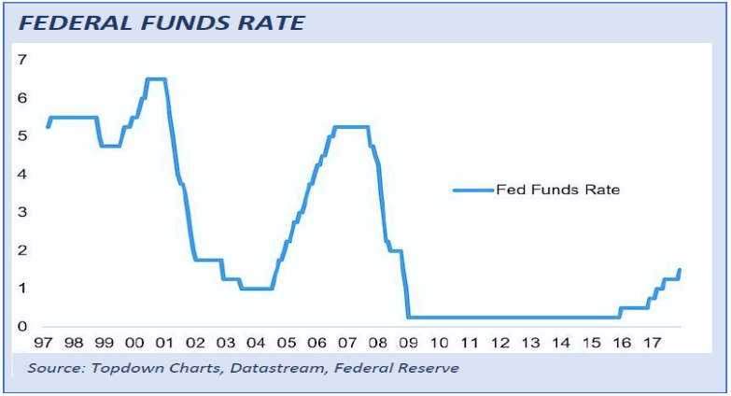
This can generate “interest rate risk.”

As defined by Investopedia.com, “Interest rate risk affects the value of bonds more directly than stocks, and it is a major risk to all bondholders. As interest rates rise, bond prices fall and vice versa. The rationale is that as interest rates increase, the opportunity cost of holding a bond decreases since investors are able to realize greater yields by switching to other investments that reflect the higher interest rate. For example, a 5% bond is worth more if interest rates decrease since the bondholder receives a fixed rate of return relative to the market, which is offering a lower rate of return as a result of the decrease in rates.”

Due to increased interest rate risks, some investment professionals have looked elsewhere when appropriate. (i.e. the income-producing side of equities, or preferred shares). "Laddering" with a series of short-term bonds can be another way to address this problem, since low-duration debt reaches maturity in a short time. While one- to five-year securities pay little in yield, at least investors may recover some or all of their invested capital when the security matures, unless they overpaid for the bonds in the secondary market. Longer term bonds may produce higher yields but are more vulnerable when rate changes or market fluctuations occur.

Recent market volatility has reminded investors that this market high could see a correction on the horizon. Short-term fixed income instruments may have lower yields but could be less susceptible to volatility.

Rebalancing Focuses on the Long Term
High level financial strategists like Charles Ellis, Former Chairman of the Yale Endowment who guided Yale's massive endowment with a rebalancing strategy based on diversified investments that provided far above-average returns, advise high-income investors to take pains to make sure they rebalance to suit clients' needs. Ellis says personal advice and individual goal-setting are key components of successful rebalancing strategy.

The long-term strategy behind a disciplined approach is to stick with asset allocations that you review on a periodic basis.

Final Thoughts on
Rebalancing Your Portfolio
Your primary goal as an investor should be the overall success of your portfolio.

Changes in your lifestyle may warrant a change to your asset-allocation strategy. Whatever your preference, the following guideline provides the basic actions needed for rebalancing your portfolio:
- Record - If you have recently decided on an asset-allocation strategy perfect for you and purchased the appropriate securities in each asset class, keep a record of the total weightings you are attempting to hold in each asset class. These numbers will provide you with historical data of your portfolio.
- Compare - On a chosen future date, review the current value of your portfolio and of each asset class. Calculate the weightings of each holding in your portfolio by dividing the current value of each asset class by the total current portfolio value. Compare this figure to the original weightings. Are there any significant changes?
- Adjust - If you find that changes in your asset class weightings have distorted the portfolio's exposure to risk, take the current total value of your portfolio and multiply it by each of the (percentage) weightings originally assigned to each asset class. The figures you calculate will be the amounts that should be invested in each asset class in order to maintain your original asset allocation. You may want to sell positions from asset classes whose weights are too high, and purchase additional investments in asset classes whose weights have declined. When selling assets to rebalance your portfolio, consider taking a moment to consider the tax implications of readjusting your portfolio. If you are adding new money to your portfolio, in some cases it might be more beneficial to simply not contribute any new funds to the asset class that is overweighed while continuing to contribute to other asset classes that are underweighted. Your portfolio might be able to rebalance over time without you incurring capital gains taxes.
Conclusion

Rebalancing your portfolio can help you maintain your original asset-allocation strategy and allow implementation of any changes you may want to make to your investing style. The optimal frequency of portfolio rebalancing depends on your transaction costs, personal preferences and tax considerations, including what type of account you are selling from and whether your capital gains or losses will be taxed at a short-term versus long-term rate. This is where a qualified advisor can provide help.

The primary goal of rebalancing is to focus on minimizing an investor’s risk by staying within targeted allocations. It is not a pursuit of maximizing your investment returns.

How often and how much of your portfolio you need to rebalance is where a qualified financial advisor can add value. Simple rebalancing suggests that your entire portfolio is performing well, and sometimes that might not be the case. Essentially, rebalancing tries to help you stick to your investing plan regardless of what the market does.
Our goal is to understand our clients’ needs and to monitor their portfolios. Our primary objective is to take the emotions out of investing for our clients. We can discuss your specific situation at your next review meeting or you can call to schedule an appointment. As always, we appreciate the opportunity to assist you in addressing your financial issues.

Help us grow in 2018!
This year, one of our goals is to offer our services to several other people just like you!
Many of our best relationships have come from introductions from our clients.
Do you know someone who could benefit from our services?

We would be honored if you would:
- Add a name to our mailing list,
- Bring a guest to a workshop,
- Have someone come in for a complimentary financial checkup.
Please call Name at Business Name, (Phone) and we would be happy to assist you!

v Approved Broker/Dealer Disclosure and Contact Information
Insert Approved B/D Disclosure and Contact Information

This article is for informational purposes only. This information is not intended to be a substitute for specific individualized tax, legal or investment planning advice as individual situations will vary. For specific advice about your situation, please consult with a lawyer or financial professional. The views stated in this letter are not necessarily the opinion of Insert Full B/D Name and should not be construed, directly or indirectly, as an offer to buy or sell any securities mentioned herein. Investing involves risk including the potential loss of principal. No investment strategy, such as rebalancing and asset allocation, can guarantee a profit or protect against loss. Rebalancing investments may cause investors to incur transaction costs and, when rebalancing a non-retirement account, taxable events will be created that may increase your tax liability. Indexes are unmanaged and investors are not able to invest directly into any index. Past performance is no guarantee of future results. In general, the bond market is volatile as prices rise when interest rates fall and vice versa. This effect is usually pronounced for longer-term securities. Any fixed income security sold or redeemed prior to maturity may be subject to a substantial gain or loss. The payment of dividends is not guaranteed. Companies may reduce or eliminate the payment of dividends at any given time. This article provided the Academy of Preferred Financial Advisor, Inc. APFA, Inc.©

