Quarterly Economic Update
Second Quarter 2018
Insert Logo/Masthead

Your Name

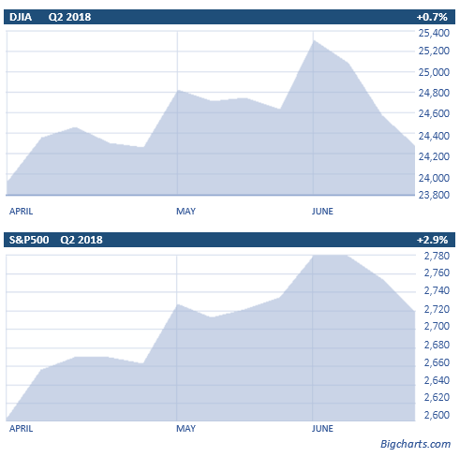
The second quarter of 2018 contained ups, downs and tariffs. Equity prices were very volatile as investors seemed to back off of many industrial heavyweights, while favoring large technology companies. Although the tensions of trade wars, tariffs, political uncertainty in the Eurozone and slowing momentum in the global economy surfaced, many indexes seemed to finish the quarter slightly higher.
While still below January 2018 highs, the S&P 500 and Dow Jones Industrial Average both rose for the quarter.
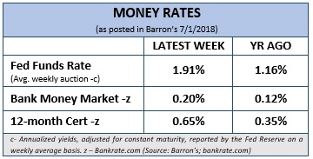
The Dow ended the quarter on a sour note, losing over 300 points in the last week of trading to bring its quarterly gain to less than 1%. The S&P 500 also fell in the quarter’s last week of trading, but it ended the quarter with a gain of 2.9%.
Some risk-oriented investors were rewarded this quarter. An example is Netflix, which, despite its price earnings multiple of over 200 (which by definition makes it risky) rose over 30%.
Jim Paulson, Chief Market Strategist at Leuthold Group warned that, “A lot of the investing public is invested in the same things.” Although high flying technology companies did reward some investors, he is concerned about the risk factors and their possible price decline for investors.
Categorically, large-cap equities did not do as well as small-cap equities in the second quarter and so conservative investors with more defensive positions might have experienced lower returns.
Barron’s reported that some fund managers headed into the quarter-end feeling optimistic.
“The tariffs are still dwarfed by the tax cuts, whose full positive effects have not made their way to the market,” argues David Waddell, Chief Investment Strategist at Waddell and Reed. He also adds, “I do not feel that many people have really done the math on the tax cuts.”
(Source: Barron’s 7/2/2018)

Gina Sanchez, CEO of Chantico Global, explained to CNBC that for the remainder of 2018 she’s expecting beaten-down value names to fall back into favor. “Now that caution has steadily crept back into the market this year amid rising global trade tensions, political uncertainty abroad and an increasingly aggressive Federal Reserve, investors may steadily return to these names that traditionally offer ‘safe’ return.”
(Source: CNBC 7/2/2018)

For the quarter, Evercore ISI research found that the economy grew at a 4% annual rate and employment statistics looked healthy. They felt that the quarter’s economic results are ones which “restrain inflation and help profit margins.”
(Source: Barrons 7/9/2018)

Key Points
- 2018 equity markets made slight advances in Quarter 2
- The bull market is now over 3,400 calendar days old.
- The Fed raised U.S. Fed Fund rates again to 1.75 – 2.00% in June and is projected to raise rates two more times in 2018.
- Inflation, trade wars and tariff talks are causing some uncertainty.
- Market volatility is back and investors need to continue to be cautious and watchful.
- Focus on your personal goals and call us with any concerns.
From a big picture standpoint, the bull market that began in 2009 is now over 3,400 calendar days and is the second longest ever (the 4,494 days starting in 1987 is the longest ever). Although the S&P 500 has risen slightly over 300% since March of 2009, during the 1987-2000 bull market, the S&P 500 rose over 582%. While investors have already seen a correction, market strategists remind us that, “bull markets don’t die of old age.” Short term interest rates have risen and cash equivalent yields are still historically low. Even the savviest of investors need to have a watchful eye on risk. As financial professionals, we try to make our best forecasts and look for a probability of success understanding we face an uncertain future. Our main goal is to continually understand our client’s goals and to match those goals with the best possible solutions.
(Source: Barron’s 7/2/2018)

Interest Rates Are Still Center Stage
As expected, in June, the Federal Reserve headed by Jerome Powell, increased its target short-term rate to a range between 1.75% and 2.00%. This seventh increase since the financial crisis was widely expected, as policymakers continue the process of normalizing interest rates. The central bank hinted at gradual hikes for this year with two more increases but turned hawkish for 2019 and 2020 citing growing confidence in the strengthening economy. As a result, some cyclical equity sectors like financials, industrials, and consumer discretionary are expected to benefit from a rising rates environment.
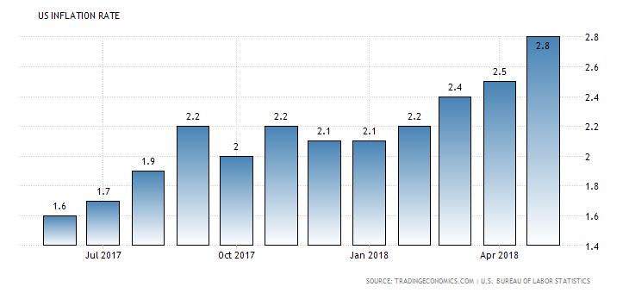
This recent rise in rates can have several important implications for an investor’s portfolio. Interest rates and bond prices have an inverse relationship. When interest rates rise, bond prices usually decrease. As interest rates rise, the decline in bond prices is most severe for longer-term bonds, compared to shorter-term and floating-rate bonds. Also, during periods of rising interest rates, stock prices could come under some pressure. Low interest rates in the bond market can make investing in stocks a relatively more attractive option, however, as interest rates rise, and bonds offer investors higher yields, long-term investors sometimes sell their stocks and invest in bonds.
Higher interest rates also mean the cost of capital for companies using debt instruments goes up. This results in less profit and many times slower growth.
While we can't predict what the future will bring, it's important that investors take appropriate steps to look for adjustments, if necessary, to prepare for any interest rate move. Interest rates continue to be a key area that investors need to watch closely in 2018.
Inflation Concerns
The inflation rate in the US increased to a six year high of 2.8% in May of 2018 from 2.5% in April, beating market forecasts of 2.7%. It is the highest inflation rate since February of 2012, mainly due to rising prices for gasoline and housing.
(Source: TradingEconomics.com 5/2018)
Since inflation has picked up, this will test the Federal Reserve policymaker’s challenge of keeping the core inflation rate under control. When connecting inflation to the Fed’s long term plan, Seeking Alpha reports that, “Fed Chair Jerome Powell has recently reiterated this fact. At the news conference after the last rate increase, Mr. Powell insisted that the Fed would cool things off if inflation were to persistently run above 2 percent.”
Although most economists feel that the current inflation rate will not influence the next few rises in Fed funds interest rates, Fed officials need to now consider how high and for how long they will let inflation increase. With unemployment decreasing, a strong dollar and inflation rising, investors now need to monitor inflation rates again.
Tariffs
The Trump administration recently placed tariffs on Mexico, Canada, EU countries, and China. A recent economic report from Nationwide stated that, “Tariffs generally stifle economic growth, but even if the proposed tariffs are fully implemented, the potential drag on the U.S. economy would be much less than the expected jolt from tax reform and higher government spending.” The report also noted that, “Investors focusing on possible negative impacts from tariffs should bear in mind that trade negotiations are in flux and the outcome is still uncertain; however, the tax reform and government spending packages are in place and already positively affecting the U.S. economy.” Their key takeaway was that the global economic cycle is progressing as expected. Tariff and trade threats from President Trump could continue to bring uncertainty for investors, but many economists still feel that momentum of the business cycle may do more to keep economic growth going than vague threats of trade protectionism.
(Source: Nationwide 6/2018)

The quarter ended with talk about more tariffs on other countries. Tariffs and their impact on equity investors are now a serious potential concern that we need to pay careful attention to moving forward.
General Electric leaves the DOW
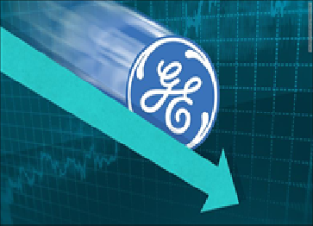
It's hard not to see GE leaving the Dow as the end of an era. Until late June, General Electric (GE), Thomas Edison’s old company, was the only original Dow component left of the 30 stocks that comprise the Dow Jones Industrial Average. It was the sole survivor from a time when the Dow consisted of mostly "old school" industrial companies.
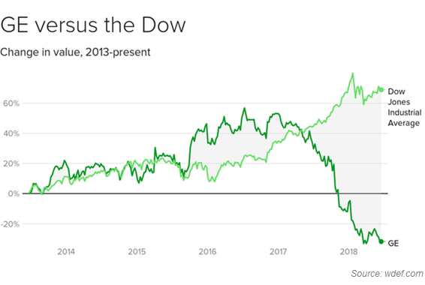
The committee that oversees the Dow issued this as a statement about GE's removal.
“General Electric was an original member of the DJIA in 1896 and a member continuously since 1907,” says David Blitzer, Managing Director and Chairman of the index committee at S&P Dow Jones Indices. “Since then the U.S. economy has changed: consumer, finance, health care and technology companies are more prominent today and the relative importance of industrial companies is less. Walgreens is a national retail drug store chain offering prescription and non-prescription drugs, related health services and general goods. With its addition, the DJIA will be more representative of the consumer and health care sectors of the U.S. economy. Today’s change to the DJIA will make the index a better measure of the economy and the stock market.”
Although Thomas Edison might not have approved, after 122 years, GE has been replaced by Walgreens Boots Alliance in the Dow Jones Industrial Average. GE was a member of the Dow long after United States Rubber and United States Leather were no longer components.
In 2009, when GE lost its AAA rating it was one of only six American companies to hold AAA status. This current Dow move not only reflects GE's recent struggles, but also the changes in today’s American economy. At one time, GE could have been viewed as a potential “buy and hold” investment. Buy and hold is a passive investment strategy in which an investor buys stocks and holds them for a long period regardless of fluctuations in the market. A buy and hold strategy is useful for some investors and a good strategy at certain periods of time, however, a buy and hold can be a poor strategy during certain periods of time.
Over the last 5 years, the equity markets have advanced but GE shares have dropped in value. As the old saying goes, “buy and hold works...until it doesn’t.” This is a great example of why the days of hold forever, might need to be revisited. For many investors, it could be helpful for a qualified professional to constantly monitor your holdings and make adjustments when it is in your best interest. When keeping holdings, managing risk is something we attempt to evaluate as we review holdings for our clients.
What Should an Investor Do?
Market volatility is expected in the investment world. Experienced investors understand that volatility is a part of investing. They also understand that more important than volatility is an investor’s response to that volatility. Sometimes volatility is a sign of heightened risk but at other times it is just a normal part of investing.
Stock market volatility can unnerve even the best of investors. This is not a new concept. In 1990, Robert Shiller, a Yale professor penned one of the times most extensive studies of how market volatility affects investor behavior. Empirical studies many times show that investors who react to market volatility in the wrong manner can harm their overall investment performance. Remember, a stock market correction is a 10% decline in stocks from a recent high. A correction is less severe than a bear market. A bear market is defined as when stocks decline 20% from their recent highs. Market volatility is different from corrections and bear markets. Low volatility means small fluctuations and high volatility means large fluctuations. Market volatility is possibly one of the most misunderstood concepts in investing. Simply put, market volatility is a statistical measure of when the equity markets rise or fall sharper than usual within a short period of time.

Proceed with CAUTION
is still the principal notion for investors.
This year investors have seen a return to a volatile investment environment, so we thought it would be helpful to share some things to think about during volatile times.
Things to Consider in Times of
Market Volatility
- Revisit your financial goals and objectives.
Panic is not a strategy. It’s important to keep perspective when markets get choppy. A sudden drop in the market can have dramatically different implications for someone just starting their career compared to someone nearing retirement. What’s important is you understand your situation and your financial plan.
- Consider avoiding or ignoring nightly financial news.
Short term downward market movements can trigger anxiety, but letting emotions drive your investment decisions may prove costly. Looking at the forest and not the trees can be helpful. For long term investors, a day-to-day focus can be very distracting. Forbes reminds us that, “the typical daily ‘noise’ from news outlets should not cause steadfast investors to abandon ship." One key to living with market volatility is avoiding or ignoring daily financial returns and staying focused on long-term results rather than the daily bumps along the way.
- Revisit your risk tolerance.
Being comfortable with your plan and your portfolio are important, but so is knowing your tolerance for risk. According to Forbes, successful investors know that volatility is part of the process on Wall Street. Instead of fearing volatility, they have learned to plan for it and actually embrace it. Volatile markets or corrections can provide a good reminder for long-term investors to reassess their holdings.
(Source: Forbes 6/5/2018)
- Review important paperwork
These days you're probably thinking about the beach, the mountains, or a road trip with the family. During the summer, when life may be a little slower and your mind a little less cluttered, it is actually a good time to do a quick financial reality check.
For example, making sure you have a will, health care proxy, and power of attorney is sometimes an uncomfortable topic, but the alternative could be messy and costly. Do you want someone else making important financial and health decisions on your behalf without any input from you? If you are missing some of these key documents, let us know at your next review. If you have them, talk with us about reviewing your paperwork based on any recent life events you’ve been through. Marriage, divorce, birth, and death are four of the bigger events that affect estate plans, but there are other factors that could affect your planning. Reviewing housekeeping items, like checking beneficiaries, is not complicated, but it can potentially cause serious consequences if neglected. Trying to protect our clients is something we always try to do.
- Connect with us to discuss your investing time frame, goals and strategy to make sure you’re still on track.
While CDs and money markets can offer the highest level of safety, they can also bring the lowest return, especially in the current climate of historically low interest rates. Full market risk is not appropriate for most investors even though today's traditional fixed rates might not help many investors pursue their desired goals. Most investors attempt to build a plan that includes risk awareness. Many times, this can lead to safer but lower returns. Traditionally, bonds have been used as a nice hedge against market risk, but with interest rates projected to rise investors need to be extremely cautious.
If you are concerned with your current investments or your goals or risk tolerance levels have changed, call us.
Let’s focus on YOUR
personal goals and Strategy.

During confusing times, it is always wise to have realistic time horizons and return expectations for your own personal situation and to adjust your investments accordingly.
Now is the time to make sure you are comfortable with your investments.
Equity markets will continue to move up and down. Even if your time horizons are long, you could see some short-term downward movements in your portfolios. Each type of investment poses a certain level of risk and offers a level of potential reward. It’s always a good idea to regularly re-evaluate your portfolio and your level of risk exposure. Peaks and valleys have always been a part of financial markets and it is highly likely that trend will continue.
Discuss any concerns with us.
Our advice is not one-size-fits-all. We will always consider your feelings about risk and the markets and review your unique financial situation when making recommendations. If you would like to revisit your specific holdings or risk tolerance please call our office or bring it up at our next scheduled meeting.

We pride ourselves in offering:

- consistent and strong communication,
- a schedule of regular client meetings, and
- continuing education for every member of our team on the issues that affect our clients.

A skilled financial advisor can help make your journey easier. Our goal is to understand our clients’ needs and then try to create a plan to address those needs. Should you need to discuss your investments, please call us.

Insert Approved B/D Disclaimer Here
Approved Contact Information

Note: The views stated in this letter are not necessarily the opinion of Approved B/D and should not be construed, directly or indirectly, as an offer to buy or sell any securities mentioned herein. Investors should be aware that there are risks inherent in all investments, such as fluctuations in investment principal. With any investment vehicle, past performance is not a guarantee of future results. Material discussed herewith is meant for general illustration and/or informational purposes only, please note that individual situations can vary. Therefore, the information should be relied upon when coordinated with individual professional advice. This material contains forward looking statements and projections. There are no guarantees that these results will be achieved. All indices referenced are unmanaged and cannot be invested into directly. Unmanaged index returns do not reflect fees, expenses, or sales charges. Index performance is not indicative of the performance of any investment. The S&P 500 is an unmanaged index of 500 widely held stocks that is general considered representative of the U.S. Stock market. Dow Jones Industrial Average (DJIA), commonly known as “The Dow” is an index representing 30 stock of companies maintained and reviewed by the editors of the Wall Street Journal. Due to volatility within the markets mentioned, opinions are subject to change without notice. Information is based on sources believed to be reliable; however, their accuracy or completeness cannot be guaranteed. International investing involves special risks, including currency fluctuations, different financial accounting standards, and possible political and economic volatility. investing in emerging markets can be riskier than investing in well established markets. Investing in small cap stocks generally involves greater risk and therefore, may not be appropriate for every investor. Stocks of smaller, or newer, or mid-size companies may be more likely to realize more substantial growth as well as suffer more significant losses than larger or more established issuers. Companies engaged in business related to a specific sector are subject to fierce competition and their products and services may be subject to rapid obsolescence. Additional risks associated with investing with an individual sector may include limited diversification. Investing always involves risk and you may incur a profit or loss. No investment strategy can guarantee success.

Sources: Barron’s; nationwidefinancial.com, amjpmorgan.com; cnbc.com; tradingeconomics.com; wdef.com; Academy of Preferred Financial Advisors, Inc.©
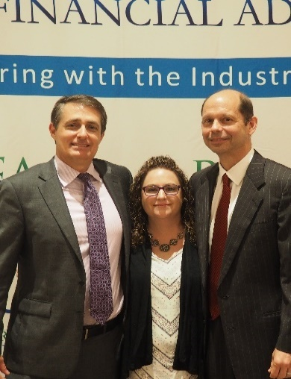
Our commitment to
continuing education
Chad Smith and Heather Thurgood with Academy Founder Ken Unger

Our practice has invested in our continuing education by becoming members of The Academy of Preferred Financial Advisors’ Exclusive Coaching Program.
As part of our effort to provide our clients with comprehensive, first-class services, key team members were recently invited to an intense two-day training program.
This session featured training on the new tax laws, current estate planning rules and strategies, and overall wealth management practices for high level financial advisors. This information can be helpful for our clients and reinforces our commitment to make sure clients come first!

Working with an advisor that is part of The Academy of Preferred Financial Advisors (APFA) cannot guarantee investment success or that financial goals will be achieved. There can be no assurance that working with a member of APFA will produce or achieve better results than working with an advisor not affiliated with The Academy of Preferred Financial Advisors. Advisors who participate in this program pay a fee to belong to the program. APFA is not affiliated with _____________________(Insert broker dealer) and is not sponsored or endorsed by the broker/dealer.
Has your current advisor reviewed
your specific situation recently?
Would you like a second opinion?
If you are currently not a client of Business Name, we would like to offer you a complimentary, one-hour, private consultation with one of our professionals at absolutely no cost or obligation to you.

To schedule your financial check-up, please call Name at Phone Number.

