Volatility Is Back:
Insert Your Company
Logo Here
What Does It Mean for You?
Your Name

The last few days have been confusing and interesting ones for investors. The recent stock market fluctuations have created a rollercoaster-type of ride that has attracted almost every media outlet. On Friday February 2nd, and then again on Monday February 5th, the Dow Jones Industrial Average had its largest and seventh largest declines in points terms in two consecutive sessions.
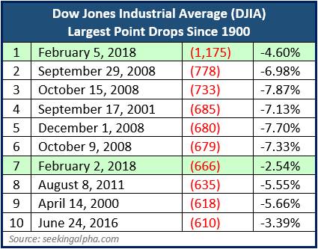
Investors should always be aware of market swings and movements, but they also need to remember that equity market pullbacks and corrections are a part of investing. Historically, a market correction, or a 10% decline, happens approximately once a year. A 5% pullback happens about 3 times a year, however in the last few years that has not been the case. 2017 was a year of limited and low volatility, so many investors were not ready for these large declines. Also, typically these pullbacks happen over a longer period than two days. While this might not be the end of the equity markets fall, it might be helpful to put these media grabbing falls into perspective.
When you analyze these declines, they are smaller when framed in percentage terms. In fact, the notable day on Friday, February 2nd became more noteworthy with Monday's consecutive decline. Friday's 666 point decline in the Dow Jones Industrial Average was the sixth largest drop ever (it became the 7th after Monday’s drop). Of course, that historical move was in point terms. In percentage terms, the 2.54% drop was just the 538th largest one-day decline at that time. Monday’s drop was far greater than Friday's, so it can be helpful to put Monday's move and the two-day meltdown for the Dow Jones Industrial average in a historical context. To do that you can reach back to equity market movements since the beginning of 1900.
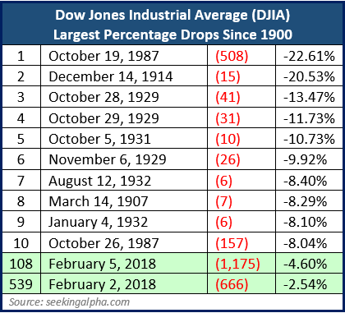
As the first chart from Seeking Alpha shares, here are the ten largest point drops in the Dow Jones Industrial Average since 1900. The combined sell off of over 1,800 points is obviously historic.
However, when you look at these movements from a percentage standpoint, they tell a concerning but perhaps different story. In percentage terms, those two trading sessions were far from top percentage declines on the Dow Jones Industrial Average. The second table shares the largest percentage declines since 1900, and also adds those two sessions. While February 5th created the largest move in point terms, it was just the 108th largest single day decline in the 118-year dataset.
According to Seeking Alpha, the two-day move for the Dow Jones Industrial Average was the largest in points terms and the 70th largest in percentage terms.
Many explanations are being given for this downswing of equity prices. They include the fact that the overall equity market has risen too quickly since Thanksgiving, when the reality of Tax Law changes were felt. Overpriced equity markets and rising interest rates are also discussed as factors. The potential return of inflation is also something economists are suggesting as well. As we have indicated in many of our communications investors need to always proceed with caution.
Most analysts still feel that this downswing was not the start of a recession. Corporate profits and the economy seem to be in a reasonable place. So again, what should investors do?
Focus on YOUR personal goals and strategy!
This includes:
- Making sure you are comfortable with your time horizons.
- Re-assessing your risk tolerance.
- Re-confirming your investments are compatible with both your time horizon and risk tolerance.
If someone has not reviewed your portfolio or communicated with you, we would like to offer you a complimentary review of your overall financial plan. Please call Name at Company at (123) 456-7890 and we would be happy to assist you!

- Maintaining liquidity for all short-term and near-term needs.
Investors need to be prepared. Market volatility should cause concern, but panic is not a plan. Market downturns do happen and so do recoveries. This is the ideal time to ensure that you fully understand your time horizons, goals and risk tolerances. Looking at your entire picture can be a helpful exercise in determining your strategy.
Now is the time to make sure you are comfortable with your investments. Equity markets will continue to move up and down. Even if your time horizons are long, you could see some short-term downward movements in your portfolios. Make sure your investing plan is centered on your personal goals and timelines. Peaks and valleys have always been a part of financial markets and it is highly likely that trend will continue.
Discuss any concerns with us.
No one can tell when this volatility will stop, so, again proceed with caution is advised. If you have any questions, please do not procrastinate in asking them. We are always available to review your investment portfolio with you. We will always consider your feelings about risk and the markets and review your unique financial situation when providing any recommendations.

Insert Approved B/D/ Disclaimer Here Insert approved contact information

Note: The views stated in this letter are not necessarily the opinion of Broker/Dealer and should not be construed, directly or indirectly, as an offer to buy or sell any securities mentioned herein. Investors should be aware that there are risks inherent in all investments, such as fluctuations in investment principal. With any investment vehicle, past performance is not a guarantee of future results. Material discussed herewith is meant for general illustration and/or informational purposes only, please note that individual situations can vary. Therefore, the information should be relied upon when coordinated with individual professional advice. This material contains forward looking statements and projections. There are no guarantees that these results will be achieved. Information is based on sources believed to be reliable; however, their accuracy or completeness cannot be guaranteed. All indexes are unmanaged and cannot be invested into directly. Unmanaged index returns do not reflect fees, expenses, or sales charges. Index performance is not indicative of the performance of any investment. Source: seekingalfa.com; Contents provided by the Academy of Preferred Financial Advisors, Inc. ©

