Quarterly Economic Update
Fourth Quarter 2018
Your Name

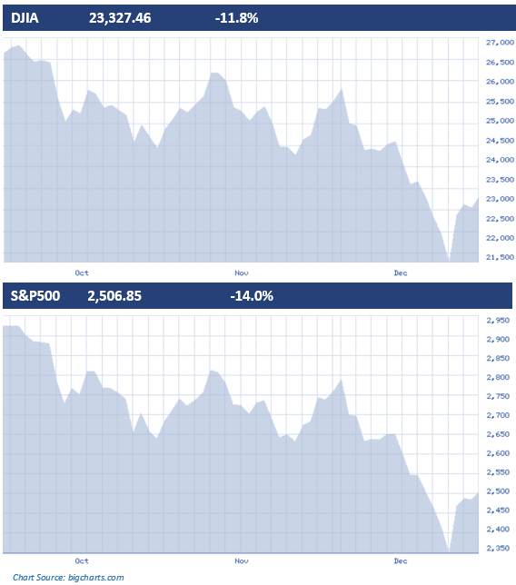
After a long period of respectable returns, many investors in equities during the fourth quarter of 2018 experienced losses. After a strong third quarter, the fourth quarter of 2018 was filled with a great deal of uncertainty, which is the equity market’s least favorite scenario. Interest rate hikes and trade wars caused major concerns. As a result, U.S. equity markets posted their worst October numbers since the financial crisis of 2008. Even though November saw equity markets calm down, much of this quarter’s losses came during a disappointing December. In that month, all three major U.S. indexes dropped at least 8.7 percent. The Dow Jones Industrial Average (DJIA or Dow) and S&P 500 also recorded their biggest monthly loss since February 2009.
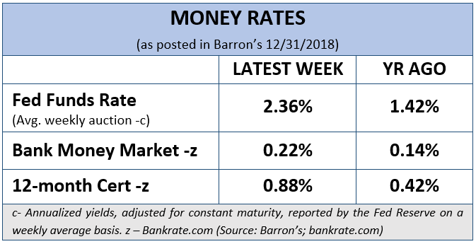
For the quarter, the S&P 500 and NASDAQ dropped 14 percent and 17.5 percent, respectively, their worst quarterly performances since the fourth quarter of 2008. The Dow recorded its worst quarter since the first quarter of 2009, falling nearly 12 percent. As bad as they were, the final numbers do not fully explain just how crazy and wild a ride December really was for investors. Based on the lowest levels of the S&P 500 on Christmas Eve, the index was down over 20 percent from its record high on an intraday basis, briefly meeting the requirement for a bear market. The stock market would then come rising back in the next session, with the Dow over 1,000 points on December 26th, its biggest ever point gain.
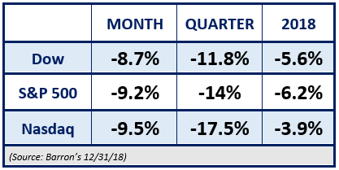
Many market analysts felt the declines were driven by concerns of an economic slowdown and fears the Federal Reserve might be making a monetary policy mistake. In December, the Fed raised interest rates once again by 0.25%, elevating the U.S. Federal Funds rate range to 2.25% - 2.50%. The Fed has also forecasted additional rate hikes in 2019 and that was not helpful for equity markets.
The continuing concern over ongoing trade negotiations between China and the U.S. also pressured equities this quarter.
While a correction (defined as a drop of over 10%) in equity markets is not uncommon, there was one interesting characteristic of the fourth-quarter market: intraday volatility. During the fourth quarter, the Dow had a record number of sessions with intraday 500+ point swings. That is roughly 2% of the current level of the Dow. The Dow had five consecutive sessions with 500+ point swings from December 4 to December 11. This unusually high intraday volatility attracted a lot of media attention and it seemed as if the stock market was one of the main discussion topics every night on the news. (Source: Seeking Alpha 12/2018)

A Review of 2018

After 2017 featured strong equity returns and an environment of very low volatility, 2018 tested the commitment of long-term investors. In 2018, the S&P 500 and Dow fell for the first time in three years, while the NASDAQ broke a six-year winning streak. 2018 was characterized by the return of volatility, record highs and sharp reversals. It also resulted in the first time ever the S&P 500 posted a decline after rising in the first three quarters. It was also the first time since 1978 that the Dow finished out the year in the red after rising in the first three quarters.

According to Morningstar Research, results for 2018 “were even worse for those invested in markets outside the United States”. The MSCI EAFE Index (an equity index which captures large and mid-cap representation across 21 Developed Markets not including the US and Canada) plunged about 14% in U.S. dollar terms. Morningstar noted that a variety of concerns hurt international markets. These included local political issues and troublesome economic data. Many other stock markets abroad also posted deeper losses than those in the U.S. For example, China’s Shanghai Composite entered a bear market in June and declined nearly 25% in 2018. The Shenzhen Composite (which includes many of the country’s tech firms) dropped by over 33% for the year.

A variety of problems affected foreign-stock funds. Economic growth in the U.S. was much stronger than that of Europe, where the trends that finally had moved in a positive direction reversed course, with growth rates down to near zero or even dipping into negative territory in some countries. Europe's biggest market, the United Kingdom, has been stressed by uncertainty over the details of its path to exit the European Union. Political difficulties in Italy and other European countries didn't help matters.

For the past decade, income vehicle returns have been significantly lower than equity returns and cash equivalents brought in very little. Although they add less return, low return cash equivalents and income vehicles provided less volatility and stress. Many investors abandoned diversification and fully allocated into potentially higher returning stocks. This strategy can be advantageous when markets rise, but dangerous when they fall. Sometimes, investors are emotionally driven to change their allocations, but doing so could add additional risk.
After almost a decade of strong equity returns, 2018 was a confusing and difficult year for investors. After the sour year-end close, it’s easy to forget that the Dow recorded 15 new highs in 2018, (ahead of the annual average of 11 new highs per year since inception). While the Dow reached more new highs in 2017 (71 in total, more than any year in history), there have been 53 calendar years when the DJIA notched at least 1 new high and 70 when none were recorded. For most investors, 2018 fully tested their commitment and patience. (Source: Seeking Alpha 12/2018)

2019 Outlook
Stocks may be coming off their worst year since the financial crisis of 2008, but for 2019, many analysts feel that equity markets will head higher. Over 65 percent of 29 respondents to CNBC’s exclusive “Halftime Report Stock Survey” said their overall stock market outlook is positive. Over 58 percent feel that equities look cheap at current valuations. CNBC noted that no one responded that he or she believes equities are overvalued at current levels. About 41 percent believe stocks are correctly valued, and nearly 60 percent felt current valuations look cheap, which indicates an overall bullish sentiment. (Source: CNBC 1/7/2019)
Key Points
- Q4 finished 2018 with poor returns for equity investors.
- After a quiet 2017, volatility returned to equity markets in a historic way in 2018.
- The Fed raised U.S. Fed Fund rates to 2.25 - 2.50% in December and could raise interest rates again in 2019.
- Key economic data indicators are still reasonable.
- Analysts suggest 2019 will have positive equity returns.
- Investors need to still be very cautious and watchful.
- Focus on your personal goals and call us with any concerns.
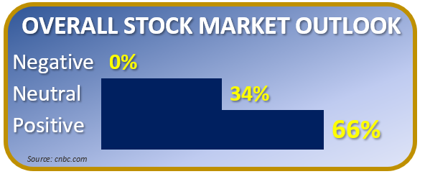
Forbes, in a 2019 Outlook asked, “What do stocks do after a down year?” They felt 2018’s decline might not be the best forecast and shared, “Let’s pull out all the down years from 1926 through 2017, of which there were 24. The average return in the year following a down year was 10 percent, the same as the overall average.” They also shared, “Uncertainty about the future course of stocks is large, so investors should fall back on a few fundamental principles. Diversification of investments reduces risk.”
(Source: Forbes 1/5/2019)

Barron’s 2019 Outlook reported that, investors will be happy to bid good riddance to 2018, a stressful year marked by two stock market corrections, rising interest rates, an ugly trade battle, and growing fears that a bear market lies just around the corner. All 10 market strategists Barron’s consulted in late December had 2019 targets for the S&P 500 index finishing the year higher. (Source: Barron’s 12/14/2018)
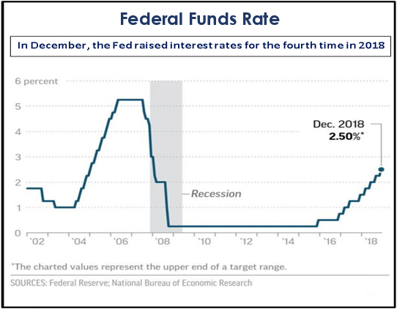
Seeking Alpha notes that, “Forecasting how 2019 will play out may be pure guesswork under the current circumstances.” They also add that, as we begin the year, there is a shut-down of important U.S. government services and a new political landscape (a Democratic Congress). They also report that although the Federal Reserve has raised rates and the global trade war is far from being resolved, current economic indicators are not pointing to an immediate recession. They cite that, on the employment front, we now have a tightening labor market with unemployment down to 3.7%. They share that, The Index of Leading Economic Indicators (which consists of ten forward-looking variables such as; unemployment claims, manufacturing shipments and orders, housing starts, interest rate spreads, M2 money supply, the S&P 500, and consumer sentiment) is still in expansion territory as of 1/1/2019.
Interest Rates are Still Critical
Three years ago, the Fed moved away from the near-zero rate that had been in place since the days of the global financial crisis. In December, the Fed raised interest rates for the fourth time in 2018 to move the target range for its benchmark fund to 2.25 percent to 2.5 percent. As of that session, Fed officials forecasted two more hikes in 2019, down from three rate raises previously projected. This is because Gross Domestic Product (GDP) was seen as rising 3 percent for the full year of 2018, down one-tenth of a percentage point from September, and forecasted for 2.3 percent for 2019, a 0.2 percent point reduction.
While investors wanted certainty about rate hikes ending, the Fed included in its statement that further “gradual” rate hikes would be appropriate. Charlie Ripley, senior investment strategist for Allianz Investment Management said that, “while this was a dovish hike from the stance that the Fed was in before, this is somewhat not as dovish as many participants probably wanted.” He also added that, “It would have been a difficult move for the Fed to completely remove some of the 2019 hike expectations, but I think they’re making the message clear that they’re going to remain more data dependent as we go into 2019.” The Fed’s official meeting notes described economic growth as “rising at a strong rate” and therefore the door is still open for further rate hikes. (Source: CNBC)
Besides potential rate hikes, further trade wars with China can keep markets quite volatile in 2019. Trade wars and signs China's economy is slowing have added to the global uncertainty. Interest rates, trade wars, and worldwide growth rates should all be on an investor’s watch list for 2019.
Conclusion:
What should an investor consider?

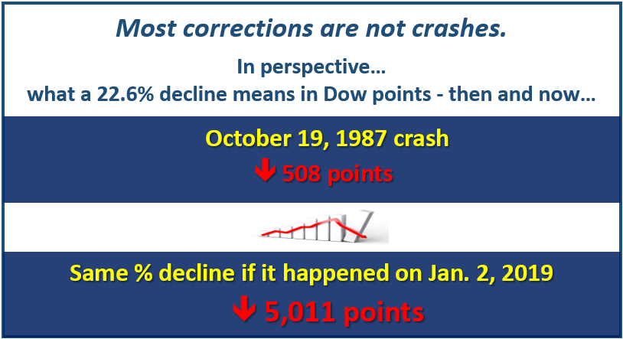
While numerous analysts remain optimistic, investors should not expect a straight line uptrend. Corrections and bear markets will always be a part of the investment sequence. Although the old Wall Street joke can remind us that 10 out of 9 analysts can correctly predict the next recession, predicting exactly when equity markets will start back upward is near impossible. Investors with very long-time horizons of 10 to 20 years or longer can often accept more risk than those with shorter horizons. While past performance is no indication of future performance it still gives us data to consider. Based on the DJIA, 10-year returns since the index’s inception have averaged over 83%. This year, despite the negative performance, the 10-year return is an impressive 165%. How is that possible? It's because this most recent 10-year period began after the DJIA was beaten up during the financial crisis. Since then, the DJIA has risen from approximately 8,800 to over 23,000. (Source: Seeking Alpha 1/4/2019)

CNBC reported on January 1st that some strategists are saying if the stock market’s two worst fears are resolved in 2019, that it could be a good year for stocks. While strategists see volatility continuing in 2019, they felt that the biggest worries for investors are still trade wars and the Fed’s interest rate movements. While many analysts remain optimistic, investors should prepare for continued volatility and not a straight-line uptrend.

Knowledge is Powerful
While the nightly news and financial tabloids like to use harsh and scary language to attract viewers, oftentimes their quick views of equity market performance include media magnification, which is the act of making something look larger or more important than it really is.
Currently, equity markets are volatile and have experienced a correction (some are even in bear market territory) but not a crash. As our chart shows, most corrections are not market crashes. If you recall the October 19th, 1987 market drop of 508 points (a 22.6% decline), that clearly is a market crash. The same percentage decline for the Dow if it happened on January 2nd, 2019, would have been over 5,000 points (which clearly did not happen).
It is often said that an emotional investor can make decisions that might not work out best. An informed and knowledgeable investor can often be less emotional. Differentiating a correction (with a frequency on average of once a year) from a bear market (with a frequency on average of once every three years) can help investors when making decisions. (Source: NASDAQ)

What Should Investors Do?
Completely avoiding market risk may not be appropriate for most investors and today’s traditional fixed rates might not help you achieve your desired goals. Most investors attempt to build a plan that includes risk awareness. Often, this can lead to safer but lower returns. Traditionally, bonds have been a nice hedge against market risk, but with interest rates projected to rise, investors must be extremely cautious.
For 2019, let’s focus on
YOUR personal goals and strategy.
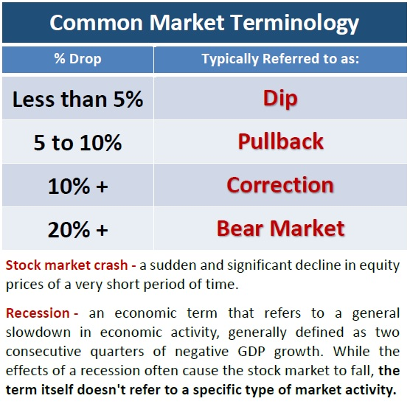
We focus on your own personal objectives. During confusing times, it is always wise to create realistic time horizons and return expectations for your own personal situation and to adjust your investments accordingly. We try to understand your personal commitments, so we can categorize your investments into near- term, short- term and longer- term.
Now is the time to make sure you are comfortable with your investments.
Equity markets will continue to move up and down. Even if your time horizons are long, you could see some short-term downward movements in your portfolios. Make sure your investing plan is centered on your personal goals and timelines. Peaks and valleys have always been a part of financial markets and it is highly likely that trend will continue.
CAUTION in 2019
is still the principal notion for investors.
Investors need to be prepared. Market volatility has caused concern, but panic is not a plan. Market downturns happen and so do recoveries. This is the ideal time to ensure that you fully review and understand your time horizons, goals and risk tolerances. Looking at your entire picture can be a helpful exercise in determining your strategy.

Discuss any concerns with us.
Our advice is not one-size-fits-all. We will always consider your feelings about risk and the markets and review your unique financial situation when making recommendations. If you would like to revisit your specific holdings or risk tolerance, please call our office or bring it up at our next scheduled meeting.

We pride ourselves in offering:
- consistent and strong communication,
- a schedule of regular client meetings, and
- continuing education for every member of our team on the issues that affect our clients.

A skilled financial advisor can help make your journey easier.

Our goal is to understand your needs and then try to create a plan to address those needs. We continually monitor your portfolio. While we cannot control financial markets or interest rates, we keep a watchful eye on them. No one can predict the future with complete accuracy, so we keep the lines of communication open with you. Our primary objective is to take the emotions out of investing. We can discuss your specific situation at your next review meeting or you can call to schedule an appointment. As always, we appreciate the opportunity to assist you with your financial matters.

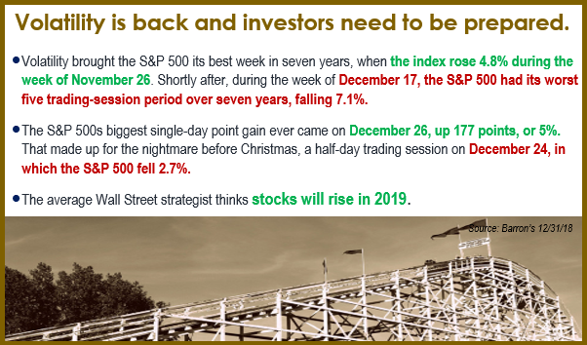

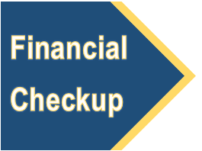
To schedule your financial check-up,
please call NAME at (xxx) xxx-xxxx
and we would be happy to assist you!

If you are currently not a client of
YOUR BUSINESS NAME, we would like to offer you a complimentary, one-hour, private consultation with one of our professionals at absolutely no cost or obligation to you.

Insert Approved B/D Disclaimer
Approved Contact Information

Note: The views stated in this letter are not necessarily the opinion of insert B/D, and should not be construed, directly or indirectly, as an offer to buy or sell any securities mentioned herein. Investors should be aware that there are risks inherent in all investments, such as fluctuations in investment principal. With any investment vehicle, past performance is not a guarantee of future results. Material discussed herewith is meant for general illustration and/or informational purposes only, please note that individual situations can vary. Therefore, the information should be relied upon when coordinated with individual professional advice. This material contains forward looking statements and projections. There are no guarantees these results will be achieved. All indices referenced are unmanaged and cannot be invested into directly. Unmanaged index returns do not reflect fees, expenses, or sales charges. Index performance is not indicative of the performance of any investment. The S&P 500 is an unmanaged index of 500 widely held stocks that is generally considered representative of the U.S. Stock market. Dow Jones Industrial Average (DJIA), commonly known as “The Dow” is an index representing 30 stock of companies maintained and reviewed by the editors of the Wall Street Journal. Past performance is no guarantee of future results. Due to volatility within the markets mentioned, opinions are subject to change without notice. The NASDAQ Composite Index is an unmanaged index of all stocks traded on the NASDAQ over-the-counter market. The Shanghai Stock Exchange Composite Index is a capitalization-weighted index that tracks the daily price performance of all A-shares and B-shares listed on the Shanghai Stock Exchange. The SZSE Component Index is an index of 500 stocks that are traded at the Shenzhen Stock Exchange. International investing involves special risks, including currency fluctuations, differing financial accounting standards, and possible political and economic volatility. Diversification and asset allocation do not ensure a profit or protect against a loss. Holding investments for the long term does not insure a profitable outcome. Information is based on sources believed to be reliable; however, their accuracy or completeness cannot be guaranteed. There is no guarantee that a diversified portfolio will enhance overall returns or outperform a non-diversified portfolio. No investment strategy or risk management technique can guarantee return or eliminate risk in all market environments. There is no guarantee that a diversified portfolio will enhance overall returns or outperform a non-diversified portfolio. Diversification does not protect against market risk. International investing involves special risks such as currency fluctuation and political instability and may not be suitable for all investors.
Sources: Barron’s, Forbes, CNBC, Seeking Alpha, Morningstar, cnbc.com, NASDAQ, Market Watch; Academy of Preferred Financial Advisors, Inc. ©

