The Four Phases of Retirement
Your Name

Years ago, when you mentioned the concept of retirement, visions of a long and relaxing stretch of time after your career came to mind. Most people envisioned having a 20 to 30-year time span filled with activities such as traveling to exotic locations, leisurely days of relaxation and recreation and time with grandchildren. The possibility of long-term care was usually the only concerning issue in retirement.
Times have certainly changed!
Today the concept of retirement has taken on a new meaning. The cost of living has become very expensive and those who would like to enjoy their mature years are finding that it is becoming less and less financially feasible. In order to realize their dreams, retirees are finding that simply living off of social security and a savings account is not enough.
Social security, which is typically a component of any retirement plan, was never intended to be the sole source of retirement for anybody. To reach any sort of comfortable retirement income, people today will need quite a bit more than what social security can provide. The Social Security Administration recently stated that 96% of American workers are covered by social security, (including non-working spouses who are also eligible for payments). However, the amount you are eligible for can be different depending on when you start to collect. Even though in most circumstances you cannot collect Social Security until age 62, there is an even higher benefit offered to those who wait until age 70 to start. Although social security should be a part of your retirement planning, for purposes of this article, we want to point out that social security will most often not help satisfy someone’s retirement income needs.
Some people have saved their entire lives with the intent of being able to enjoy the golden years, but when putting together a plan for living comfortably from these savings, they now have to take into consideration many factors, including:
- The impact of inflation.

- How much you can afford to take out of your retirement plan each year.

- What required minimum distributions, if any, do you need to take from your retirement plan.

- What financial benefits you may have if you delay your retirement.

- What mortgages, large debts and bills you may have outstanding.

- The total amount of wealth you have collected and saved for retirement.

- Your health and long-term care costs during retirement.
These are just a few of the complex issues that retirees need to consider. A good strategy for approaching and preparing for retirement is through a well-executed, long-term plan. Sadly, the reality for many people is that their lifetime may have included unexpected situations like an untimely death, a divorce, an unfortunate disability, or any one of a number of unpredictable and unpreventable obstacles that changed or altered even the best of intentions. As a result, many people today find themselves in the twilight of their working years having saved less for their retirement than they anticipated and scrambling to find a way to compensate or make up for the cash they will need to realize the retirement they once desired.
Those who are in their 50s and 60s without large retirement accounts may not have the time to receive the full benefits from compounding the returns on their investments. Also, in today’s low interest rate environment, many of your safer choices will not grow as fast as they would have when interest rates were higher. Your retirement savings can still have the opportunity to grow by the time you need to access your funds. The tax law provides a few provisions for individuals over 50 that are continuing or even starting to save for their retirement. If you are 50 or older you can put up to $7,000 ($1,000 more than younger savers) in your regular IRA or Roth IRA. If you are over 50 years old you can also add an extra $6,000 to a 401(k) plan (compared to your younger co-workers). IRAs and 401(k) plans provide for tax-deferred growth, while Roth IRAs can offer tax-free growth. These options are always attractive for those still working and over age 50, but there are many restrictions and guidelines on who can participate and to what extent. This is an area where we can help. For clients who are interested in learning how to maximize their retirement savings, we always enjoy the opportunity to discuss their specific situation and plans.
Today, many people are delaying their actual retirement date. Every year you continue to work can help your planning in two ways. First, delaying retirement means there is another year you are working and earning an income and saving for retirement. Second, because you are still working, you may not need to use your retirement savings that year for financial help. Delaying your retirement allows your nest egg to hopefully grow for another year.
For many Americans, retirement today can be broken down into four phases:
- Pre-retirement;
- Early retirement;
- Full retirement; and
- Final retirement.
Let’s take a brief look at each of these stages.
Pre-retirement Phase
Pre-retirement is that time period when you begin to take a look at slowing down and begin to plan your life after your career. This is the time you should ask yourself how much money you will need and how you can make the most of your retirement. As a starting point, most experts suggest that you will not need your full earnings to carry you through retirement but a high percentage of it. Obviously, the percentage is higher if you earn less, and can be lower if you earn more. Although everyone’s situation is different, one of the keys to success is to consider preparing an active budget of your expected expenses in retirement. You can then review how much you have saved and invested to meet your unique situation.
Remember, most people in retirement pare back certain expenses like commuting costs and clothes that are required for work. However, some incur additional expenses such as health care. It is crucial in this phase that you map out what you want your retirement to look like and how and where you expect to live so that you can begin to plan for life after your career has ended. This time period is also helpful to think about setting some goals you can stick to and monitor your cash flow.

Early Retirement Phase
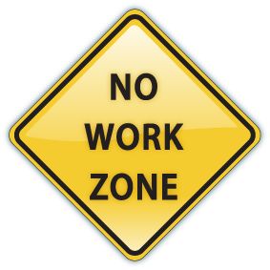
The next stage is the early stage of retirement. During this phase, many people can still have a lot of energy and enthusiasm and therefore can focus on enjoying physical sports (like golf and tennis) and traveling. During this phase it is important to have a plan for cash flow. It can be very likely that your expenses will be higher in these early years due to potentially more extensive travel and activities.
It is not unusual today for many individuals in this early stage to work on a part-time basis. In addition to traditional work, many people in this stage also still work on boards of trustees and volunteer at not-for-profit organizations.
The increase in life expectancy can affect your decisions during this stage. Also, many people during this stage need to replace or supplement corporate benefits such as life and health insurance and, if you work part time, possibly disability insurance.
The challenges of this early retirement phase are not just financial. They can also be about filling time. Many retired clients find themselves looking for work often part time, simply out of boredom. Although early retirement may sound appealing, it is important to think through the financial and non-financial implications for making this decision. It is essential during this period that you hold a full review of your estate plan so any unexpected situations do not interrupt the comfort of you or your loved ones. This is another area where we can offer assistance to clients.
Full Retirement Phase
This next stage is the middle of your retirement cycle. By now, you have hopefully realized your travel dreams and fulfilled many of the goals you had planned for in your retirement.
Although you may be in good health, many people during this phase are more likely to decide to slow down and may possibly find more enjoyment in activities that are less fatiguing and slower paced. The hassles of traveling don’t sound as tolerable. Instead, local events and the pursuit of hobbies that are less physically tasking sound more appealing.
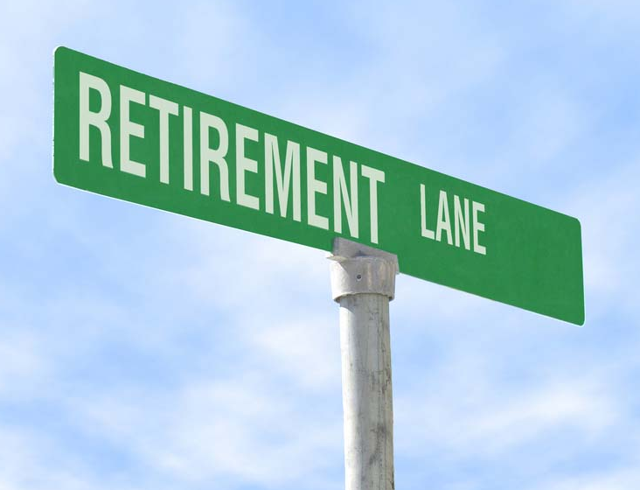
During this phase many people belong to groups or clubs that meet regularly and provide social interaction. Your expenses may actually be lower than in the early retirement phase if your activities (such as traveling) have minimized.
In today’s low interest rate environment, many experts are recommending that withdrawals from retirement plans be more conservative than those taken during periods of higher interest rates. This is why we like to sit with clients to help determine an appropriate withdrawal schedule.
Final Retirement Phase
The final years of retirement are the last stage. This is when you may find yourself battling the physical and mental challenges of old age. During this final phase, some retirees move out of their homes and into assisted care facilities or even nursing homes. Many times, medical expenses, including prescription drugs, take up a significant share of your monthly income. You can even become restricted in your activities due to physical limitations.
Conclusion
Regardless of your age or which phase you are in or approaching, here are some important things that you need to constantly review and consider:
- Realize that your cash flow needs can be different for each phase of retirement. Your early phase and final phase have the potential to have the most expenses. Expenses can usually be lower in the full or pre-retirement stage.

- People are living longer. Better health habits, advances in medicine, and many new drugs have extended people's lives longer than prior generations. It is imperative to monitor and review your investment choices on a regular basis to give yourself the best possibility of meeting the cash flow needs you will require throughout each phase of retirement.

- It is imperative to periodically rebalance your investment portfolios to reflect the various changing priorities and living patterns as you go through each of these retirement stages. You should systematically revisit how you can adjust your portfolio based upon your actual life and health changes, goals, needs, objectives, and risk tolerances.

- It is essential to review your needs for long-term care and other costs (like medical and burial expenses) before and during retirement.
- It is crucial to constantly monitor your cash distributions from your retirement savings. We have experienced a significant decline in interest rates over the last decade and that can affect your portfolio. In this low interest rate environment, it is even more essential that you have a strategy for taking distributions from your portfolio. In the past, a larger distribution rate might have been acceptable, however, with today's low interest rates it is imperative to make sure that your withdrawal rates are reasonable and will be sustainable over the long-term.
The bottom line is that throughout each stage of retirement it is wise to make sure that you plan and monitor. Remember, the only thing that is constant is change!
Our role is to help and assist you through each stage of your retirement. We take great pride and satisfaction in reviewing each of our client’s individual situations and needs. Our goal is to fully understand and review your retirement and estate planning needs. Please call us if you have any questions or need any assistance and we will be happy to help you.
This article is for informational purposes only. The views stated in this letter are not necessarily the opinion of Insert Full B/D Name and should not be construed, directly or indirectly, as an offer to buy or sell any securities mentioned herein. This information is not intended to be a substitute for specific individualized tax, legal or investment planning advice as individual situations will vary. For specific advice about your situation, please consult with a lawyer or financial professional. A Roth IRA distribution is qualified if you’ve had the account for at least five years and/or the distribution is made after you’ve reached age 59 ½. Investing involves risk including the potential loss of principal. No investment strategy can guarantee a profit or protect against loss in periods of declining values. Please note that rebalancing investments may cause investors to incur transaction costs and, when rebalancing a non-retirement account, taxable events will be created that may increase your tax liability. This article provided by Contents provided by the Academy of Preferred Financial Advisors, Inc. © APFA, Inc.
Complimentary Financial Check-up
If you are currently not a client of Your Company Name, we would like to offer you a complimentary, one-hour, private consultation with one of our professionals at absolutely no cost or obligation to you.

To schedule your financial check-up, please call Contact name and information and we’d be happy to assist you.

Insert approved b/d disclosure and contact information

