

**Quarterly Economic Update  
Second Quarter 2019**

Your Name

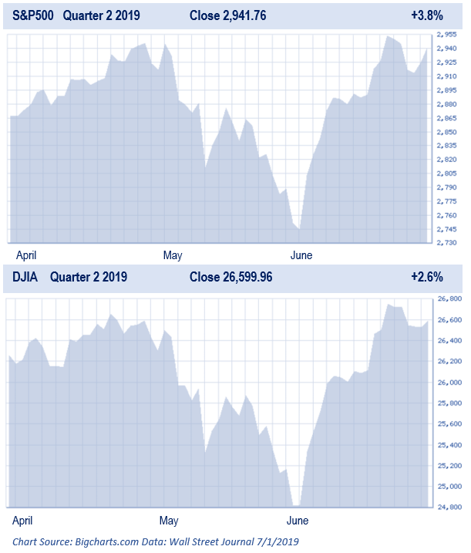

The first half of 2019 brought very strong results for financial markets. Both equity and bond investors saw positive results leaving investors in a happy mood. The Dow Jones Industrial Average (DJIA) enjoyed its largest June gain since 1938 and the S&P 500 experienced its best first half in two decades.

***(Source: CNBC.com 6/28/2019)***

Concerns of an economic slowdown overshadowed the quarter for many investors. In May, the major equity indexes started heading lower. Although the quarter’s final results showed an upward move of 3.8% for the S&P 500 and 2.6% for the DJIA, these gains came with an extension of the volatility that investors have been experiencing since October of 2018.

***(Source: Wall Street Journal 6/29/2019)***

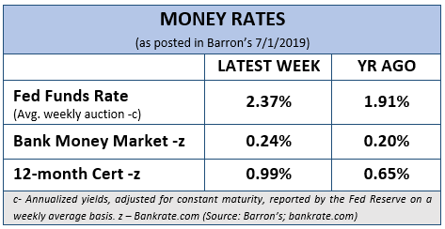The strong six-month period that both equity and debt securities have enjoyed has been tied to the pivot that the Federal Reserve has made on its interest rate outlook. In 2018, the Federal Reserve’s stance was to raise short-term interest rates multiple times. Early in the month of January 2019, Fed Chairman Jerome Powell, switched that thinking when he announced that the Fed would be “patient” in boosting rates. In late spring, the dialogue from the Fed shifted toward indicating that their next move might be a rate cut. This shift helped to create the environment which led to attractive returns for both stock and bond investors.

***(Source: Barron’s 7/1/2019)***

While equity markets closed the quarter at or near all-time highs, analysts ended the quarter with a checklist of concerns for the future. A slowing global economy, trade wars and tariffs, sluggish corporate earnings and the Federal Reserve’s upcoming decisions all headline a list of issues that could affect year-end results.

|  |
| --- |
| **Key Points** |
| 1. **Equity markets reached new highs again this quarter.** |
| 1. **The bull market is now over 10 years old and is the longest on record.** |
| 1. **The Fed changed its stance on raising interest rates and has indicated that a future move could be to lower rates.** |
| 1. **Trade wars and tariffs have created market and investment uncertainty.** |
| 1. **The U.S. economy is now in the longest period of expansion ever (over 11 years).** |
| 1. **Market volatility continues and investors need to remain cautious.** |
| 1. **Focus on your personal goals and call us with any concerns.** |

According to FactSet, although the S&P 500 made new all-time highs in the 2nd quarter, that was after S&P 500 earnings dipped 0.4% in the first quarter and were projected to decline in the second and third quarters of 2019 as well (compared to a year prior). A weak global economy and trade wars were cited as major contributors to earnings declines.

***(Source: USA Today 7/1/2019)***

Although equity markets are high and investors should be cautious, some positive signs exist. At quarter close, the United States and China seemed to be on a constructive path. While Japan and many countries in Europe seem to be in economic stress, U.S.-based companies appear to be on more solid footing.

***(Source: USA Today 7/1/2019)***

Investors are now enjoying the longest bull market ever and two camps of thought are now emerging. One camp points to the fact that based on historical numbers, like price earnings (P/E), that equities are highly overvalued and overpriced. The other camp insists that we are in a “**TINA**” market, meaning, **T**here **I**s **N**o **A**lternative to stocks. This group feels that until rates rise significantly, this will remain true and that means there could be significant upside in the current market. Equities are not cheap and even the savviest of investors need to have a watchful eye on risk. As financial professionals, we always try to make our best forecasts. We look for a probability of success, understanding we face an inexact future. Short-term interest rates and cash equivalent yields are still historically low. Our goal is to focus on client’s timeframes and needed returns to achieve their goals.

**Interest Rates Are Crucial**

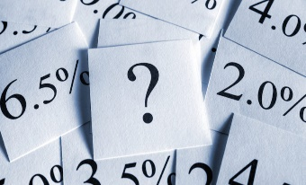Interest rates are crucial for investors and the way the system works is that everyone follows the federal funds rate, which is the interest rate banks charge one another for overnight borrowing. The decision to raise, lower or maintain the rate is determined by the Fed’s Federal Open Market Committee (FOMC). At their June meeting, the committee signaled a willingness to lower short-term interest rates to sustain economic expansion. While the Federal Open Market Committee voted 9-1 to keep the benchmark rate in a target range of 2.25% to 2.5%, eight members favored a rate cut this year. When discussing potential rate cuts and the need to keep the economy moving in a healthy direction, Fed Chairperson Jerome Powell said in a press conference that some officials believe the case for accommodation has “strengthened.” At the session, the central bank suggested one or two rate cuts, but not until 2020. Despite cautious wording in the post-meeting statements many analysts are claiming that markets are behaving as if the Fed will cut rates in 2019.

#### **Treasury Yields** (Close of **7/2/19**)

* **1-month:** **2.21%** up from 2.11% prior week (1.82% a year ago)
* **6-month: 2.09%** down from 2.10% prior week (2.13% a year ago)
* **1-year:** **1.91%** down from 1.93% prior week (2.34% a year ago)
* **2-year:** **1.77%** up from 1.71% prior week (2.54% a year ago)
* **5-year:** **1.75%** up from 1.73% prior week (2.75% a year ago)
* **10-year:** **1.98%** down from 2.00% prior week (2.87% a year ago)
* **30-year:** **2.51%** down from 2.53% prior week (3.02% a year ago)

*Source:* [*www.depositaccounts.com*](http://www.depositaccounts.com)

***(Source: CNBC 6/19/2019)***

This scenario has set up a confrontation between Fed Chairman Jerome Powell and President Donald Trump, who has been pressuring the Fed to cut rates. The committee’s June report changed language from its May statement to indicate that economic activity is, “rising at a moderate rate,” a downgrade from “solid.” “In light of these uncertainties and muted inflation pressures, the committee will closely monitor the implications of incoming information for the economic outlook and will act as appropriate to sustain the expansion, with a strong labor market and inflation near its symmetric 2 percent objective,” the statement said. The “act as appropriate to sustain the expansion” language mirrors a statement from Powell in early June. The Federal Reserve’s next meeting is on July 31.

***(Source: CNBC 6/19/2019)***

In response to the Fed’s decision, the yield on the benchmark 10-year Treasury note fell to below 2%. This means that investors looking for better returns would have to consider equities even if they were highly priced. Due to low interest rates, mortgage rates also continue to be at historically attractive levels. Low rates also allow companies to borrow money at cheaper levels and therefore can encourage expansion and investment. While low rates are good news if you are a homeowner thinking of refinancing your mortgage or a chief financial officer about to roll over some of your company’s bonds, it is concerning news if you want to see faster global economic growth in the years ahead. Lower long-term rates imply that investors expect even lower growth and inflation than had seemed probable just weeks ago.

***(Sources: CNBC 6/25/2019, New York Times 7/4/2019)***

Savers looking at current interest rates to meet their goals will find today’s low rates concerning. This is where a conversation with your financial professional could help you understand your alternatives and options. One of our primary objectives is to help our clients navigate today’s low interest rate environment. Low short-term interest rates seem likely to continue and investors will still need to keep a watchful eye on rates.

**Trade Wars and Tariffs**

Financial powerhouse BlackRock lowered its global growth outlook based on expectations that trade and geopolitical frictions will continue for the remainder of 2019. The firm said central banks are responding to the weaker outlook and are loosening policy, creating a constructive environment for U.S. and European stocks. BlackRock sees the tariff and trade tensions between the United States and China as part of a bigger concern for global markets. They note that trade issues create concern and uncertainty. Tariffs make costs higher for corporations and force some companies to change their supply chains altogether. According to Jean Boivin, head of the BlackRock Investment Institute, the uncertainty from trade wars should continue for some time. “We see the ebbing and flowing,” he said. “We’re going to feel the intensity go up. Then there’s going to be a truce. We think that’s going to continue.

***(Source: CNBC 7/8/2019)***

On June 29th, Presidents Trump and Xi agreed to continue trade negotiations during their much-anticipated meeting on the sidelines of the G-20 summit in Japan. “We’re holding on tariffs, and they’re going to buy farm product,” Trump said at a press conference after the summit. That same day, equity markets rose in response.

***(Source: CNN Business 7/1/2019)***

A trade truce can bring good news to stocks and possibly even boost markets, however, uncertainty about whether a meaningful agreement can be finalized could loom over markets in the second half of the year. Steve Chiavarone, a portfolio manager at Federated Investors, described the cease-fire between the two Presidents as a good start toward the U. S. and China resolving its trade spat. He also shares that the vague terms and indefinite suspensions do not do much to alter the uncertainties facing the stock market.

***(Source: Wall Street Journal 7/1/2019)***

For now, existing tariffs remain in place and will continue to affect businesses. Tariffs and trade negotiations could also affect equities, so this is another key area that investors need to continue to monitor.

**The Economy**

The U.S. economy has now entered into a record 11th year of expansion. Now officially the longest in history, this recovery began in June 2009 and has lasted 121 months (breaking the previous record of 120 months set from 1991 to 2001).

***(Source: MarketWatch 7/2/2019)***

While recoveries are good, this one hasn’t been without issues. This expansion took some time to really get going and has been somewhat uneven. This quarter, analysts expressed concern about a slowing economy in the U.S., but in June, a robust 224,000 new jobs were added. “Today’s jobs report shows the U.S. economy continues to create jobs at a strong pace even as we enter the longest period of economic expansion on record,” said Tony Bedikian, head of global markets at Citizens Bank. This result means that unemployment is still near a 50-year low and was a clear rebound from a recent lull and calming worries about the health of an economy in an 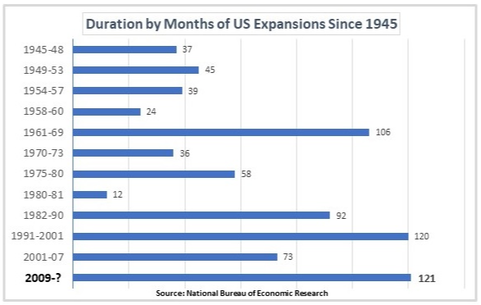elongated period of expansion. ***(Source: MarketWatch 7/2/2019, CNBC 7/5/2019)***

Another economic concern is Gross Domestic Product (GDP), the longtime indicatory of economic growth. It has averaged just 2.3% since the U.S. exited recession in mid-2009. This expansion is the first one since WWII where the economy has failed to reach 3% annual growth in any single calendar year.

***(Source: MarketWatch 7/2/2019)***

Fidelity Investments feels that, “the U.S. is firmly in the late-cycle phase but with low near-term risk of recession”. They go on to also say that, “while a strong labor market and higher wages have buoyed US consumer confidence, the present large gap between current conditions and forward expectations has often occurred toward the end of prior economic cycles. Furthermore, the improvement in wage growth over the past 2 to 3 years has stalled in recent months despite a cyclically low unemployment rate and continued job gains”.

***(Source: Fidelity Viewpoints 7/10/2019)***

Some economists feel the biggest risk to the economy right now is political. President Trump’s tough stance on trade with China, Mexico and other countries has unsettled both the domestic and global economies. Economic growth is always something investors need to watch and we will continue to be mindful of further updates.

**What Should an Investor Do?**

Investors were clearly rewarded in the first half of 2019 and markets ended the quarter at or near record highs. CDs and money market funds can offer some of the highest level of safety but in today’s low interest rate environment they offer rates of around 2% or less. Some analysts are predicting equity markets will continue to rise while others are fearful. So, what should an investor do?

Barclays predicts it is most likely that the market will continue to rise, but investors need to continue to proceed with caution. In December of 2018, the S&P 500 saw a sharp decline (its worst December drop since 1931), then in the first quarter of 2019, the index more than recovered that entire decline. May of 2019 was also a period of downfall for equities, however by the end of June, equity indexes were again at or near new highs.

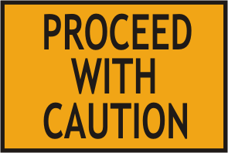***(Source: CNBC 7/3/2019, Barron’s 7/1/2019)***

Proceed with caution is still a great mantra for investors. An investor needs to be prepared to build a plan that includes risk awareness. While equities have risen, the continuing backdrop of a weakening economy, trade war fears and interest rate concerns create a need to recheck your time horizons. Today's traditional fixed rates might not help many investors to achieve their desired goals, so most investors may still need to include a strong mix of equities. Markets can continue to rise but they also could head lower. Bernstein Economist Phillipp Carlsson-Szlezak writes that, “though stocks, on average aren’t any more volatile than they were 100 years ago, the calm periods are calmer and the turbulent periods are more turbulent”. He also asks the question, “Do we live in times of high or low equity volatility? The answer is: both.”

***(Source: Barron’s 7/1/2019)***

Investors seem to enjoy predictions and no one has a precise crystal ball into the future. The media enjoys providing forecasts and U.S. News and World Report recently shared these market predictions from media outlets that came within the same 24 hours:

* There is a high probability that the S&P 500 index will rise 10%.
* If not for trade wars, the S&P 500 would currently be almost 5% higher.
* Markets continue to hit resistance.
* Markets are likely to hit new highs in 2020.

***(Source: US News and World Report 7/10/2019)***

No one can predict the next rise or selloff with precision, therefore, its essential for investors to prepare. For those who feel markets are overbought, or that the economy is peaking, they probably side with the more bearish forecasts. On the flip side, if you believe there is still more upside potential, the bullish forecasts will resonate with you. Investors should always put their primary focus on their own personal goals and objectives. This is something we enjoy helping clients achieve. This is a great time to review your financial goals—and the investments that go along with them—to see if anything has changed.

**Economic and Financial Market   
Cycles and Our Emotions**

Both the economy and financial markets move in cycles. Not every economic cycle is the same length. Some last months, while others last years. Economic cycles can move financial market cycles and during extreme movements in financial cycles investors can act with emotion.

Our main focus is on clients and their long term-goals. We attempt to take out the emotions that you could feel at different phases of the cycle. Investors need to focus on what they should do long-term, versus what they feel now, when crafting a plan for long-term investment success.

It’s important to keep perspective when markets are volatile and that you understand your unique situation and financial plan. **If anything has changed for you please let us know.**

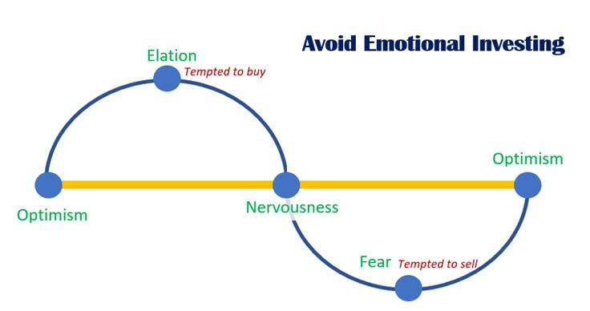

***Let’s focus on YOUR personal   
goals and strategy.***

**Our primary objective remains to continually understand our client’s goals and to match those goals with the best possible solutions.**

**Discuss any concerns with us.**

Our advice is not one-size-fits-all. We will always consider your feelings about risk and the markets and review your unique financial situation when making recommendations. If you would like to revisit your specific holdings or risk tolerance please call our office or discuss this at our next scheduled meeting.

**We pride ourselves in offering:**

* consistent and strong communication,
* a schedule of regular client meetings, and
* continuing education for every member of our team on the issues that affect our clients.

A skilled financial advisor can help make your journey easier. Our goal is to understand each of our client’s needs and then try to create a plan to address those needs. **Should you need to discuss your investments, please call our office.**

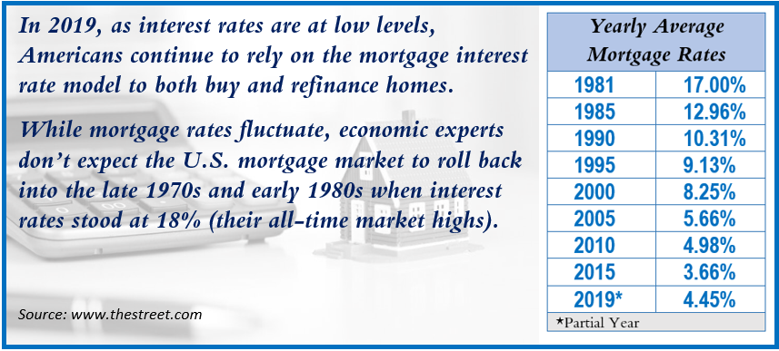





**Please share this report with others!**

**This year, our goal is to offer services to several other clients just like you!**

If you would like to share this report with a friend or colleague, please call:

**NAME at Company at (123) 456-7890** and we would be happy to assist you!

Insert Approved B/D/ Disclaimer Here

Approved Contact Information

Note: The views stated in this letter are not necessarily the opinion of broker/dealer and should not be construed, directly or indirectly, as an offer to buy or sell any securities mentioned herein. Investors should be aware that there are risks inherent in all investments, such as fluctuations in investment principal. With any investment vehicle, past performance is not a guarantee of future results. Material discussed herewith is meant for general illustration and/or informational purposes only, please note that individual situations can vary. Therefore, the information should be relied upon when coordinated with individual professional advice. This material contains forward looking statements and projections. There are no guarantees that these results will be achieved. All indices referenced are unmanaged and cannot be invested into directly. Unmanaged index returns do not reflect fees, expenses, or sales charges. Index performance is not indicative of the performance of any investment. The S&P 500 is an unmanaged index of 500 widely held stocks that is general considered representative of the U.S. Stock market. Dow Jones Industrial Average (DJIA), commonly known as “The Dow” is an index representing 30 stock of companies maintained and reviewed by the editors of the Wall Street Journal. Past performance is no guarantee of future results. Due to volatility within the markets mentioned, opinions are subject to change without notice. Information is based on sources believed to be reliable; however, their accuracy or completeness cannot be guaranteed.

Sources: Barron’s, USAToday.com; cnbc.com; cnn.com; Wall Street Journal; New York Times; CNN Business; National Bureau of Economic Research; Fidelity Viewpoints; U.S. News & World Report; marketwatch.com; Contents provided by the Academy of Preferred Financial Advisors, Inc.©