**Year-end Planning for Investors**

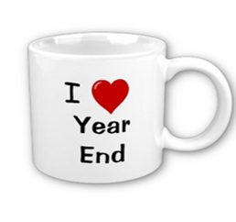

**Date  
Time  
Location  
Dinner Served**

**We encourage you to bring a friend!   
  
*Seating is limited. Please RSVP to (123-456-7890) to reserve your spots today!***

**This Gold Medal Service Event is for our clients and their guests.**

Your Workshop Sponsor:

Your Name or Name of Company

**Now is a good time to review your investments!**

**This informative event for our clients and their guests will discuss potential year-end strategies that could help investors minimize taxes and solidify their overall financial planning.**

**Topics Include:**

**🗸New tax laws** **🗸New tax forms** **🗸Market volatility**

***This workshop is for informational purposes only!***Approved Broker/Dealer Disclaimer and Registered Contact Information