**Year-end Planning for Investors**

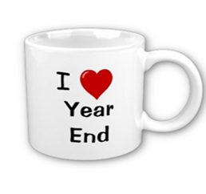

***This workshop is for informational purposes only! There is no assurance that the techniques and strategies discussed are suitable for all investors or will yield positive outcomes. The purchase of certain securities may be required to affect some of the strategies. Investing involves risks including possible loss of principal.***

Approved Broker/Dealer Disclaimer and Registered Contact Information

Your Workshop Sponsor:

Your Name or Name of Company

**We encourage you to bring a friend!   
  
*Seating is limited. Please RSVP to (123-456-7890) to reserve your spots today!***

**This Gold Medal Service Event is for our clients and their guests.**

**Date  
Time  
Location  
Dinner Served**

**Now is a good time to review your investments!**

**This informative event for our clients and their guests will discuss potential year-end strategies that could help investors minimize taxes and solidify their overall financial planning.**

**Topics Include:**

**🗸New tax laws** **🗸New tax forms** **🗸Market volatility**