The Setting Every Community Up for
Retirement Enhancement (SECURE) Act
Your Name

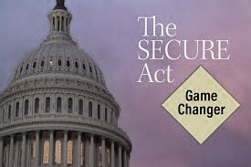
The Setting Every Community Up for Retirement Enhancement (SECURE) Act, was passed by the Senate on December 19, 2019. This bill increased access to retirement plans and also includes some reforms to Defined Contribution (DC) Plans, Defined Benefit (DB) plans, Investment Retirement accounts (IRAs) and 529 plans. Open Multiple Employer Provisions (MEP’s) will be effective January 1, 2021, but many of the other provisions in the law become effective January 1, 2020. The SECURE Act also brought changes for retirement plan holders.

Our goal is to help you with updates as your situation requires this year.

Among the many changes the SECURE Act included, we feel there are three major areas that could affect many client’s retirement planning strategy. These are:

- One of the most impactful provisions of the SECURE Act is the “death” of the stretch IRA as an estate planning tool for most non-spousal beneficiaries. If the original owner of an IRA passes away after December 31, 2019, fewer beneficiaries will be able to extend distributions from the inherited IRA over their lifetime. Many will instead need to withdraw all assets from the inherited IRA within 10 years following the death of the original account holder. Exceptions to the 10-year distribution requirement include assets left to a surviving spouse, a minor child, a disabled or chronically ill individual, and beneficiaries who are less than 10 years younger than the decedent. Please note that this new rule will only apply to IRAs inherited after the January 1st, 2020 effective date. All existing inherited IRAs are grandfathered in under the old rules. This NEW change will result in us taking a look at all clients that have accumulated retirement assets to discuss potential strategies that could be best for their situation.

- Another notable change is the RMD age moved from 70½ to 72. The Act states that this change applies beginning with IRA account owner who will attain age 70½ on or after January 1, 2020. This was in response to the fact that Americans are currently working and living longer. Congress updated RMD rules to reflect changes in life expectancies. The CARES Act suspended RMD for the year 2020.

- The SECURE Act now allows anyone with earned income the ability to contribute to an IRA after age 70½. The SECURE Act permanently removes the age limit at which an individual can contribute to a traditional IRA. Previously, an individual could only contribute to ROTH IRAs after age 70½, as they have no age limit. Starting in 2020, the SECURE Act allows anyone that is working and has earned income to contribute to a traditional IRA regardless of age.

Proactive Tax Planning

Industry expert Bob Keebler, CPA, MST of Keebler & Associates suggests that IRA owners talk with their financial professional about proactive tax planning. He feels that it will help tax deferred IRA holders to examine the values of alternative strategies. He encourages these IRA owners to consider proactively planning to minimize taxes when passing on the account to a non-spouse heir, especially if the bill eventually becomes law.

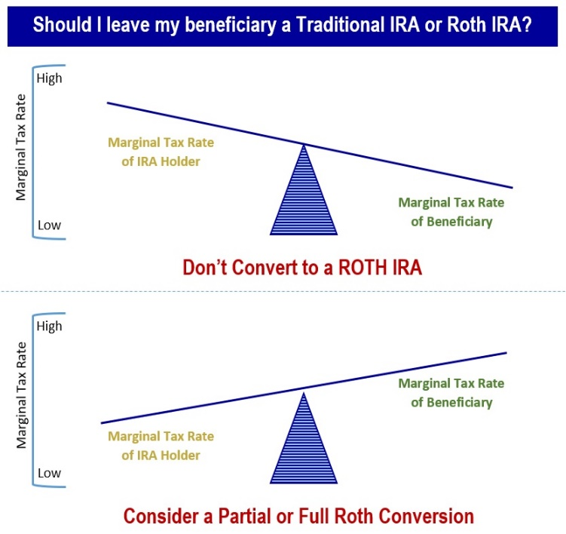
Keebler shares that, “Charitable remainder trusts allow investors to leave assets to a charitable organization and to a beneficiary. In that scenario, your beneficiary would collect a stream of income from the assets for a specified time span. At the end of that period, the charity collects whatever is left.”

Some Reasons Why You May Want to Convert a
Traditional IRA to a Roth IRA
For the right candidate, Keebler likes the benefits of a Roth conversion. “A Roth conversion refers to taking all or part of the balance of an existing traditional IRA and moving it into a Roth IRA. This is a strategy we think about when the IRA owner is in a lower bracket than their beneficiary.”

Enjoy tax-free withdrawals in retirement.
When taking withdrawals from a traditional IRA, you'd have to pay taxes on the money your investments earned—and on any contributions you originally deducted on your taxes. With a Roth IRA, as long as you meet certain requirements, all of your withdrawals are tax-free.

Watch your money grow tax-free for longer.
Traditional IRAs force you to take required minimum distributions (RMDs) every year after you reach the RMD required age, regardless of whether you actually need the money. ROTH IRA’s have no RMD requirement, so your money can stay in the account and keep growing tax-free.

Leave a tax-free inheritance to your heirs.
The non-spouses who eventually inherit your Roth IRA will have to take the money out of a tax-free growth situation within 10 years of your passing but they won't have to pay any federal income tax on their withdrawals as long as the account's been open for at least 5 years.

Deciding whether to convert to a Roth IRA hinges on a variety of issues including what your tax rate is now versus later, the tax bill you'll have to pay to convert, and your future plans for your estate. Also remember, the conversion will be permanent. Once you convert to a ROTH IRA you can't revert the money back to a traditional IRA.
Some considerations before deciding include:

- Will you need the money in the first five years? ROTH IRA conversions have penalties if used in the first five years.

- Will you end up in a higher or lower bracket in the future?

- Where will you take the money from to pay the taxes?

This is where a financial professional can offer some help suggestions and strategies. We enjoy talking with clients about the pros and cons of both partial or full ROTH conversions.

Qualified Charitable Distributions (QCDs)

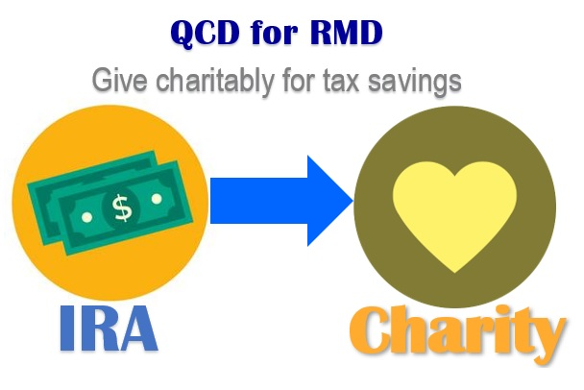
While they are not new to this law, under today’s tax laws and with more taxpayers using standard deductions, Qualified Charitable Distributions (QCD) are a proactive strategy for tax planning for anyone taking a Required Minimum Distribution (RMD). A QCD is a tax-savvy strategy that allows you to transfer up to $100,000 per year from your IRA directly to a qualified charity. It is only available to IRAs and individuals who are 70½ and older. Any amount processed as a QCD can also count toward your RMD requirement (now at age 72) and reduce the taxable amount of your IRA distribution. This QCD lowers both your adjusted gross income and taxable income, resulting in a lower overall tax liability. It also lowers your income for purposes of seeing if your social security is taxable. By using, or preparing to use, a QCD, you can potentially meet your RMD requirements and satisfy your charitable intents, all while saving money on taxes both today and into the future.

Please note, for tax return filings, your IRA custodian is not required to specially identify the QCD on your annual 1099-R form. The responsibility is on you to inform your tax preparer that you used a QCD. If you don’t let your preparer know, they could report this transaction as fully taxable, which would negate the benefit of your smart planning. Also, the distribution must be made directly to a qualified charity.

Once again, this is a specific area where a professional can offer some help, suggestions and strategies. We enjoy talking with clients about looking into QCDs for anyone over the age of 70 ½.

Notable Change: 529 Plans

Another notable change the SECURE Act brings is to 529 Plans. These tax-advantaged 529 plans will be allowed to help pay off qualified student loan repayments (up to $10,000 lifetime).

Many provisions of the SECURE Act will be subject to the interpretation of the IRS or other authorities. As always, clients should consider consulting with their personal tax advisor regarding their specific situation.

Final Thoughts on
Proactive Retirement Planning

Over your life you may accumulate assets in tax deferred retirement accounts like 401(k) plans and traditional IRAs. You may also have Roth accounts that compound without tax consequences. When thinking about the assets you have accumulated in your retirement accounts, a key issue is tax efficiency. Accumulating assets in a tax efficient way is only one part of the strategy, the other more complex part is withdrawing those assets while making use of the most available tax advantages. The goal is to try to proactively plan the withdrawals from retirement accounts to minimize your tax liability.

The SECURE Act now provides some slight flexibility on the timing of some of your RMD strategies since the RMD age was lengthened to age 72. This provides another 18 months of time before a mandatory distribution is required.

One of our primary goals is to review the SECURE Act, find possible opportunities and then share our observations with clients. We want to provide proactive tax planning ideas when possible.

Determining the most efficient ways to either withdraw or pass to your beneficiaries your accumulated wealth is always an important decision. Our goal is to remain aware of changes that affect our clients and then share those changes with them.
The new SECURE Act could
change retirement strategies!

The new SECURE Act could change the retirement strategies of many savers. Now is the time to review your strategy and approach to reaching your retirement goals.
If you need help with your retirement strategy, we would be happy to provide you a complimentary financial check-up of your unique situation.

Please call Name at Company at (123) 456-7890 and we would be happy to set this up for you!

Our goal is to work with clients to explore efficient ways to drawdown retirement savings and transfer wealth. If you would like to discuss your retirement plan and withdrawal strategy, please call us. As always, we appreciate the opportunity to assist you in addressing your financial goals. As always, we appreciate the opportunity to assist you in addressing your financial issues.

Proactive Tax Planning
A “Proactive” approach to your tax planning
instead of a “Reactive” approach could produce better results!

Insert Approved B/D Disclosure and Contact Information

This article is for informational purposes only. This information is not intended to be a substitute for specific individualized tax, legal or investment planning advice as individual situations will vary. For specific advice about your situation, please consult with a lawyer or tax professional.

The Roth IRA offers tax deferral on any earnings in the account. Withdrawals from the account may be tax free, as long as they are considered qualified. Limitations and restrictions may apply. Withdrawals prior to age 59 ½ may result in a 10% IRS penalty tax. Future tax laws can change at any time and may impact the benefits of Roth IRAs. Their tax treatment may change. Roth IRA account owners should consider the potential tax ramifications, age and contribution limits in regard to funding a Roth IRA. Traditional IRA account owners should consider the tax ramifications, age and income restrictions in regard to executing a conversion from a Traditional IRA to a Roth IRA. The converted amount is generally subject to income taxation. RMDs are generally subject to federal income tax and may be subject to state taxes.

The views stated in this letter are not necessarily the opinion of Insert Full B/D Name and should not be construed, directly or indirectly, as an offer to buy or sell any securities mentioned herein. Investing involves risk including the potential loss of principal. No investment strategy, such as rebalancing and asset allocation, can guarantee a profit or protect against loss. Rebalancing investments may cause investors to incur transaction costs and, when rebalancing a non-retirement account, taxable events will be created that may increase your tax liability. Indexes are unmanaged and investors are not able to invest directly into any index. Past performance is no guarantee of future results. In general, the bond market is volatile as prices rise when interest rates fall and vice versa. This effect is usually pronounced for longer-term securities. Any fixed income security sold or redeemed prior to maturity may be subject to a substantial gain or loss. The payment of dividends is not guaranteed. Companies may reduce or eliminate the payment of dividends at any given time. This article provided the Academy of Preferred Financial Advisor, Inc. APFA, Inc.©

