Proactive Retirement Planning
Using the New SECURE Act
Your Name

On December 20, 2019, the Setting Every Community Up for Retirement Enhancement (SECURE) Act was signed into law. This new legislation made major changes to a number of tax rules that govern retirement savings. Many of these changes started in 2020 and some of the details are still being finalized.
Some provisions of the SECURE Act that could help Americans better save for retirement included allowing two or more unrelated employers to join a pooled employer plan, creating an economy of scale that lowers both employer and plan participant costs.

While making retirement plans more available was the driving force behind the SECURE Act, included in this bill are some significant changes that all retirement savers should know for planning purposes. Financial professionals knowledgeable of the key parts of the SECURE Act could proactively help their clients understand the impact the Act may have on their situation.

While the path and purpose of the SECURE Act was to encourage retirement saving, retirement account owners now need to be familiar with some new requirements.

The RMD age increased from 70½ to 72

The SECURE Act increased the age for Required Minimum Distributions (RMD) starting January 1, 2020.

Under previous law, participants were generally required to begin taking distributions from their retirement plan at age 70½. The policy behind the Required Minimum Distribution (RMD) rule is to ensure that individuals spend their retirement savings during their lifetime and not use their retirement plans for estate planning purposes to transfer wealth to beneficiaries.

The age 70½ was first applied for retirement plans in the early 1960s and has never been adjusted to consider increases in today’s life expectancy. The SECURE Act increased the required minimum distribution age from 70½ to 72.

Someone over 70 ½ with earned income can still contribute to a traditional IRA

The SECURE Act also repealed the maximum age for Traditional IRA contributions, effective January 1, 2020. Specifically, this legislation repeals the prohibition on contributions of earned income to a traditional IRA by an individual who has attained age 70½.

As Americans live longer, an increasing number continue employment beyond traditional retirement age. This new law allows Americans with earned income to keep contributing to retirement plans after age 70½.

One consideration that comes with this new option is that if you choose to contribute to a traditional IRA after age 70½, it will reduce your ability to make a full Qualified Charitable Distribution (QCD).

Qualified Charitable Distributions (QCDs)

While they are not new or changed by the SECURE Act, under today’s tax laws and with more taxpayers using standard deductions, Qualified Charitable Distributions (QCDs) can be a proactive strategy for tax planning for anyone taking a Required Minimum Distribution (RMD). A QCD is a tax-savvy strategy that allows you to transfer up to $100,000 per year from your IRA directly to a qualified charity. It is only available to IRAs and individuals who have reached age 70½. Any amount processed as a QCD counts toward your RMD requirement and reduces the taxable amount of your IRA distribution. This QCD lowers both your adjusted gross income and taxable income, resulting in a lower overall tax liability. It also lowers your income for purposes of seeing if your Social Security is taxable. By using, or preparing to use, a QCD, you can potentially meet your RMD requirements and satisfy your charitable intents, all while saving money on taxes both today and into the future.

Please note, for tax return filings, your IRA custodian is not required to specially identify the QCD on your annual 1099-R form. The responsibility is on you to inform your tax preparer that you used a QCD. If you don’t let your preparer know, they could report this transaction as fully taxable, which would negate the benefit of your smart planning. Also, the distribution must be made directly to a qualified charity.

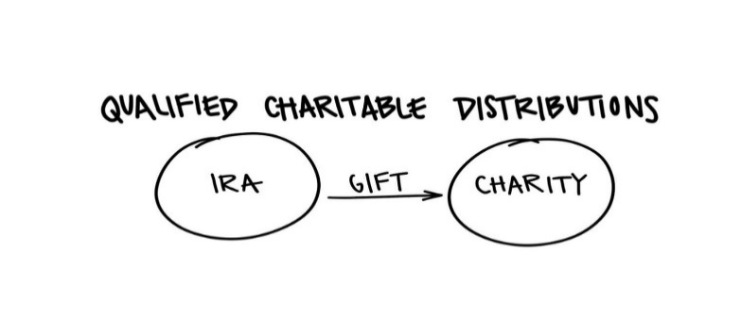
This is a specific area where a professional can offer some help, suggestions and strategies. We enjoy talking with clients about looking into QCDs for anyone over the age of 70½.

Changes to Beneficiary Payout Options

A new provision in the SECURE Act removed most non-spousal beneficiary’s ability to maximize tax-savings through a strategy known as the “Stretch IRA.” The Stretch IRA allowed beneficiaries like children or grandchildren to take required minimum distributions from an inherited account based on their own much longer life expectancy. This new bill makes most non-spousal inheritors deplete the account’s value within 10 years of the original owner’s death. Exceptions to this 10-year rule are: surviving spouses, disabled individuals, chronically ill individuals, minor children of the IRA holder (till they reach the age of majority in their state and non-spouse beneficiaries who are less than 10 years younger than the original IRA holder. This is another specific area where a professional can offer some help, suggestions and strategies. Each case can present different opportunities and it is best to talk with us or your tax professional about your situation.

Proactive Tax Planning

One of the retirement community’s most experienced experts, Robert Keebler CPA, MST, AEP suggests that IRA owners talk with their financial professional about proactive tax planning. He feels that it will help tax deferred IRA holders to examine the values of alternative strategies. He encourages these IRA owners to consider proactively planning to minimize taxes when passing on the account to a non-spouse heir.

Keebler shares that, “Helping an IRA owner navigate their situation with proactive tax planning is a massive value that an advisor can offer.”

Family Tax Bracket Management ©

Under the new payout rules, a well thought out strategy can help you identify your choices of tax deferral and when it might be opportune to take distributions or convert your IRAs to Roth IRAs. We refer to this as Family Tax Bracket Management.

The concept of Family Tax Bracket Management is to evaluate several situations, including: the IRA owners current tax rate, the IRA owner’s future tax rate and the tax rates of all of the IRA owner’s beneficiaries.
For the right client, Keebler likes the benefits of a series of Roth conversions. “A Roth conversion refers to taking all or part of the balance of an existing traditional IRA and moving it into a Roth IRA. This is a strategy we think about when the IRA owner is in a lower bracket than their beneficiary.”
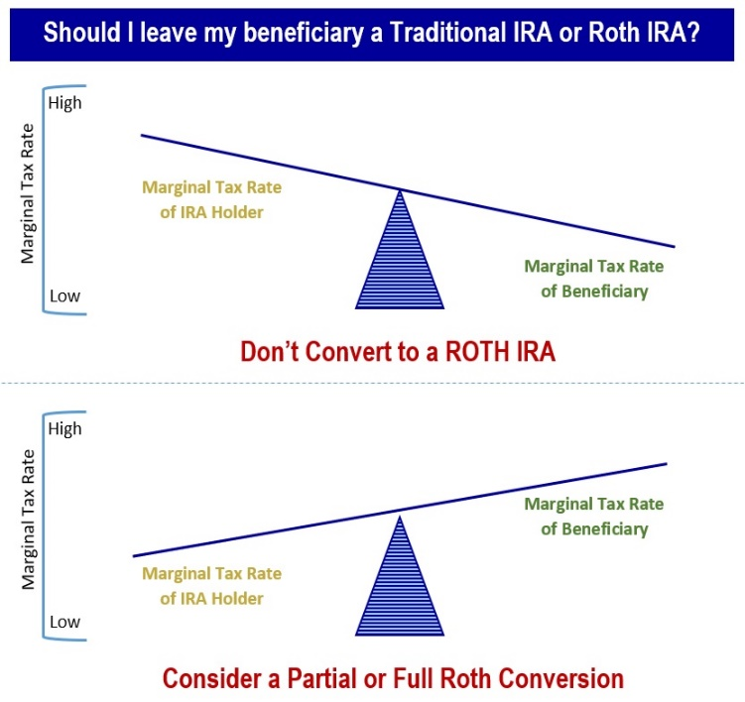
Some reasons why you might convert
a Traditional IRA to a Roth IRA

Enjoy tax-free withdrawals in retirement.
When taking withdrawals from a traditional IRA, you'd have to pay taxes on the money your investments earned—and on any contributions you originally deducted on your taxes. With a Roth IRA, as long as you meet certain requirements, all of your withdrawals are tax-free.

Watch your money grow tax-free for longer.
Traditional IRAs force you to take Required Minimum Distributions (RMDs) every year after you reach age 72, regardless of whether you actually need the money. Roth IRA’s have no RMD requirement, so your money can stay in the account and keep growing tax-free.

Leave a tax-free inheritance to your heirs.
The non-spouses who eventually inherit your Roth IRA will have to eventually take the money out of a tax-free growth situation (with the SECURE Act, they could possibly enjoy a full 10 years of tax deferral after your passing) but they won't have to pay any federal income tax on their withdrawals as long as the account has been open for at least five years.
Making the decision on converting to a Roth IRA hinges on a variety of issues including what your tax rate is now versus later, the tax bill you'll have to pay to convert, and your future plans for your estate. Also remember, the conversion will be permanent. Once you convert to a Roth IRA you can't revert the money back to a traditional IRA.

Some considerations before deciding include:

- Will you need the money in the first five years? Roth IRA conversions have penalties if used in the first five years.

- Will you end up in a higher or lower bracket in the future?

- Where will you take the money from to pay the taxes?
Roth conversions come with rules and possible complications. This is where a financial professional can offer some help suggestions and strategies. We enjoy talking with clients about the pros and cons of both partial of full Roth conversions.

Final Thoughts on
Proactive Retirement Planning

Over your life you may accumulate assets in tax deferred retirement accounts like 401(k) plans and traditional IRAs. You may also have Roth accounts that compound without tax consequences. When thinking about the assets you have accumulated in your retirement accounts, a key issue is tax efficiency. Accumulating assets in a tax efficient way is only one part of the strategy, the other more complex part is withdrawing those assets while making use of the most available tax advantages. The goal is to try to proactively plan the withdrawals from retirement accounts to minimize your tax liability.

The SECURE Act creates an opportunity to review your retirement plan with an eye for tax planning.
Determining the most efficient ways to either withdraw or pass to your beneficiaries your accumulated wealth is always an important decision. Our goal is to remain aware of changes that affect our clients and then share those changes with them. We want to provide proactive tax planning ideas when possible.

If you would like to discuss your retirement plan and withdrawal strategy, please call us. Our goal is to understand our clients’ needs and to monitor their wealth. Our primary objective is to take the emotions out of decisions for our clients. We can discuss your specific situation at your next review meeting or you can call to schedule an appointment. As always, we appreciate the opportunity to assist you in addressing your financial issues.

Insert Approved B/D Disclosure and Contact Information

The views expressed are not necessarily the opinion of (Insert Broker-dealer name). Information is based on sources believed to be reliable, however, their accuracy or completeness cannot be guaranteed. This information is not intended to be a substitute for specific individualized tax, legal, or investment planning advice and should not be construed as a recommendation or solicitation to buy or sell any security. Please note that statements made in this presentation may be subject to change depending on any revisions to the tax code or any additional changes in government policy. Please note that individual situations can vary.

Contributions to a traditional IRA may be tax deductible in the contribution year, with current income tax due at withdrawal. Withdrawals prior to age 59 ½ may result in a 10% IRS penalty tax in addition to current income tax. Unless certain criteria are met, Roth IRA owners must be 59½ or older and have held the IRA for five years before tax-free withdrawals are permitted. Additionally, each converted amount may be subject to its own five-year holding period. Converting a traditional IRA into a Roth IRA has tax implications. Investors should consult a tax advisor before deciding to do a conversion. rebalancing a non-retirement account could be a taxable event that may increase your tax liability.
Material discussed herewith is meant for general illustration and/or informational purposes only, please note that individual situations can vary. Therefore, the information should be relied upon when coordinated with individual professional advice. This material may contain forward looking statements and projections. There are no guarantees that these results will be achieved. This article provided the Academy of Preferred Financial Advisor, Inc.©
Complimentary Financial Check-up
If you are currently not a client of Your Company Name, we would like to offer you a complimentary, one-hour, private consultation with one of our professionals at absolutely no cost or obligation to you. To schedule your financial check-up, please call Contact name and information.

Proactive Tax Planning
Does your current advisor offer a “Proactive” approach to your tax planning?
If not, we would like the opportunity to talk with you.
A “Proactive” approach to your tax planning instead of a
“Reactive” approach could produce better results!

