

An Overview of Some Key SECURE Act Changes That May Affect Your Retirement Strategy

**SETTING EVERY COMMUNITY UP FOR RETIREMENT ENHANCEMENT**  
Enacted: December 20, 2019

Company Logo

The Academy of Preferred Financial Advisors, Inc.  
866.866.0472 **|** [info@theapfa.com](mailto:info@theapfa.com) **|** www.theapfa.com

**Proactive Retirement Planning Using the New SECURE Act**

The **Setting Every Community Up for Retirement Enhancement Act of 2019** or **SECURE Act** is the largest package of retirement plan reforms in more than A Decade.

**Proactive Tax Planning   
with the SECURE Act**

Here are some of the changes that may affect retirement savers and their tax strategies:

* **The Required Minimum Distribution (RMD) age was raised from 70 ½ to 72.**
* **The age limit for traditional IRA contributions was eliminated.**
* **A new 10-year rule essentially requires (there are some exceptions) all inherited IRAs, Roth IRAs, and qualified plans to be distributed within 10-years of death.**
* **There are new 529 Education Fund Rules.**
* **There is a 10% retirement account penalty exception for both births and adoptions.**



On December 20, 2019, the **Setting Every Community Up for Retirement Enhancement (SECURE) Act** was signed into law. This new legislation made major changes to a number of tax rules that govern retirement savings. Many of these changes started in 2020 and some of the details are still being finalized.

Making retirement plans more available to Americans and encouraging retirement savings was the driving force behind the creation and enactment of the **SECURE Act**. It includes significant changes that all retirement savers should be aware of for retirement and tax planning purposes.

Familiarizing yourself with how the **SECURE Act** may impact your current retirement plan and discussing it with a knowledgeable financial professional can help you proactively and properly amend your strategy to adjust to the SECURE Act changes.

*This booklet is for informational purposes only.*

*This information is not intended to be a substitute for specific individualized tax, legal or investment planning advice as individual situations will vary. For specific advice about your situation, please consult with a lawyer or tax professional.*

**The Required Minimum Distribution (RMD)   
AGE was raised from 70 ½ to 72.**

The policy behind the Required Minimum Distribution (RMD) rule is to ensure that individuals spend their retirement savings during their lifetime and not use their retirement plans for estate planning purposes to transfer wealth to beneficiaries.

**NEW RULE**

Under the new **SECURE Act**, distributions are required to begin by April 1st of the year after you reach 72.

This new rule applies to anyone who has not reached 70½ by December 31, 2019.

*NOTE: While not a part of the* ***SECURE Act****, required minimum distributions were waived for the year 2020.*

**PREVIOUS RULE**

Previously, participants were generally required to begin taking distributions from their retirement plan at age 70½.

The age 70½ was first applied for retirement plans in the early 1960s and has never been adjusted to consider increases in today’s life expectancy.



**The age limit for traditional IRA   
contributions was eliminated.**

**NEW RULE**

Effective on January 1, 2020, the **SECURE Act** repealed the maximum age for Traditional IRA contributions. Now you can make up to a $7,000 contribution ($6,000 plus $1,000 catch-up contribution) to a Traditional IRA at any age if you have that much or more in earned income.

*Note: One change that also came with this new option was that if you choose to contribute to a traditional IRA after age 70½, it will reduce your ability to make a full Qualified Charitable Distribution (QCD).*

**PREVIOUS RULE**

Previously, the IRA rules prohibited contributions of earned income to a Traditional IRA by an individual who had attained age 70½.

**Qualified Charitable Distributions (QCDs) are a potential strategy for retirement savers.**

While they are not new or changed by the **SECURE Act**, under today’s tax laws and with more taxpayers using standard deductions, Qualified Charitable Distributions (QCDs) of up to $100,000 are available to an IRA owner over 70 ½ years old. They are many times used as a proactive tax planning strategy for anyone over 72 taking a Required Minimum Distribution (RMD). An amount directly given to an eligible charity processed as a QCD counts toward your RMD requirement and reduces the taxable amount of your IRA distribution. This QCD lowers both your adjusted gross income and taxable income, resulting in a lower overall tax liability. It also lowers your income for purposes of calculating if your social security is taxable. By using, or preparing to use, a QCD, you can potentially meet your RMD requirements and satisfy your charitable intents, all while reducing your taxes.

Please note, for tax return filings, your IRA custodian is not required to specially identify the QCD on your annual 1099-R form. The responsibility is on you to inform your tax preparer that you used a QCD. If you do not let your preparer know, they could report this transaction as fully taxable, which would negate the benefit of your smart planning. Also, the distribution must be made directly to a qualified charity.

**This is a specific area where a financial professional can offer some suggestions and strategies. We would be happy discuss with you whether or not this tax saving strategy may beneficial to your specific situation.**



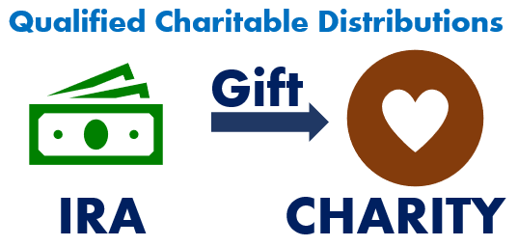

**tHE new 10-year rule**

**NEW RULE**

The **SECURE Act** makes most non-spousal inheritors deplete the value of all IRAs, Roth IRAs, and qualified plans within 10 years of the original owner’s death.

Exceptions to this 10-year rule are:

* surviving spouses,
* disabled individuals,
* chronically ill individuals,
* minor children of the IRA holder (till they reach the age of majority in their state), and
* non-spouse beneficiaries who are less than 10 years younger than the original IRA holder.

***WARNING –******For some beneficiaries, the Five-year rule may apply. Talk with a tax professional to assess your situation. Also, remember that the plan documents of a company retirement plan can override the 10-year rule.***

**PREVIOUS RULE**

Previously, most non-spousal beneficiaries were able to maximize tax-savings through a strategy known as the “Stretch IRA.”

The Stretch IRA allowed beneficiaries like children or grandchildren to take required minimum distributions from an inherited account based on their own much longer life expectancy.



***Your objective is to reduce your taxes and take advantage of tax deferral as long as possible.***

**potential new 10-year rule strategies.**

**PREVIOUS RULE** “Best Practice”

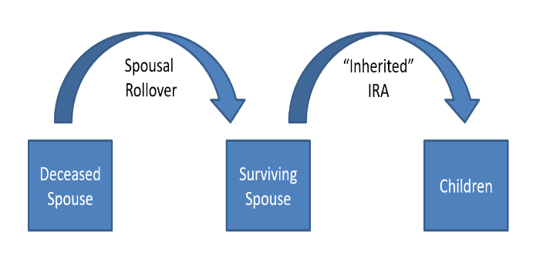

According to industry experts, like Robert Keebler, CPA, MST, AEP of Keebler and Associates, one of the old rule’s best practices was to, whenever possible, leave all of your retirement assets to your spouse who, upon death, would leave them in an “inherited” IRA to heirs who then have the option to “stretch” their withdrawals over their lifetime. This enabled a potentially long period of tax deferral and hopefully asset growth.

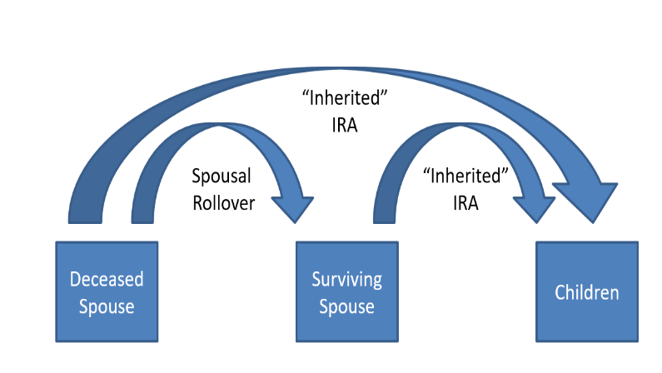

**NEW RULE** “Best Practice”

Industry experts are now sharing that the potential new best practice is to review a plan that should consider, if appropriate, leaving some of your retirement assets to your spouse who, upon death, would leave those assets in an “inherited” IRA to heirs and also leaving some directly in an “inherited” IRA to your children or others. This could potentially create a spread of tax liability over more brackets and more years.

**potential new 10-year rule strategies.**  
Roth IRA Conversions

The new 10–Year rule reminds us that a proactive approach could potentially reap rewards. To maximize your situation under the new 10-year rule, you may want to consider Roth conversions and possibly spreading distributions over many years and lower brackets. Unlike distributions from regular IRAs, Roth IRA qualified distributions are not taxed.

**Roth IRA Conversion considerations**

Your personal critical decision factors include your:

* Tax rate differential (tax in year of conversion vs. tax rate in withdrawal years).
* Use of “outside funds” to pay the income tax liability.
* Need for IRA funds to meet annual living expenses.
* RMD considerations (remember these begin at age 72 for non-Roth IRAs).
* Time horizon (how old are you and how long can you defer taxes).
* Estate tax considerations.
* Ten-year Rule.

**Potential Benefits of a roth ira conversion**

* They could lower overall taxable income long-term.
* ROTH IRAs enjoy tax-free compounding.
* ROTH IRAs have no RMDs (at age 72).
* ROTH IRAS allow tax-free withdrawals for beneficiaries.

**We understand this decision can be complex and these are not easy choices. We are here to help you review your personal situation and recommend the best course of action.**



*Each case can present different opportunities and it is best to talk with us or your tax professional about your specific situation.*

***Family Tax Bracket Management©***

A critical area to review due to the SECURE Act is what we refer to as overall ***Family Tax Bracket Management©.*** Mathematically speaking, if you are in a higher tax bracket than your beneficiaries, it might make sense to let them take distributions in their tax bracket rather than you in yours. However, if your beneficiaries are in a higher tax bracket, it might make sense to take distributions in your bracket, convert these accounts to Roth IRAs and leave them an account that still has to be taken out in 10 years, but can grow tax free.

One strategy we can help with is to review you and your beneficiary’s marginal tax rate(s) each year.

***Should I leave My Beneficiaries A Traditional or Roth IRA?***

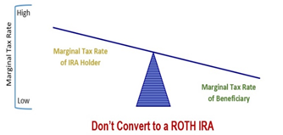

**additional secure act changes**

**new 529 Education   
Fund Rules.**

A major change enacted by the **SECURE Act** was to create new 529 plan rules.

They include the ability to use up to $10,000 in your lifetime for qualified student loan repayments.

**Something to Consider:**

* Even if NO changes are made to tax rates, in 2026 current law states that tax brackets will return to the older higher rates.

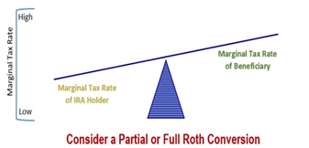

**10% retirement account   
penalty exception for births   
and adoptions.**

If you are under the age 59½ and had a childbirth or adopted, the **SECURE Act** removed the 10% retirement account penalty for up to $5,000 of retirement fund withdrawals incurred within a year of this childbirth or adoption There are also abilities to repay this into your plan. If this is a strategy you would like to consider, see us or your tax advisor for details.

Over your lifetime, you may accumulate assets in tax deferred retirement accounts like 401(k) plans and traditional IRAs. When thinking about the assets you have accumulated in your retirement accounts, a key issue is tax efficiency. Accumulating assets in a tax efficient way is only one part of the strategy, the other complex part is withdrawing those assets while attempting to minimize taxation. A common goal is to try to proactively plan withdrawals from retirement accounts to minimize your tax liability.

The **SECURE Act** creates an opportunity to review your retirement plan with an eye for tax planning. Determining the most efficient ways to either withdraw or pass to your beneficiaries your accumulated wealth is always an important decision. Our goal is to remain aware of changes that affect our clients and then share those changes with them. **We want to provide proactive tax planning ideas when possible.**

**If you would like to discuss your retirement plan and withdrawal strategy, please call us. Our goal is to understand our clients’ needs and to monitor their wealth. We can discuss your specific situation at your next review meeting or you can call to schedule an appointment. As always, we appreciate the opportunity to assist you in addressing your financial issues.**



Help us help others!

Our goal this year is to help others with their financial decisions. Please help us by offering a copy of this report to a friend, colleague or family member. **To add someone to our mailing list please call (NAME) at (PHONE #)**.

Insert Approved B/D Disclosure and Contact Information

The views expressed are not necessarily the opinion of (Insert Broker-dealer name). Information is based on sources believed to be reliable, however, their accuracy or completeness cannot be guaranteed. This information is not intended to be a substitute for specific individualized tax, legal, or investment planning advice and should not be construed as a recommendation or solicitation to buy or sell any security. Please note that statements made in this presentation may be subject to change depending on any revisions to the tax code or any additional changes in government policy. Please note that individual situations can vary.

Contributions to a traditional IRA may be tax deductible in the contribution year, with current income tax due at withdrawal. Withdrawals prior to age 59 ½ may result in a 10% IRS penalty tax in addition to current income tax. Unless certain criteria are met, Roth IRA owners must be 59½ or older and have held the IRA for five years before tax-free withdrawals are permitted. Additionally, each converted amount may be subject to its own five-year holding period. Converting a traditional IRA into a Roth IRA has tax implications. Investors should consult a tax advisor before deciding to do a conversion.

Material discussed herewith is meant for general illustration and/or informational purposes only, please note that individual situations can vary. Therefore, the information should be relied upon when coordinated with individual professional advice. This material may contain forward looking statements and projections. There are no guarantees that these results will be achieved. This article provided the Academy of Preferred Financial Advisor, Inc.©

