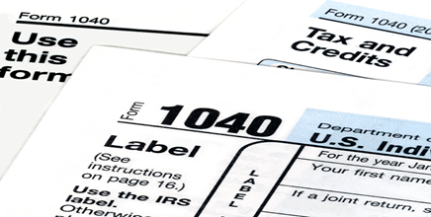Have you considered these proactive tax strategies that  
could be helpful to implement before December 31?

YEAR-END TAX REVIEW CHECKLIST

**Reactive**

**Proactive**

***Tax Planning***

***vs***

2020 has been an unprecedented year.

Now, more than ever, you should be optimizing your tax-saving strategies. Please review the following items to help us explore all potential tax reduction strategies for you and your unique situation.

|  |  |  |
| --- | --- | --- |
|  |  | Maximized Retirement Plan Contributions |
|  |  | Discussed Tax Bracket Management |
|  |  | Identified Opportunities for Capital Loss Harvesting |
|  |  | Identified Opportunities for Capital Gain Harvesting |
|  |  | Explored All Roth Conversion Opportunities |
|  |  | Considered Charitable Gifting |
|  |  | Maximized Annual Exclusion Gifts |
|  |  | Reviewed Use of 529 Plans |
|  |  | Discussed Potential Deduction Timing |
|  |  | Reviewed Estate Plan Strategies |

“The hardest thing to understand in the world is the income tax.”   
Albert Einstein

**Yes No**

*This document is meant to be helpful but does not replace the need to discuss your situation with a qualified tax professional.*

As part of our holistic financial planning services, one of our goals is to discover the best potential tax reduction strategies for your situation.

Please connect with us if you would like to learn more   
about any of these strategies that could help your 2020 taxes.