Quarterly Economic Update
Fourth Quarter 2021
Your Name

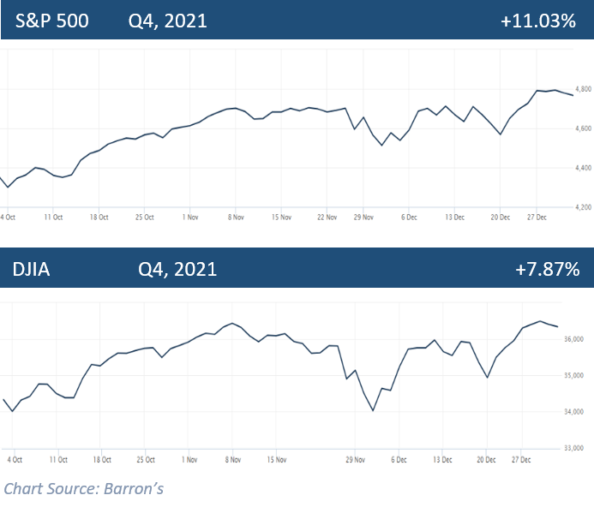

2021 closed as a banner year for many investors. Although the year ended with both winners and losers, in retrospect, the sudden recession created by the COVID pandemic in 2020 lasted only two months for investors. Although history will record the Covid pandemic for causing one of the sharpest recessions ever felt by the global economy, the rebound that investors continue to see nearly two years later has been just as remarkable. Post-pandemic equity markets in 2021 saw the S&P 500 create 70 record closes, the last one on Wednesday, December 29. The DJIA also realized 45 record closes in 2021. (Source: Barron’s 12/31/21)
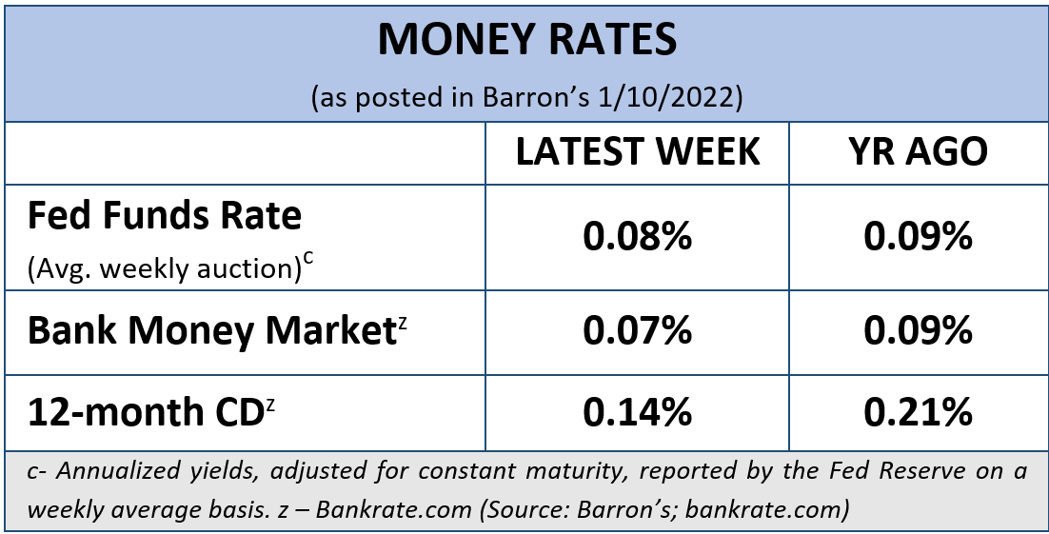
The S&P 500 closed the quarter at 4,766.18, ending the year up 27%. 2021 will mark the indexes third consecutive year of double-digit gains. The Dow Jones Industrial Average (DJIA) closed at 36,338.30 ending the year up 19%. (Source: Barron’s 12/31/21)
Stock valuations have soared in large part due to ultra-low interest rates and a healthy economic recovery. With a few exceptions like some bonds and gold, almost every asset class produced gains in 2021. (Source: Barron’s 12/17/21)
KEY TAKEAWAYS
- Equity markets ended on a high note despite many potentially detrimental variables.
- Inflation and consumer price index highest in decades.
- The Fed announces interest rates set to rise in 2022 to help fight inflation.
- Tapering began in December and the Fed will double its pace of reductions of asset purchases beginning in mid-January.
- Covid variants a key factor in economic recovery.
- Volatility is likely on the horizon.
- Call us for a comprehensive review of your personal financial situation.

Throughout the year, equity markets showed perseverance and resilience against many potentially detrimental events and rewarded investors with notable gains, but investors still face continued variables that could affect the uptick of the economy and its recovery.
As we enter 2022, there are several areas that should play a key role in the economy and how it may affect investors. These include:
- The trajectory of the COVID-19 pandemic recovery – hopefully we will not experience any newer emerging COVID variants and we will see a reduction of new cases. The emergence of new variants and their severity could keep many investors anxious and Covid aftershocks could still play a major role in determining the direction of the market.

- The Federal Reserve’s tapering and ultimate goal of ending the monetary stimulus that they have been infusing into the economy to stave off the effects of the pandemic-induced recession.

- The slowing down of global economic growth, particularly in China – the world’s second largest economy.

- The current high valuations of stocks and real estate.

- Rising interest rates. The Fed announced in December their intention is to begin raising interest rates in 2022. Currently, the Fed is forecasting three rate hikes in 2022, followed by three more in 2023.

- Inflation rates that could remain elevated, particularly due to the continuation of broken supply chains and labor shortages, and the residual effects of the pandemic. The results of the Fed’s efforts to fight inflation is yet to be seen.
These and any other economic factors could complicate equity market performance in 2022, so investors need to be prepared.
Inflation & Interest Rates
Interest rates and inflation concerns continue to be at the forefront of the economic news, especially after the Fed announced in December it will speed up its timeline for tapering down its stimulus.

In November, inflation statistics rose 6.8% versus the preceding twelve months. This was the fastest rise in inflation since 1982. The consumer price index also soared and settled at a 6.8% pace, also the fastest since 1982. Headliners for price increases were gasoline, up 58.1% since November 2020, food prices, which were up 6.1% and used vehicle prices, which were up 31.4%, year over year. Housing prices increased 3.8%, the highest since 2007. (Source: cnbc.com 12/10/2021)

Several factors have contributed to a swift elevation of inflation, including the imbalance of the supply and demand chain and the reopening of the economy. The Fed expects that supply chain bottlenecks and shortages will continue well into 2022.

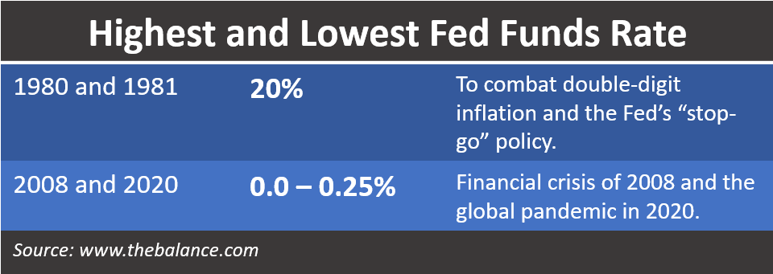
Due to elevated labor market and inflation pressures, the Fed decided to “speed up the reduction of their asset purchases.” The Committee agreed to double the pace of reductions of asset purchases and beginning in mid-January, it will reduce its monthly pace of net asset purchases of $120 billion. The reduction proposed will see $10 billion less in Treasurys and $5 billion less in mortgage-backed securities a month. Chairman Jerome Powell states the Fed’s goal would be to cease any increase of securities holdings by mid-March 2022, instead of November 2022, which they had originally anticipated.

Powell expressed that this was all predicated on the forward movement of the economy and would be “prepared to adjust the pace of purchases” if warranted.

With the annual consumer price index rising faster than ever since the early 1980s, high inflation can pose significant hardships for many individuals and families. According to Labor Department statistics, even though gross pay has increased 4.8% over the past twelve months, average hourly earnings accounting for inflation have actually decreased by 1.9%. (Source: cnbc.com 12/10/2021)

The Federal Open Market Committee (FOMC) stressed that it is “committed to our price stability goal” and is ready to use “tools both to support the economy and a strong labor market and to prevent higher inflation from becoming entrenched.”
Interest rates and tapering are currently closely connected. Even though 2022 is forecasted to bring slightly higher rates, at the conclusion of the Federal Reserve’s meeting in December, the Federal Open Market Committee (FOMC) kept the federal funds rate at or near zero (0 – 0.25%). The median forecast of FOMC members is three quarter-point rate increases in 2022 and three more in 2023, which would raise rates to 2.1% at the end of 2024.

What does this mean for investors? While these rate ranges are still low, the possibility of new volatility, less robust equity returns, and negative returns on bonds (when you factor in inflation) has investors wary and some have their selling finger on the trigger.

Remember, interest rates and tapering are closely connected and the Fed will consider many factors, including the labor market and the course of COVID variants before it makes a move to increase interest rates.

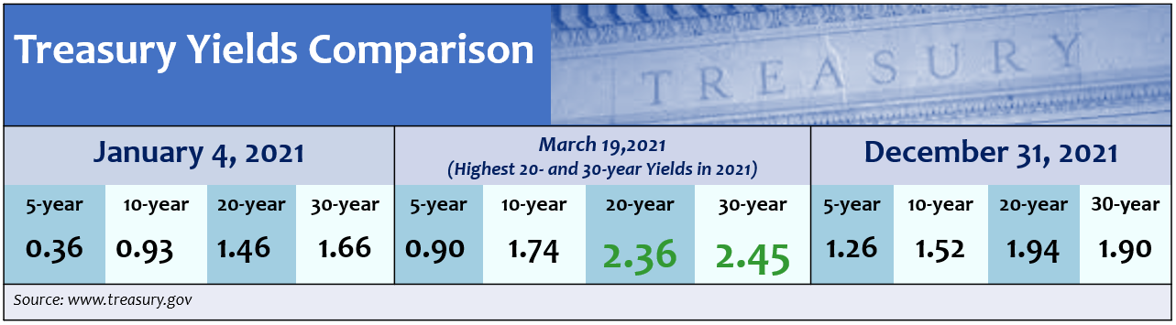
As your financial professional, we are committed to keeping a watchful eye on the economy and how interest rate hikes and the trajectory of inflation affects our clients. If you are concerned about how these key items could affect you, please connect with us to discuss possible hedges against inflation and rising rates.

Treasury Yields
2021 was not the best year for bond holders. While today’s interest rates are still historically low, as we said earlier, the Fed is expecting to raise interest rates several times in the next two years. When interest rates rise, the demand for bonds typically falls, reducing their prices and raising their yields. Thus, 2022 may see a slightly better performance from bonds.
The Fed does not expect to raise rates sharply, and as mentioned, they are currently projecting that the Federal Fund rate could rise to only 2.1% at the end of 2024. How much and when the Fed moves to increase rates is not set in stone and thus, neither is the extent to how it will affect bonds.
The 10-year Treasury yield finished the quarter at 1.52%. According to Russell Investment’s research, a 1.5% to 2.0% yield on 10-year U.S. Treasuries is expected by the end of 2022. (Source: russellinvestments.com 12/1/2021)
We are monitoring interest rates movements and their effect of bond yields. Investors should remember that bonds can be a critical component to a diversified portfolio. Bonds can be a good shield from volatility in equities and provide income. However, investors who put a high percentage of their portfolios in bonds with the hopes of producing stable returns could see minimal results.

Investor’s Outlook
As the calendar turns to 2022, it provides an opportune time to reflect on longer-term horizons, your risk appetite, and adjustments in your cash flow needs.
Rising interest rates and the course of inflation will be at the top of analyst’s and investor’s watch lists. The Fed’s expectation of raising interest rates several times next year and tapering off the pandemic stimulus, combined with other variables, including the potential decline in corporate earnings, supply chain issues, and continued concern over COVID variants, could lead to increased volatility in equity markets.
Investors are not out of the woods from COVID and its effects on the economy. Omicron introduced itself to the world in late November and equity markets reminded us that they are still vulnerable to coronavirus. The DJIA responded with its worst day since October 2020 and the S&P500 had its worst performance since February 2021. However, the markets quickly rebounded.
Monetary policy also could alter equity markets. The Build Back Better Act, which was not passed in 2021 is still proposing to bring some changes to tax laws that could also affect investors in 2022 and beyond. How the Fed’s elimination of the $1.4 trillion of annual stimulus they have been pumping into the economy within a short time period will impact equity markets is uncertain.
Even though the equity markets have been rewarding, complacency should not settle into investor’s attitudes toward their investment strategies. We still stand by our mantra of “Proceed with Caution.”
As you can see from the over 40-year chart, part of the investment experience is pullbacks and downturns. Having a long-term plan, being properly invested, diversified, and staying the course toward your investment goals can assist in helping you ride out volatility in the market.
Remember, market pullbacks are not uncommon and can offer a healthy “reset” for high stock valuations. Often times, pullbacks can provide opportunities for entry points, not exit points. Staying away from emotional investing decisions can help investors ride the pullback waves and stay on track toward their financial goals.

With interest rates hikes on the horizon, we suggest you consider:

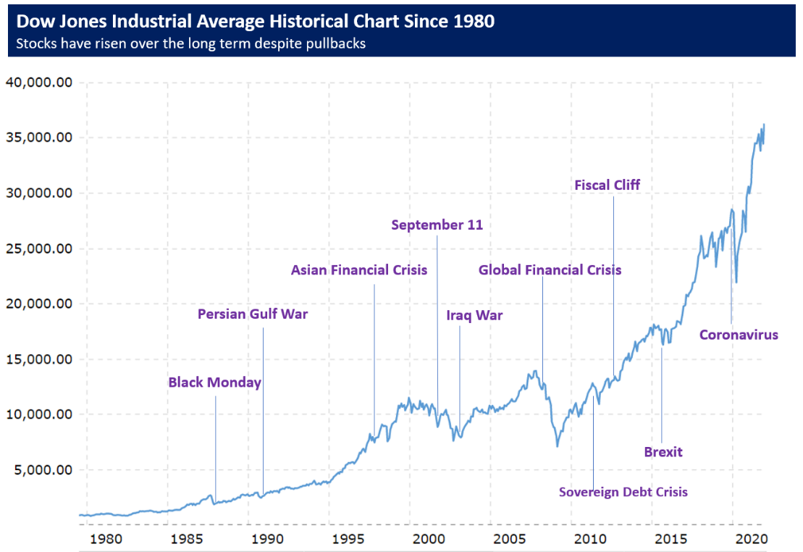
- reviewing all of your income-producing investments.

- locking in your mortgage rates.

- maintaining liquidity for all near-term needs.

- connecting with us to review your personal financial plan, including risk management, diversification, and time horizons.
Many economists are still looking at continued favorable returns in 2022, but in more moderation. We favor longer-term investment horizons as short-term movements of the market are unpredictable and do not abide by any average. Although historically, stocks have provided higher long-term returns than bonds or short-term investments, stock prices do not move in a straight line.
Wall Street Economist Ed Yardeni believes that “Consumer and capital spending will continue to drive the economy next year, but we’ll return to a more normal growth rate.” Yardeni forecasts a 3.3% increase in the U.S. Gross Domestic Product in 2022, down from this year’s expected growth rate of over 5%. (Source: Barron’s 12/17/21)
Regardless of how equities are performing, investors should always focus on their personal objectives and long-term goals. Even when investing for the long-term, there is no guarantee that market volatility will decrease, stabilize, or increase over any timeframe.
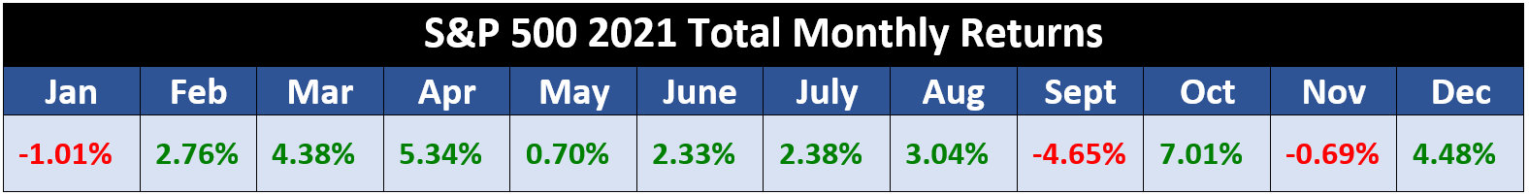
While investors enjoyed an overall strong return in 2021, as the monthly S&P 500 returns chart shows, monthly returns were very inconsistent. The past few years have been an excellent reminder for investors to be prepared for anything that could affect the economic environment and their own personal situation. Having a solid investment strategy is an integral part of a well-devised, holistic financial plan. Staying disciplined and following that strategy during times of volatility is equally important. As your financial professional, we are here to help you pursue your goals. We treat each client as an individual case with unique goals and circumstances. Prior to making any financial decisions, we highly recommend you contact us so we can help determine the best strategy. There are often other factors to consider, including tax ramifications, increased risk, and time horizon fluctuations when changing anything in your financial plan.
Now is a good time to revisit your specific holdings, your time horizons, and risk tolerance. Please call our office to discuss any concerns or ideas you have or bring them up at your next scheduled meeting. As always, please feel free to connect with us with via telephone or email with any concerns or questions you may have.
We are here for you!
We pride ourselves in offering:
- individualized advice tailored to your specific needs and goals;
- consistent and meaningful communication throughout the year;
- a schedule of regular client meetings;
- continuing education for all our team members on issues that may affect you.

- Proactive planning to navigate the changing landscape.

Remember, a skilled financial professional can help make your financial journey easier. Our goal is to understand your needs and create an optimal plan to address those needs.

Are you working with an advisor who coordinates taxes and investments?

Do you feel your advisor is fully aware of your financial situation? | Yes No Not Sure
Are you satisfied with how your advisor is keeping you updated? | Yes No Not Sure
Has your advisor reviewed your tax forms to understand how to coordinate your investments with your taxes? | Yes No Not Sure
Has your advisor discussed tax planning strategies that could help you keep more of what you make? | Yes No Not Sure
Is your advisor updated and current on tax planning strategies? | Yes No Not Sure
Would you like a complimentary review of your financial situation? | Yes No Not Sure
If you answered No or Not Sure to any of these questions, consider scheduling a complimentary session so we can review all of your information.
If you are currently not a client of YOUR BUSINESS NAME, we would like to offer you a complimentary, one-hour, private consultation with one of our professionals at absolutely no cost or obligation to you. To schedule your financial check-up, please call NAME at (xxx) xxx-xxxx.

Insert Approved B/D/ Disclaimer Here

Note: The views stated in this letter are not necessarily the opinion of broker/dealer, and should not be construed, directly or indirectly, as an offer to buy or sell any securities mentioned herein. Investors should be aware that there are risks inherent in all investments, such as fluctuations in investment principal. With any investment vehicle, past performance is not a guarantee of future results. Material discussed herewith is meant for general illustration and/or informational purposes only, please note that individual situations can vary. Therefore, the information should be relied upon when coordinated with individual professional advice.

This material contains forward looking statements and projections. There are no guarantees that these results will be achieved. All indices referenced are unmanaged and cannot be invested into directly. Unmanaged index returns do not reflect fees, expenses, or sales charges. Index performance is not indicative of the performance of any investment.

The S&P 500 is an unmanaged index of 500 widely held stocks that is general considered representative of the U.S. Stock market. The modern design of the S&P 500 stock index was first launched in 1957. Performance prior to 1957 incorporates the performance of the predecessor index, the S&P 90. Dow Jones Industrial Average (DJIA), commonly known as “The Dow” is an index representing 30 stocks of companies maintained and reviewed by the editors of the Wall Street Journal. Past performance is no guarantee of future results. CDs are FDIC Insured and offer a fixed rate of return if held to maturity. Due to volatility within the markets mentioned, opinions are subject to change without notice. Information is based on sources believed to be reliable; however, their accuracy or completeness cannot be guaranteed.

There is an inverse relationship between interest rate movements and bond prices. Generally, when interest rates rise, bond prices fall and when interest rates fall, bond prices generally rise.

There is no guarantee that a diversified portfolio will enhance overall returns out outperform a non-diversified portfolio. Diversification does not protect against market risk.

Sources: barrons.com; federalreserve.gov; russellinvestments.com; cnbc.com; forbes.com; treasury.gov. Contents provided by the Academy of Preferred Financial Advisors, 2022©

