Quarterly Economic Update
Fourth Quarter 2021
Your Name
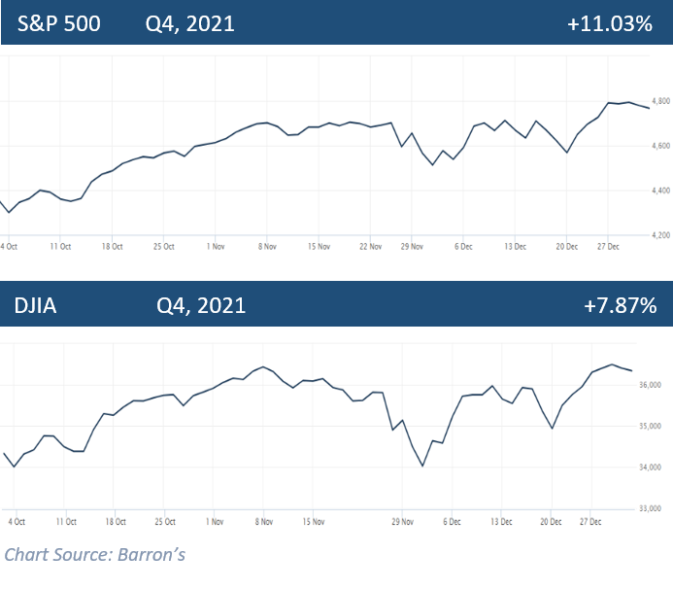

2021 closed as a banner year for many investors. Although history will record the Covid pandemic for causing one of the sharpest recessions ever felt by the global economy, the rebound investors continue to see nearly two years later has been just as remarkable. Post-pandemic equity markets in 2021 saw the S&P 500 create 70 record closes, the last one on Wednesday, December 29. The DJIA also realized 45 record closes in 2021. (Source: Barron’s 12/31/21)
The S&P 500 closed the quarter at 4,766.18, ending the year up 27%. 2021 will mark the indexes third consecutive year of double-digit gains. The Dow Jones Industrial Average (DJIA) closed at 36,338.30 ending the year up 19%. (Source: Barron’s 12/31/21)
Stock valuations have soared in large part due to ultra-low interest rates and a healthy economic recovery. With a few exceptions like some bonds and gold, almost every asset class produced gains in 2021. (Source: Barron’s 12/17/21)
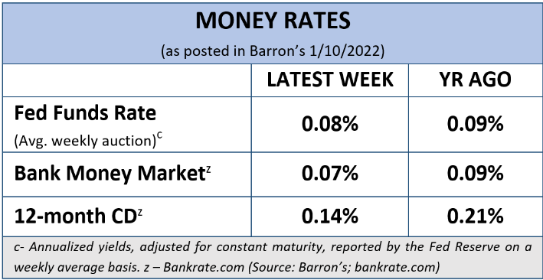
Throughout the year equity markets showed perseverance and resilience against many potentially detrimental events and rewarded investors with notable gains, but investors still face continued variables that could affect the uptick of the economy and its recovery.
As we enter 2022, there are several areas that should play a key role in the economy and how it may affect investors. These include:
- The trajectory of the COVID-19 pandemic recovery – hopefully we will not experience any newer emerging COVID variants and we will see a reduction of new cases.
- The Federal Reserve’s tapering and ultimate goal of ending the pandemic-induced monetary stimulus.
- The slowing down of global economic growth, particularly in China – the world’s second largest economy.
- The current high valuations of stocks and real estate.
- Rising interest rates.
KEY TAKEAWAYS
- Equity markets ended on a high note despite many potentially detrimental variables.
- Inflation and consumer price index had their highest rise in decades.
- The Fed started reducing tapering and intends to increase interest rates in 2022.
- Fed tapering began in December and the Fed will double its pace of reductions of asset purchases beginning in mid-January.
- Covid variants still a key factor in economic recovery.
- Volatility is likely in 2022.
- Call us for a comprehensive review of your personal financial situation.

- Inflation rates that could remain elevated.
These and a variety of economic factors could complicate equity market performance in 2022, so investors need to be prepared.
Inflation & Interest Rates
Interest rates and inflation concerns continue to be at the forefront of the economic news, especially after the Fed announced in December it will speed up its timeline for tapering down its stimulus.

In November, inflation statistics rose 6.8% versus the preceding twelve months. This was the fastest rise in inflation since 1982. The consumer price index also soared and settled at a 6.8% pace, also the fastest since 1982. (Source: cnbc.com 12/10/2021)

Several factors have contributed to a swift elevation of inflation, including the imbalance of the supply and demand chain and the reopening of the economy. The Fed expects that supply chain bottlenecks and shortages will continue well into 2022.

With the annual consumer price index rising faster than ever since the early 1980s, high inflation can pose significant hardships for many individuals and families. The Federal Open Market Committee (FOMC) stressed that it is “committed to our price stability goal” and is ready to use “tools both to support the economy and a strong labor market and to prevent higher inflation from becoming entrenched.”

Interest rates and tapering are currently closely connected. Even though 2022, is forecasted to bring slightly higher rates, at the conclusion of the Federal Reserve’s meeting in December, the Federal Open Market Committee (FOMC) kept the federal funds rate at or near zero (0 – 0.25%). The median forecast of FOMC members is three quarter-point rate increases in 2022 and three more in 2023, which would raise rates to 2.1% at the end of 2024. Powell expressed that this was all predicated on the forward movement of the economy and would be “prepared to adjust the pace of purchases “ if warranted.
What does this mean for investors? While these rate ranges are still low, the possibility of new volatility, less robust equity returns, and negative returns on bonds (when you factor in inflation) has investors wary and some have their selling finger on the trigger.

As your financial professional, we are committed to keeping a watchful eye on the economy and how interest rate hikes and the trajectory of inflation affects our clients. If you are concerned about how these key items could affect you, please connect with us to discuss possible hedges against inflation and rising rates.

Treasury Yields
2021 was a lackluster year for bond holders. While today’s interest rates are still historically low, as we stated earlier, the Fed is expecting to raise interest rates several times in the next two years. When interest rates rise, the demand for bonds typically falls, reducing their prices and raising their yields. Thus, 2022 may see a slightly better performance from bonds.
The 10-year Treasury yield finished the quarter at 1.52%. According to Russell Investment’s research, a 1.5% to 2.0% yield on 10-year U.S. Treasuries is expected by the end of 2022. (Source: russellinvestments.com 12/1/2021)
We are monitoring interest rate movements and their effect on bond yields. Investors should remember that bonds can be a critical component to a diversified portfolio. Bonds can be a good shield from volatility in equities and provide income. However, investors who put a high percentage of their portfolios in bonds with the hopes of producing stable returns could see minimal results.

Investor’s Outlook
As the calendar turns to 2022, it provides an opportune time to reflect on longer-term horizons, your risk appetite, and adjustments in your cash flow needs.
Rising interest rates and the course of inflation will be at the top of analyst’s and investor’s watch lists. The Fed’s expectation of raising interest rates several times next year and tapering off the pandemic stimulus, combined with other variables, including the potential decline in corporate earnings, supply chain issues, and continued concern over COVID variants, could lead to increased volatility in equity markets.
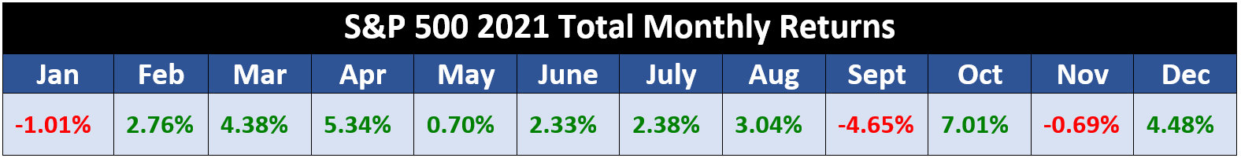
Investors are not out of the woods from COVID and its effects on the economy. Omicron introduced itself to the world in late November and equity markets reminded us that they are still vulnerable to the coronavirus. The DJIA responded with its worst day since October 2020 and the S&P500 had its worst performance since February 2021. However, the markets quickly rebounded.
Monetary policy also could alter equity markets. The Build Back Better Act, which was not passed in 2021 is still proposing to bring some changes to tax laws that could also affect investors in 2022 and beyond. How the Fed’s elimination of the $1.4 trillion of annual stimulus they have been pumping into the economy within a short time period will impact equity markets is uncertain.
While investors enjoyed an overall strong return in 2021, as the monthly S&P 500 returns chart shows, monthly returns were very inconsistent. Even though the equity markets have been rewarding, complacency should not settle into investor’s attitudes toward their investment strategies. We still stand by our mantra of “Proceed with Caution.”
Many economists are still looking at continued favorable returns in 2022, but in more moderation. We favor longer-term investment horizons as short-term movements of the market are unpredictable and do not abide by any average. Although historically, stocks have provided higher long-term returns than bonds or short-term investments, stock prices do not move in a straight line.
Remember, market pullbacks are not uncommon and can offer a healthy “reset” for high stock valuations. Often times, pullbacks can provide opportunities for entry points, not exit points. Staying away from emotional investing decisions can help investors ride the pullback waves and stay on track toward their financial goals.
With interest rates hikes on the horizon, we suggest you consider:

- reviewing all of your income-producing investments.
- locking in your mortgage rates.
- maintaining liquidity for all near-term needs.
- connecting with us to review your personal financial plan, including risk management, diversification, and time horizons.
Regardless of how equities are performing, investors should always focus on their personal objectives and long-term goals. Even when investing for the long-term, there is no guarantee that market volatility will decrease, stabilize, or increase over any timeframe.
Having a solid investment strategy is an integral part of a well-devised, holistic financial plan. Staying disciplined and following that strategy during times of volatility is equally important. As your financial professional, we are here to help you with your goals. We treat each client as an individual case with unique goals and circumstances. Prior to making any financial decisions, we highly recommend you contact us so we can help determine the best strategy. There are often other factors to consider, including tax ramifications, increased risk, and time horizon fluctuations when changing anything in your financial plan. As always, please feel free to connect with us with via telephone or email with any concerns or questions you may have.
We are here for you!
Remember, a skilled financial professional can help make your financial journey easier. Our goal is to connect with you on a consistent basis, understand your needs and goals, and create an optimal plan tailored to your unique situation.
Complimentary Financial Check Up
If you are currently not a client of Business Name, we would like to offer you a complimentary, one-hour, private consultation at absolutely no cost or obligation to you. To schedule your financial check-up, please call Name at Phone Number.

Insert Approved B/D/ Disclaimer Here

Note: The views stated in this letter are not necessarily the opinion of broker/dealer, and should not be construed, directly or indirectly, as an offer to buy or sell any securities mentioned herein. Investors should be aware that there are risks inherent in all investments, such as fluctuations in investment principal. With any investment vehicle, past performance is not a guarantee of future results. Material discussed herewith is meant for general illustration and/or informational purposes only, please note that individual situations can vary. Therefore, the information should be relied upon when coordinated with individual professional advice.

This material contains forward looking statements and projections. There are no guarantees that these results will be achieved. All indices referenced are unmanaged and cannot be invested into directly. Unmanaged index returns do not reflect fees, expenses, or sales charges. Index performance is not indicative of the performance of any investment.

The S&P 500 is an unmanaged index of 500 widely held stocks that is general considered representative of the U.S. Stock market. The modern design of the S&P 500 stock index was first launched in 1957. Performance prior to 1957 incorporates the performance of the predecessor index, the S&P 90. Dow Jones Industrial Average (DJIA), commonly known as “The Dow” is an index representing 30 stocks of companies maintained and reviewed by the editors of the Wall Street Journal. Past performance is no guarantee of future results. CDs are FDIC Insured and offer a fixed rate of return if held to maturity. Due to volatility within the markets mentioned, opinions are subject to change without notice. Information is based on sources believed to be reliable; however, their accuracy or completeness cannot be guaranteed.

There is an inverse relationship between interest rate movements and bond prices. Generally, when interest rates rise, bond prices fall and when interest rates fall, bond prices generally rise.

There is no guarantee that a diversified portfolio will enhance overall returns out outperform a non-diversified portfolio. Diversification does not protect against market risk.

Sources: barrons.com; federalreserve.gov; russellinvestments.com; cnbc.com; forbes.com; treasury.gov. Contents provided by the Academy of Preferred Financial Advisors, 2022

