

**Date:** Date  
**Time:** Time   
**Location:** Restaurant

*Dinner Served*

**Name of Firm**

**Your Name**

**CONTACT INFORMATION:**

**ADDRESS**

**PHONE**

**EMAIL**

**WEBSITE**

**Managing Wealth in 2022**

Including Proactive Tax Planning Strategies

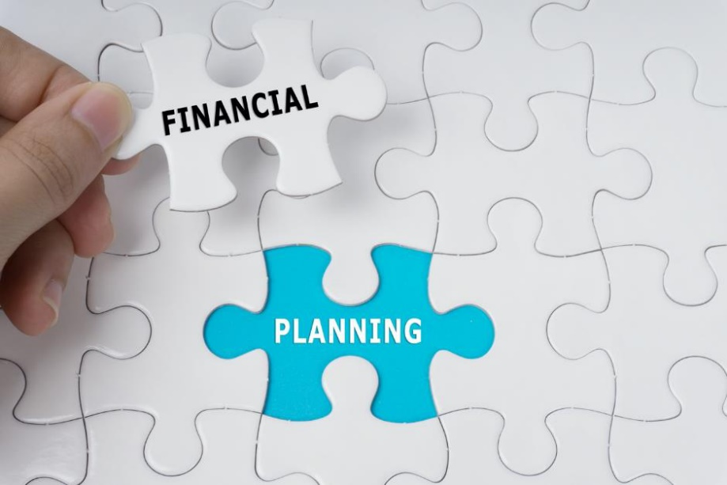

**Bring a friend!**

**This event is for our clients and their guests.**

***Seating is limited!  
Please RSVP to Name at   
(xxx) xxx-xxxx to reserve your spots today!***

***This workshop is for informational purposes only!***  
BROKER/DEALER DISCLAIMER

**Please join us   
for this   
informative workshop!**