Quarterly Economic Update
First Quarter 2022
Your Name

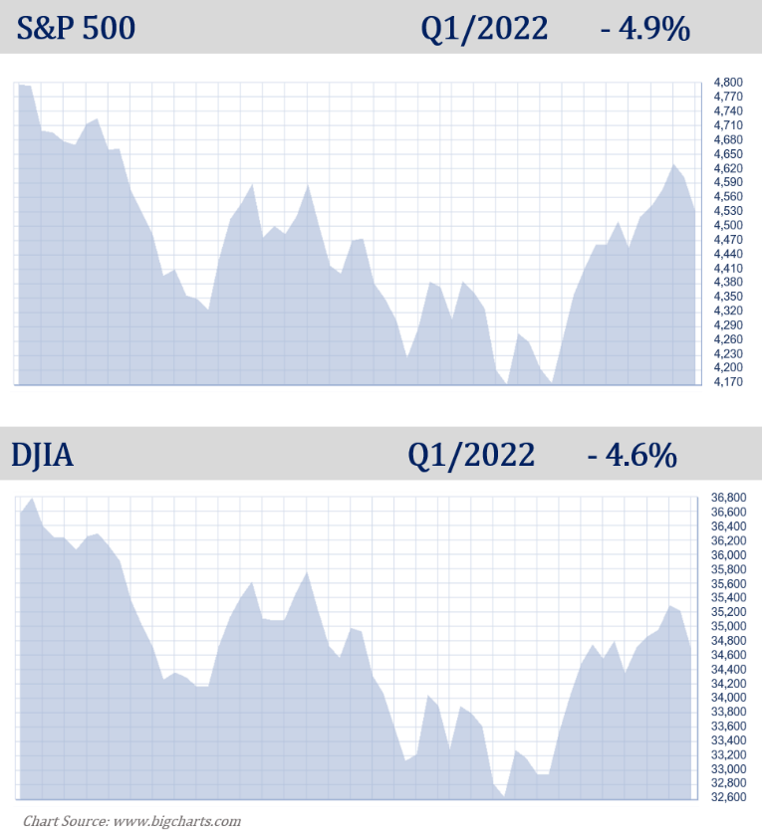

The past few years have proved the Greek philosopher Heraclitus right when he proclaimed that, “the only thing constant is change.” Just when a sense of normalcy seemed to be realized, during the first quarter of 2022 the world was thrown another hardship as Russia invaded Ukraine. For investors, this added more fuel for market volatility. Combined with inflation and rising interest rates, the first three months of 2022 became a roller coaster ride, challenging even the steadiest investors.
The first quarter of 2022 can effectively be described as volatile. After experiencing its worst January since 2009, the S&P 500 hit correction territory in February. After several more drops, equity markets began to rally toward the end of the quarter. In March, the S&P 500 rose more than 3% while the Dow Jones Industrial Average (DJIA) rose 2.2%. Even with those increases, both bellwether indexes did not reach the same values they held at the beginning of the quarter.
At the end of March, U.S. stock markets realized their first losing quarter since March of 2020. The S&P 500 closed at 4,530.41, down 4.9% and the Dow Jones Industrial Average closed at 34,678.35, down 4.6%.
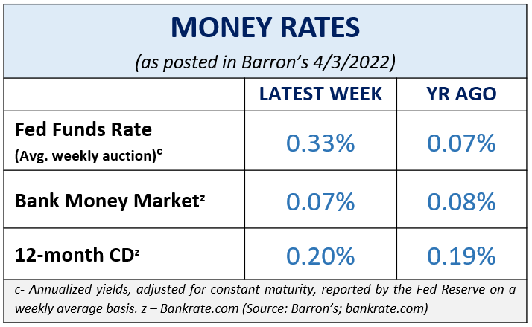
All eyes were on the Federal Reserve and interest rates as the Federal Open Market Committee (FOMC) met in March and raised the federal funds interest rates range for the first time since 2018. This move set the tone for anticipating several more rate hikes in 2022 and 2023, and at possibly higher basis points than expected.
In February, inflation rose 7.9% from 12 months earlier. This means that inflation is now at a 40-year high. It’s virtually impossible to avoid being affected by the current environment of inflationary pressure somewhere in your daily life. In March, consumers experienced an average 24% jump at the gas pump from February, which meant as much as a 53% increase over the past year. Whether it is at the gas pump or the grocery store, consumers are feeling squeezed and are looking for ways to cut costs and spending in their daily lives. (Source: cnbc.com 3/10/222)
Stock markets can fall as an immediate response to rising interest rates. This time, markets defied conventional history and rallied. After an initial drop, the S&P 500 closed the day that the FOMC announced the rate hike on a very strong note with the S&P 500 closing 2.2% higher than the day’s opening and the DJIA closed 1.6% higher. (Source: www.fortune.com 3/16/22)
There are always multiple factors in the economic environment that need to be watched because they can directly affect equity markets. With an excessive number of media sources nowadays, investors are being barraged with data and news making it difficult to keep up with the facts and information that may affect their personal situation. As your financial professional, we strive to keep an active eye on any issues, changes and activity that could directly affect you and your situation.
KEY TAKEAWAYS

- Equity markets experienced worst quarter since Q1 2020.
- The Fed raised the interest rate range to 0.25–0.5%.
- The expectation that interest rates will rise faster than anticipated depends on the path of inflation.
- Inflation highest in 40 years.
- Many variables, including global conflicts, Covid variants, and quantitative tightening are key factors in economic recovery.
- Volatility is here.
- Call us if you have concerns!
Inflation & Interest Rates
In March, the Federal Reserve raised the federal funds rate for the first time since 2018 by a quarter percentage point to between 0.25-0.5%.
With interest rates combating the rapid rise of inflation, Fed officials signaled there might be six more rate hikes this year, expecting to see the fed funds rate at nearly 2% by the end of this year. The Fed also suggested the percent of increase could rise as well, with possible half-percent, or 50 basis point, increases on the horizon.
As your financial professional, we are committed to keeping a watchful eye on the economy and how interest rate hikes and the trajectory of inflation affects our clients. If you are concerned about how these key items could affect you, please connect with us to discuss possible hedges against inflation and rising rates.
The Bond Market and Treasury Yields
Bonds and interest rates move in the opposite direction. When interest rates rise, existing bond prices tend to fall, and conversely, when interest rates decline, existing bond prices tend to rise.
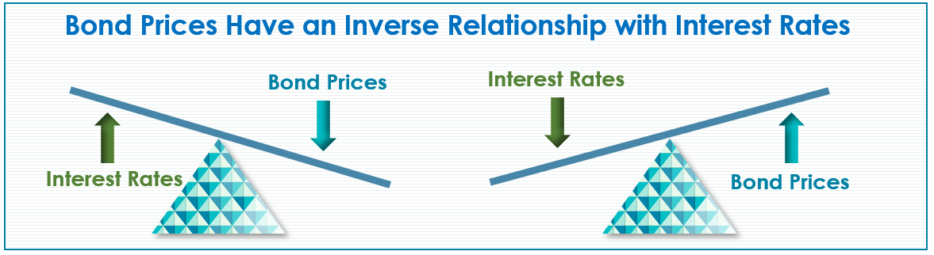
Recent times have not been very beneficial for bond holders. Bonds are often times considered to be more stable than equities for investors. This quarter, volatility in the bond market was high and U.S. bonds had their worst quarter in over 40 years. As an example, the Bloomberg U.S. Aggregate bond index, which includes mostly U.S. Treasurys, corporate bonds, and mortgage-backed securities, had a -6% return in the first quarter – its biggest quarter loss since 1980. Short- and mid-term bond yields also experienced rate increases this quarter. The 10-year Treasury yield finished the quarter at 2.35%. This is a significant jump from the 1.5% yield that 10-year bond holders had at the end of 2021. (Source: wsj.com 3/31/22)
Interest rates are rising and investors are expecting short-term yields to reach 3% in 2023, significantly higher than the current near 0.5%. This is a good time for any bond investors to review their holdings. (Source: wsj.com 3/31/22)
In addition to rising interest rates, the Fed is beginning its task of reducing its $9 trillion balance sheet in part created by its bond buying program. (Source: Morningstar.com 3/23/2022)
Eddy Vataru, Lead Portfolio Manager of the Osterweis Total Returns Fund, believes that Treasuries, which are typically viewed as "safer” investments, are also being impacted by the “calamity that’s driving inflation through the roof and trumping the flight-to-quality nature of the asset class.” (Source: Morningstar.com 3/23/2022)
Remember, bonds typically can be a key component to a diversified portfolio and can provide a good shield from equity volatility. However, please keep in mind that investors who placed a large percentage of their portfolio in bonds with the expectation of generating stable returns could have seen lackluster results. If you’d like to explore any exposure you have to bonds and whether or not they are still a good fit for your personal goals, please contact us. We are monitoring how the Fed’s movements and rising interest rates are affecting bond yields.
Investor’s Outlook
What does this all mean for investors?
As we continue on to the second quarter of 2022, many factors could complicate equity market performance and the speed and direction of the economy, including Russia’s war on the Ukraine and Covid-19 variants. Savers may need to become more disciplined and focused. Volatility isn’t likely to go away in the coming months, so investors need to be prepared.
Interest rates will continue to be at the forefront of our watch list. They can be complex and affect investors differently depending on their goals and timelines.
These five items are usually partnered with rising interest rates:
- Mortgage rates increase;
- Interest rates increase on savings accounts and Certificate of Deposits (CD);
- Existing bond prices decrease;
- Commodity prices decrease; and
- Equity markets may become more volatile.
The Fed is set to meet again the first week of May. It is widely anticipated that they will approve another rate increase. With interest rate hikes on the horizon, we suggest you consider:
- reviewing all income-producing investments.
- locking in your mortgage rates.
- maintaining liquidity for all near-term needs.
- contacting us to review your personal financial plan, including risk management, diversification, and time horizons.
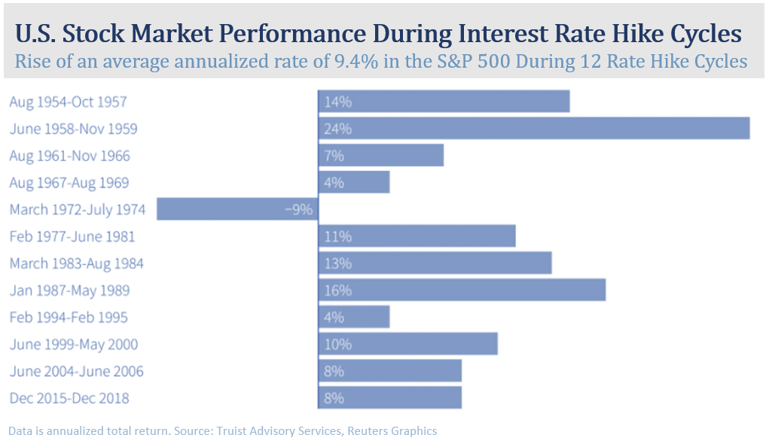
Interest rate changes are far from done and the Fed is expecting to make several more moves this year and in 2023. Combined with a lower unemployment rate and better supply chain movement, the Fed is hopeful that the increase in interest rates will help quell rising inflation. Fed officials are estimating that as energy prices ease and supply chains return to more normal operations, that we may see inflation drop down to 2.6% by the end of 2022. (Source: fidelity.com 3/10/22)

The good news is that historically, after an initial reaction, U.S. equity markets have risen during a period of rising interest rates. This is due to the fact that interest rates typically rise in a healthy economy.

According to a Deutsche Bank study of 13 interest rate increase cycles, the S&P 500 returned an average of 7.7% in the first year the Fed raised rates. An analysis by Truist Advisory Services of 12 rate hike cycles shoed the S&P 500 posting a total return average of 9.4% with 11 out of those 12 periods having positive returns. (Source: www.reuters.com 3/16/22)

Moving forward, we still stand by our mantra of “Proceed with Caution.”

There is currently a lot of noise that can distract an investor. Equity market volatility; interest rate increases; inflation; global unrest; and pandemics; have all given the media, analysts, and economists much to talk about. Now is an ideal time for a proactive approach to your financial goals. Having a solid investment strategy is an integral part of a well-devised, holistic financial plan. Staying disciplined and following that strategy during times of volatility is equally important. As your financial professional, we are here to help you pursue your goals. Please call our office to discuss any concerns or ideas you have or bring them up at your next scheduled meeting. Prior to making any financial decisions, we highly recommend you contact us so we can help determine the best strategy. There are often other factors to consider, including tax ramifications, increased risk, and time horizon fluctuations when changing anything in your financial plan. As always, please feel free to connect with us via telephone or email with any concerns or questions you may have.

We are here for you!
Remember, a skilled financial professional can help make your financial journey easier. Our goal is to understand your needs and create an optimal plan to address them.
While we cannot control financial markets, inflation, or interest rates, we keep a watchful eye on them. We can discuss your specific situation at your next review meeting or you can call to schedule an appointment. As always, we appreciate the opportunity to assist you with your financial matters.

Help us help others!
Our goal this year is to help others with their financial decisions. Please help us by offering a copy of this newsletter to a friend, colleague, or family member that you feel would benefit from this information.
To add someone to our mailing list please call (NAME) at (PHONE #).

Insert Approved B/D/ Disclaimer Here

Note: The views stated in this letter are not necessarily the opinion of broker/dealer, and should not be construed, directly or indirectly, as an offer to buy or sell any securities mentioned herein. Investors should be aware that there are risks inherent in all investments, such as fluctuations in investment principal. With any investment vehicle, past performance is not a guarantee of future results. Material discussed herewith is meant for general illustration and/or informational purposes only, please note that individual situations can vary. Therefore, the information should be relied upon when coordinated with individual professional advice. This material contains forward looking statements and projections. There are no guarantees that these results will be achieved. All indices referenced are unmanaged and cannot be invested into directly. Unmanaged index returns do not reflect fees, expenses, or sales charges. Index performance is not indicative of the performance of any investment.

The S&P 500 is an unmanaged index of 500 widely held stocks that is general considered representative of the U.S. Stock market. The modern design of the S&P 500 stock index was first launched in 1957. Performance prior to 1957 incorporates the performance of the predecessor index, the S&P 90. Dow Jones Industrial Average (DJIA), commonly known as “The Dow” is an index representing 30 stocks of companies maintained and reviewed by the editors of the Wall Street Journal. Past performance is no guarantee of future results. CDs are FDIC Insured and offer a fixed rate of return if held to maturity. Due to volatility within the markets mentioned, opinions are subject to change without notice. Information is based on sources believed to be reliable; however, their accuracy or completeness cannot be guaranteed.

There is an inverse relationship between interest rate movements and bond prices. Generally, when interest rates rise, bond prices fall and when interest rates fall, bond prices generally rise.

There is no guarantee that a diversified portfolio will enhance overall returns out outperform a non-diversified portfolio. Diversification does not protect against market risk.

Sources: federalreserve.com; cnbc.com; wsj.com; reuters.com; fortune.com; marketwatch.com; barrons.com; Morningstar.com; themortgagereports.com; fidelity.com; blackrock.com; bigcharts.com; Contents provided by the Academy of Preferred Financial Advisors, 2022©

