
Quarterly Economic Update
Fourth Quarter 2023
Your Name

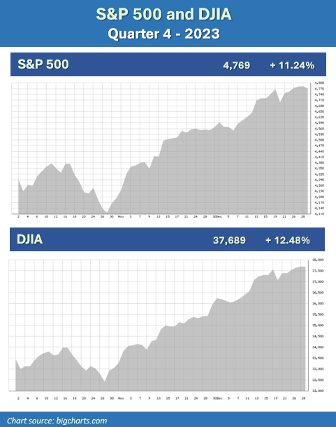

2023 is in the books and the last quarter left investors looking forward to a bright and happy new year. Historically, equities typically have advanced in the fourth quarter, and we can now add 2023 to that statistic. We entered the fourth quarter with strong momentum, including a healthy labor market and easing inflation pressures. The S&P 500 was up nine weeks straight in the fourth quarter and ended the year with a gain of more than 24%. The Dow Jones Industrial Average (DJIA) reached an all-time high and ended the quarter at 37,689, up more than 13% for the year. (Source: Barron’s 1/1/2024; cnbcnews.com, 12/29/23)

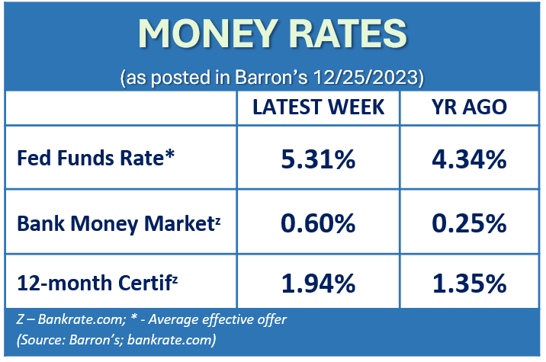
These increases were primarily attributed to the Federal Reserve signaling a pivot from its aggressive monetary position and indicating that interest rates could be cut several times in 2024. The Federal Reserve left interest rates unmoved in the fourth quarter due to the continued slowdown of inflation. “Inflation has eased from its highs, and this has come without a significant increase in unemployment. That’s very good news,” stated Fed Chair Jerome Powell during a news conference following the December FOMC meeting. Fed officials see core inflation finishing 2023 at 3.2%, and 2.4% in 2024, then to 2.2% in 2025, resting at a final destination of 2% in 2026. (Source: cnbc.com, 12/12/23)

The last quarter of 2023 could have been a pivoting point for equities. Over the past few years, the primary focus for investors has been inflation and interest rates, and many hunkered down with a focus on retention, not gains. If interest rates begin to stabilize, this could help support higher stock valuations and provide potential reentry points in 2024. A soft economic landing might come to fruition in the coming year. Inflation stabilizing or becoming stagnant, lower interest rates, a strong labor market, and confident consumer spending are all positive news. These are a few of the items investors can be grateful for. However, with optimism abounding and investors potentially beginning to come out of the shadows, this is not the time to throw caution to the wind. 2024 brings a presidential election, geopolitical unrest continues, and pandemic-era savings are dwindling.
KEY TAKEAWAYS
- The Fed has held their federal funds rate range steady at 5.25 – 5.50%, with no changes in the fourth quarter.

- Inflation pressures continue to ease, with November clocking in at a 3.1% increase compared to a year earlier.

- Bonds broke a 2-year losing streak due to a late quarter rally and Treasury yields began to drop on the potential of several possible interest rate cuts in 2024.
- Several key factors, including a presidential election and geopolitical unrest in 2024 could bring uncertainty for investors.

- Staying the course and maintaining the consistency of a well-devised, long-term focused plan has historically served investors well.

- We are here for you to discuss your unique situation.

As financial professionals, we are committed to keeping our clients apprised of any changes and activity that could directly affect their unique situation. While 2023 rewarded our focus of being disciplined with our long-term equity investments, we enter 2024 with our continued mantra of “proceed with caution.” Now is a good time to review your investments and confirm they are still congruent with your time horizon, risk tolerance, and goals.

Inflation & Interest Rates
Inflation pressure continued to ease in the fourth quarter. November’s rate came in at a 3.1% increase compared to a year earlier. While we have seen a significant improvement from the 9.1% peak in June of 2022, there is still a way to go to reach the Federal Reserve’s target of 2%.

The November core CPI (which excludes food and energy prices), which is used by many economists as a better indicator of future inflation, was up 4% from the year prior. While this is not the best of news, it is still well below its recent historical peak of 6.6% in September.

As a result of inflation easing and the economy maintaining its strength, the Federal Reserve held rates steady at their final meeting of 2023. The Fed had raised interest rates a whopping eleven times since March of 2022, so a three-time consistency of rate stagnancy was well received by investors. Even better news was the minutes shared that the Feds suggested rate cuts in 2024.

Interest rates and inflation are integral to financial planning so we will continue to keep a close eye on their movements. While the efforts of the Fed’s stringent monetary tightening policies the last few years are now being seen, the Fed still maintains their willingness to raise rate again should inflation reverse direction. Although we cannot predict what the Fed’s next move will be, we will continue to follow key economic indicators for our clients.

The Bond Market and
Treasury Yields
Thanks to a year-end surge, bond prices had a historic rally and after two straight years of losses, bond investors saw a positive year-end. Bonds were still in the negative until mid-November, and the closing rally in the fourth quarter ended their two-year losing streak.

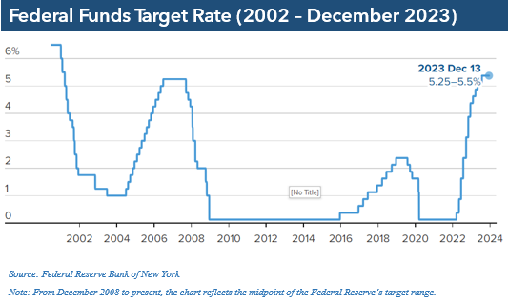
Deutsche Bank Research’s Jim Reid stated, “It was a positive year for most financial assets, but in several cases the gains were almost entirely driven by the final two months.” He continued, “If we’d have stopped in late-October, then bonds would still have been on track for a third consecutive annual loss.” (Source: marketwatch.com; 1/2/2023)

2023 was a significant year for treasury yields. In October, the 10-year treasury yield reached 5%, the first time in 16 years, before tempering back down. On December 29, the 10-year note was 3.88%, as compared to the end of the third quarter, where it reached 4.59%. The 20-year treasury ended the fourth quarter at 4.20% and the 30-year note closed at 4.03%. (Source: treasury.gov)

With the Feds anticipating interest rate cuts in 2024, this may narrow the opportunity to get lower-risk, higher yielding bonds.

For anyone who is interested in exploring adding more bonds as part of a diversified portfolio, please contact us. As a wealth manager, we want to help you make the best decision for your portfolio. Please remember, while diversification in your portfolio can help you pursue your goals, it does not ensure a profit or guarantee against loss.

Investor’s Outlook
The end of the fourth quarter brought investors to the new year with optimism and anticipation. Looking forward to 2024, recession fears have significantly diminished, and a “soft-landing” or a shallow recession appears to be more possible. It is believed that real GDP growth will regress but remain healthy and the labor market will remain strong. It’s also anticipated that inflation will continue to lose steam and will decline to about 2.5% in 2024. (Source: stlouisfed.org,11/28/23)

The interest rate hiking cycle currently seems to be coming to an end with the 5.25–5.5% rate as a high point until the Fed potentially commences with an interest rate cut cycle. This can be good news for the investor, and overall, 2023 was a healthy year.

The biggest question now is - will this rally continue during the new year?

Some things to keep an eye on in the coming months include energy and housing costs. There was good news at the gas pump this quarter, as gas prices were down 8.9% over the past year. Shelter costs are still historically high, but on a slow downtrend with mortgage rates dropping. Geopolitical unrest is still a major concern with the ongoing Russia-Ukraine war, conflict in the Middle East, and continued tensions with China. Also, the upcoming U.S. presidential election can be one of the major influencers of the market movements in 2024, since a new cabinet could signal major changes to the economy and tax laws. (Source: nytimes.com 12/11/23)

Since 1952, the average gain in the S&P 500 during a presidential election year is 7%. During a re-election year, the average annual gain is 12.2%. The average is 10% annual total returns for this major index in a non-election year. However, please remember that past performance does not guarantee future returns. (Source: money.usnews.com, 12/11/23)

While we are not in the business of trying to predict the future, Wall Street’s top strategists have released their forecast for the year ahead, with the average consensus that the S&P 500 will climb less than the historical average in 2024.(Source: finance.yahoo.com; 12/3/23)

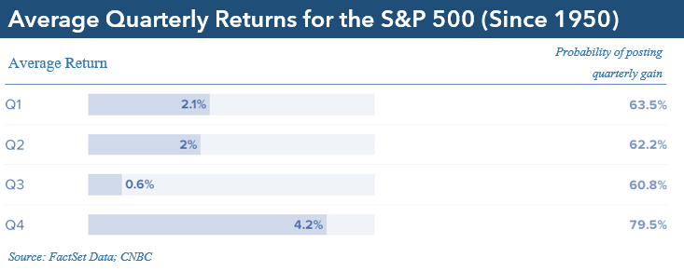
Heading into the new year, we will continue to keep an eye on inflations rates, economic growth data, and monetary policy moves. The coming months bring much uncertainty, and you should not let the recent market surge deflect you from your long-term strategy and goals. The media will be buzzing with daunting, speculative claims and predictions, and confusing information with the upcoming election. We recommend you minimize your viewing of news and social media.

2023 rewarded long-term investors and regardless of what 2024 will bring, it is always prudent to make smart money and investment decisions. We believe in proactive preparation and our goal is to provide you with a solid financial strategy that is carefully designed to withstand any market environment. From an investor standpoint, we stand by our belief that investing in equities is a long-term commitment. Heading into a new year, which is also the election year for one of the most raucous races we have seen in recent history, we believe that volatility could still be prevalent and that investors should be cautionary in any financial decisions. A long-term strategy needs to be a benchmark goal for smart investors.

We always recommend discussing any changes, concerns, or ideas that our clients may have with us prior to making any financial decisions so we can help them determine the best strategy. There are often other factors to consider, including tax ramifications, increased risk, and time horizon changes when altering anything in a financial plan.
Complimentary Financial Check-up
Our goal this year is to help more people with their financial decisions.
If you are currently not a client of Your Company Name, we would like to offer you a complimentary, one-hour, private consultation with one of our professionals at absolutely no cost or obligation to you.
To schedule your financial check-up, please call Contact name and information.

Our goal in 2024 is to exceed our client’s expectations. We take pride in offering our clients quality service and are available to review their investments. We are now accepting new clients and would welcome the opportunity to review your situation.

Insert Approved B/D/ Disclaimer Here

Note: The views stated in this letter are not necessarily the opinion of broker/dealer, and should not be construed, directly or indirectly, as an offer to buy or sell any securities mentioned herein. Investors should be aware that there are risks inherent in all investments, such as fluctuations in investment principal. With any investment vehicle, past performance is not a guarantee of future results. Material discussed herewith is meant for general illustration and/or informational purposes only, please note that individual situations can vary. Therefore, the information should be relied upon when coordinated with individual professional advice. This material contains forward-looking statements and projections. There are no guarantees that these results will be achieved. All indices referenced are unmanaged and cannot be invested into directly. Unmanaged index returns do not reflect fees, expenses, or sales charges. Index performance is not indicative of the performance of any investment.

The S&P 500 is an unmanaged index of 500 widely held stocks that is general considered representative of the U.S. Stock market. The modern design of the S&P 500 stock index was first launched in 1957. Performance prior to 1957 incorporates the performance of the predecessor index, the S&P 90. Dow Jones Industrial Average (DJIA), commonly known as “The Dow” is an index representing 30 stocks of companies maintained and reviewed by the editors of the Wall Street Journal. Past performance is no guarantee of future results. CDs are FDIC Insured and offer a fixed rate of return if held to maturity. Due to volatility within the markets mentioned, opinions are subject to change without notice. Information is based on sources believed to be reliable; however, their accuracy or completeness cannot be guaranteed.

There is an inverse relationship between interest rate movements and bond prices. Generally, when interest rates rise, bond prices fall and when interest rates fall, bond prices generally rise. There is no guarantee that a diversified portfolio will enhance overall returns out outperform a non-diversified portfolio. Diversification does not protect against market risk.

Sources: www.stlouisfed.org; usda.gov; www.cnbc.com; www.nytimes.com; www.barrons.com; www.forbes.com; www.moneyusnews.com; www.marketwatch.com; U.S. Department of Treasury; Contents provided by the Academy of Preferred Financial Advisors, 2024©

