******Gratitude:   
The Only Emotion Suitable When Investing**

Your NAME

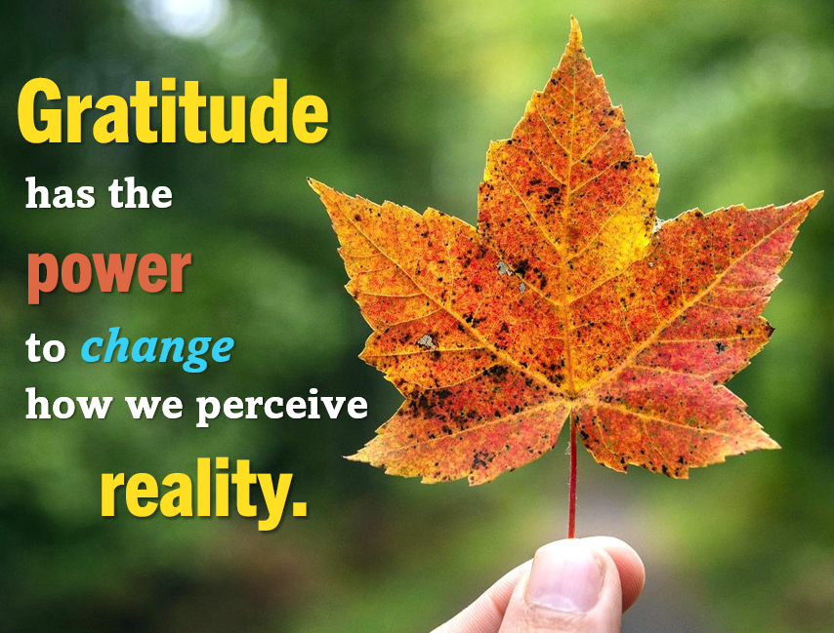

2024 has been a very eventful year. For the general population and, more specifically, investors, this year has been filled with events that kept us on our toes. From fluctuating interest rates, slowing inflation, an unusual and tumultuous election, and geopolitical instability, it has certainly been a year of significant challenges.

Despite the year’s ups and downs in the equity markets, those who stayed committed to their long-term investment strategies have seen positive outcomes. Both the S&P 500 and the Dow Jones Industrial Average (DJIA) reached multiple records, marking a favorable year for investors overall.

Looking ahead, 2025 promises to be a year of change, with a new administration, an agenda of new tax laws, and shifts in monetary policy on the horizon. Like other transitional years, investors should prepare for periods of uncertainty and volatility. One of our goals is to keep informed about these factors and any other issues that may impact our clients now and in the future.

Throughout the year, we provide timely and informative reports and newsletters that help you stay apprised of the economic environment and any aspects that could affect your situation. During this festive season, we want to shift our focus and share with you a message we feel is very important. Our topic for this article is gratitude.

We want to express our gratitude for everything we have experienced this year. It’s essential to pause and appreciate good health, wealth, and all the positive aspects of life. **The greatest gratitude our firm has is for you, our clients, and the trust you have placed in us to help you with your financial journey.**

As wealth managers, strategizing and planning are part of our daily lives. While gratitude is a spontaneous feeling, we can make conscious efforts and plans to cultivate an ongoing attitude of gratefulness deliberately.

Gratitude has the power to help transform your perception of reality. Each day offers you the opportunity to embrace and express gratitude, and developing this habit can serve as a powerful defense during challenging times. A mound of dirt in a field
Remember that gratitude enhances happiness, and happiness is crucial for well-being.

Gratitude is technically defined as “the quality of being thankful; readiness to show appreciation for and to return kindness.” This definition highlights that gratitude is a two-way street. When we are grateful, we are often inspired to "pay it forward."

Here are some ideas we use for cultivating gratitude in both our professional and personal lives:

* **Make a practice of writing down what you are grateful for**. Whether you do this daily, weekly, or yearly, taking the time to write it down is more memorable and effective than simply reflecting on it.
* **Try to compliment people consistently.** Whether it's the person who carefully bags your groceries or leaving a note for your loved ones on the refrigerator door or bathroom mirror, a single compliment can leave a lasting and meaningful impression.
* **Practice kindness.** Just like a compliment, a single act of kindness can positively impact both you and the recipient for a long time. Moreover, when people receive kindness, they are more likely to spread it further.
* **Volunteer or donate to a charitable cause.** A great way to show gratitude is by helping those who are less fortunate. Donating your time or money to your favorite charity can fill your heart and others with appreciation.
* **Purposefully smile.** Smile therapy is real, and it works. The benefits of smiling are numerous, including stress relief, lowered blood pressure, improved mood, and pain relief. Plus, smiling is contagious - moods spread. Would you rather contribute to gloominess or happiness?

**Remember, gratitude rhymes with attitude and inspires positivity in our lives and in the lives of others.**

**Gratitude and Investing**

While we believe that emotions should be kept on the back burner when making important financial decisions, they can significantly influence many people’s investment choices. Specifically, emotions can influence risk tolerance and the ability to stick to a long-term strategy.

Practicing gratitude and appreciation can help you cultivate a calm, emotionally intelligent mindset during challenging times, especially when market volatility and uncertainty are prevalent.

Market fluctuations can unsettle even the most experienced investors, leading to emotional or panic-driven decisions based on short-term security rather than long-term gains. Conversely, excessive confidence and a hasty approach can result in impulsive decisions that can derail your true goals.

In contrast, maintaining a sense of gratitude can help you stay level-headed, patient, and focused on your long-term objectives. Understanding the value of patience can prevent you from seeking immediate rewards at the expense of your long-term investment strategy. We recommend taking a moment to reflect on your motives and feelings before making any investment decisions. Consider the positives in your life before making significant changes to your financial plans, and, as always, consult with us so we can help you assess whether that proposed change aligns with your goals and the vision you have for your financial future.

**As your wealth managers, we are perpetually grateful for the long-term relationships we have with our clients**. We understand that having a good financial professional can help make your journey easier, and we appreciate your trust and confidence in our services. ***The joy we receive from helping preserve and manage wealth for our clients is abundant!***

2025 will bring changes to the investing and tax environments. As always, we are here to help you with any questions or concerns you may have.

**We want to exceed your expectations.** In the upcoming year, we are committed to delivering exceptional service to you, which will include:

* Consistent and effective communication, featuring informative reports and updates.
* Regular client meetings.
* Ongoing education for our team members on issues that impact you.

**We look forward to serving you   
in 2025! We hope you have a wonderful holiday season.**

Approved B/D/ Disclaimer Here

This article is for informational purposes only. The views expressed are not necessarily the opinion of Insert Broker-dealer name. This information is not intended to be a substitute for specific individualized tax, legal or investment planning advice as individual situations will vary. For specific advice about your situation, please consult with a lawyer, tax or financial professional. The information contained in this report does not purport to be a complete description of the securities, markets, or developments referred to in this material. The information has been obtained from sources considered to be reliable, but we do not guarantee that the foregoing material is accurate or complete. Any information is a complete summary or statement of all available data necessary for making an investment decision and does not constitute a recommendation. The S&P 500 is an unmanaged index of 500 widely held stocks that is generally considered representative of the U.S. Stock market. The Dow Jones Industrial Average (DJIA), commonly known as “The Dow” is an index representing 30 stocks of companies maintained and reviewed by the editors of the Wall Street Journal. All performance referenced is historical and is no guarantee of future results. All indices are unmanaged and may not be invested into directly. Diversification is a method used to help manage investment risk; it does not guarantee a profit or protect against investment loss.

Contents provided by the Academy of Preferred Financial Advisors, Inc.



We’d like to expand our family!

**We want to help others like you in 2025!**

Do you know someone who could benefit from our services? If so, please contact us so we can add them to our mailing list and offer them a complimentary, one-hour private consultation to explore their financial situation.

**To connect us with a friend or family member, please call us at XXX-XXX-XXX!**

Year-end Gratitude Reflection

**Things I am Grateful for:**

___________________________________________________________________________________________________________________________________________________

___________________________________________________________________________________________________________________________________________________

___________________________________________________________________________________________________________________________________________________

___________________________________________________________________________________________________________________________________________________

___________________________________________________________________________________________________________________________________________________

___________________________________________________________________________________________________________________________________________________

___________________________________________________________________________________________________________________________________________________

___________________________________________________________________________________________________________________________________________________

**Things I Look Forward to in 2025:**

___________________________________________________________________________________________________________________________________________________

___________________________________________________________________________________________________________________________________________________

___________________________________________________________________________________________________________________________________________________

___________________________________________________________________________________________________________________________________________________

___________________________________________________________________________________________________________________________________________________

___________________________________________________________________________________________________________________________________________________

___________________________________________________________________________________________________________________________________________________

___________________________________________________________________________________________________________________________________________________

Did you lose sight of some items that are integral to your overall wealth in 2024?   
What will you do to refocus in 2025?As always, if you need assistance with your financial wealth, we are here to help!