
Staying the Course: The Discipline Behind Long-Term Investment Success
Your Name

One of the greatest challenges investors often face is not selecting the right investments, it's maintaining the discipline to stay the course of their investment plan and goals when equities become volatile.
Periods of market volatility can be unsettling. Negative, doom and gloom headlines become more frequent and pronounced, predictions of an impending problem can circulate in the news, and downward daily market movement can seem more significant than it really is. It's only natural to feel concerned when account values temporarily decline; however, history has consistently demonstrated that market volatility is not an anomaly, rather, it's a normal and expected part of long-term investing and not something to fear.
Savvy investors understand that volatility is the price paid for participating in the long-term growth of the financial markets. Rather than viewing market fluctuations as something to fear, they recognize it as a natural part of the investment journey. Savvy investors know that volatility can be managed by a long-term investing mindset and staying disciplined through various market conditions. They also know it can provide an opportunity to earn higher long-term returns.
As wealth managers, we understand that every investor is unique, but one thing is universal, your goals should drive your investment decisions, not your emotions.
Some investors are planning for retirement. Some are already retired. Others want to fund a child's education, purchase a second home, leave a legacy, or create reliable income throughout retirement. Each goal has its own timeline, level of risk, and investment strategy.
When investments are designed around clearly defined personal goals, market volatility becomes easier to put into perspective. A difficult week, month, or even year in the market doesn't necessarily change the likelihood of achieving goals that may be five, ten, or twenty years away.
The market's daily movements are temporary. Your financial goals are not. One of our responsibilities as wealth managers is to help clients keep their investment decisions aligned with their long-term goals and not with their emotions.
Here are a few important reminders to help you stay committed to your well-designed investment strategy when market uncertainty causes others to lose sight of their long-term goals.

Volatility Is Normal
Many investors mistakenly believe that successful investing should be smooth and predictable. In reality, market pullbacks, corrections, and even bear markets occur regularly.
Throughout history, markets have navigated wars, recessions, inflationary periods, financial crises, pandemics, political uncertainty, and countless unexpected events. While each period felt unique at the time, one characteristic remained remarkably consistent, equity markets eventually recovered and continued their long-term upward trajectory.
Every major bull market has included corrections. Every long-term investment journey has experienced periods of uncertainty.
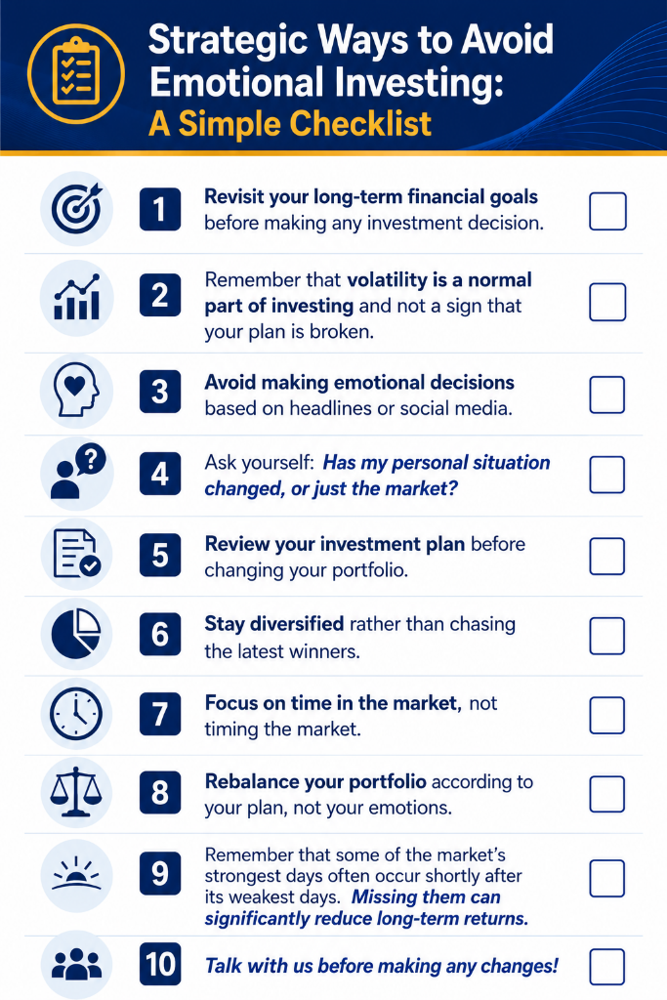
Remember: temporary declines have always been a normal part of investing, not a sign that investing has stopped working. Building a portfolio that takes into account volatility and a financial plan that can “expect the unexpected” should be a part of your investment strategy.

Emotional Investing Is Often
the Greatest Risk
Headlines are designed to capture attention. The media often amplifies uncertainty because uncertainty and fear attract viewers. Every day brings new predictions, bold forecasts, and reasons why "this time is different." It is understandable how even the most stable investors could become anxious and consider making rash, emotion-based decisions. However, while staying informed is important, making investment decisions based on daily headlines rarely produces better long-term outcomes.
Markets begin pricing in future expectations long before the news becomes obvious. By the time investors feel comfortable again, much of the recovery might often have already occurred. Some of the strongest market days throughout history have occurred shortly after significant declines. Investors who move to the sidelines during these declines often miss powerful rebounds, and unfortunately, those missed days can have a dramatic impact on long-term wealth accumulation.
One of the greatest risks during periods of volatility is not the decline itself, it's panicking and abandoning a long-term investment plan. Successful investors understand the importance of remaining focused on their long-term goals.

Time in the Market Beats
Timing the Market
Successful investing has never been about predicting the future. It's about allowing businesses to innovate, economies to grow, and compound returns to work over decades rather than days. Every market cycle eventually has led to the next expansion. Companies adapt, technologies evolve, productivity improves, and economies continue moving forward. Investors who remain disciplined allow these long-term forces to work in their favor.
Those who continually react to short-term market movements often sacrifice long-term returns in pursuit of short-term comfort.

Volatility Creates Opportunity
Periods of market volatility can actually benefit long-term investors. Lower prices can mean more ability to purchase investments at attractive prices.
Additionally, market volatility often creates opportunities to rebalance portfolios, harvest tax losses when appropriate, and ensure investment allocations remain aligned with long-term objectives.
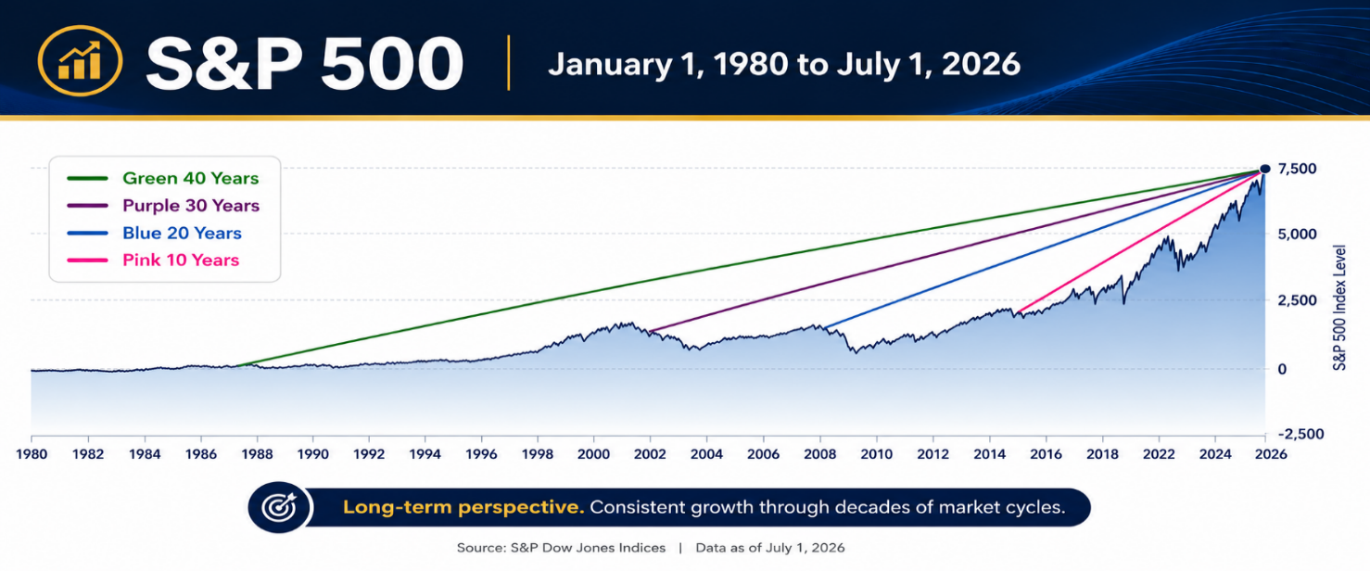
Rather than viewing volatility solely as risk, disciplined investors recognize that it can also create opportunity.

Focus on What You Can Control
No one can control inflation, interest rates, geopolitical events, or tomorrow's newest headlines.
What investors can control includes:
- Having a clearly defined financial plan.
- Maintaining an appropriate asset allocation.
- Diversifying investments.
- Rebalancing when necessary.
- Continuing to invest consistently.
- Avoiding emotional reactions to short-term market noise.
These decisions can have a far greater impact on long-term success than being reactive or attempting to outsmart the markets.

Successful Investing
Requires Patience
Building wealth is not about avoiding every downturn. It is about remaining committed to a well-designed plan through both favorable and challenging market environments.
Short-term volatility is temporary. Long-term discipline is permanent.
Investors who stay focused on their financial goals are often rewarded over time with the power of compounding and the long-term upward trend of equities.
As Warren Buffett famously said, "The stock market is a device for transferring money from the impatient to the patient."
As you can see from the chart, the S&P 500 has consistently grown through decades of market cycles. Patience has always been one of the most valuable assets an investor can own.

The Value of a Trusted Professional
One of the greatest values a trusted financial professional provides is not in selecting investments, it’s in helping clients make good decisions when emotions are running high. During periods of uncertainty, as wealth managers, we help clients reconnect with the purpose behind their investment strategy.
This requires our conversation to shift from "What is the market doing today?" to "Are you still on track to accomplish your goals?"
More often than not, the answer is yes.

Final Thoughts
Market volatility is inevitable. It cannot be eliminated, but it can be managed.
History has consistently demonstrated that disciplined investors who remain focused on their long-term objectives have generally been rewarded for their patience. Those investors who achieved the greatest long-term success are most commonly the ones who stay invested through both the good times and the challenging ones.
Rather than allowing uncertainty to drive investment decisions, successful investors recognize that temporary market declines are simply part of the journey toward achieving long-term financial goals.
Know Someone Who Could Benefit from Valued Financial Guidance?
Our practice has grown primarily through referrals from wonderful clients like you. If you have a family member, friend, or colleague who could benefit from the same level of personalized care and guidance, we'd be grateful for an introduction. You can also add them to our mailing list to receive our educational newsletters and articles. Please call Name at XXX-XXX-XXXX to make an introduction.

Markets will continue to experience periods of uncertainty and economic conditions will evolve. But the principles of long-term investing remain consistent: stay disciplined; stay diversified; stay focused on your goals; and most importantly, stay the course.
We believe an informed client is the best client. Our commitment is to offer our clients consistent, meaningful communication and to proactively help them navigate the changing economic environment. As always, we appreciate the opportunity to assist you with all your financial needs. If you have any questions during your journey, please feel free to connect with us.

Insert Approved BD Disclaimer and Contact Information
This article is for informational purposes only. This information is not intended to be a substitute for specific individualized tax, legal or investment planning advice as individual situations will vary. For specific advice about your situation, please consult with a lawyer, tax or financial professional. The information contained in this report does not purport to be a complete description of the securities, markets, or developments referred to in this material. The information has been obtained from sources considered to be reliable, but we do not guarantee that the foregoing material is accurate or complete. Any information is not a complete summary or statement of all available data necessary for making an investment decision and does not constitute a recommendation. All indices are unmanaged and cannot be invested into directly. Unmanaged index returns do not reflect fees, expenses, or sales charges. Index performance is not indicative of the performance of any investment. Past performance is no guarantee of future results.
Source: S&P Dow Jones Indices. Contents provided by the Academy of Preferred Financial Advisors, 2026

